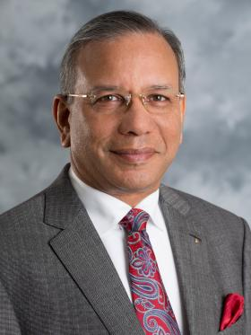
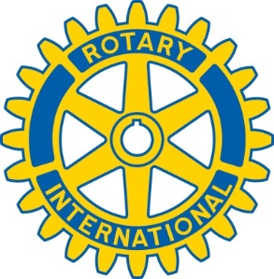
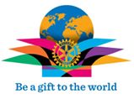

Rotary International
World President
K.R. Ravindran “ RAVI “
Invites all Rotarians of the World to
SEOUL, KOREA
May 29th to June 1st 2016
Enjoy the great experiences of an International Convention as you partake of the beauty and culture that is Korea
Book early and save
“Connect with Korea -Touch the world”

