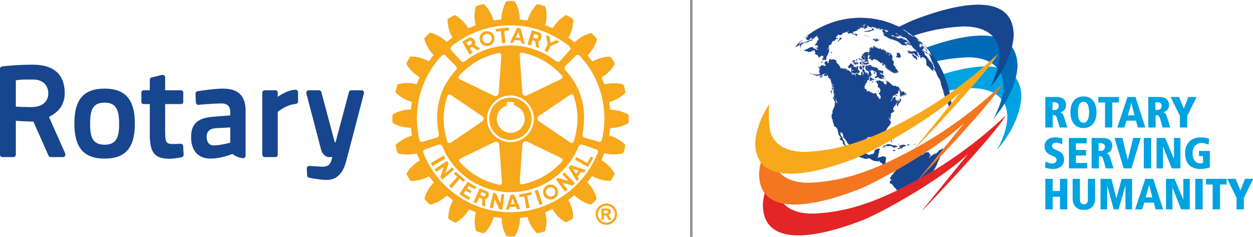

GUIDING PRINCIPLES
These principles have been developed over the years to provide Rotarians with a strong, common purpose and direction. They serve as a foundation for our relationships with each other and the action we take in the world.

OBJECT OF ROTARY
The Object of Rotary is to encourage and foster the ideal of service as a basis of worthy enterprise and, in particular, to encourage and foster:
- FIRST: The development of acquaintance as an opportunity for service;
- SECOND: High ethical standards in business and professions; the recognition of the worthiness of all useful occupations; and the dignifying of each Rotarian’s occupation as an opportunity to serve society;
- THIRD: The application of the ideal of service in each Rotarian’s personal, business, and community life;
- FOURTH: The advancement of international understanding, goodwill, and peace through a world fellowship of business and professional persons united in the ideal of service.

THE FOUR-WAY TEST
The Four-Way Test is a nonpartisan and nonsectarian ethical guide for Rotarians to use for their personal and professional relationships. The test has been translated into more than 100 languages, and Rotarians recite it at club meetings:
Of the things we think, say, or do
- Is it the TRUTH?
- Is it FAIR to all concerned?
- Will it build GOODWILL and BETTER FRIENDSHIPS?
- Will it be BENEFICIAL to all concerned?

AVENUES OF SERVICE
We channel our commitment to service at home and abroad through five Avenues of Service, which are the foundation of club activity.
- Club Service focuses on making clubs strong. A thriving club is anchored by strong relationships and an active membership development plan.
- Vocational Service calls on every Rotarian to work with integrity and contribute their expertise to the problems and needs of society.
- Community Service encourages every Rotarian to find ways to improve the quality of life for people in their communities and to serve the public interest.
- International Service exemplifies our global reach in promoting peace and understanding. We support this service avenue by sponsoring or volunteering on international projects, seeking partners abroad, and more.
- New Generations Service recognizes the importance of empowering youth and young professionals through leadership development programs such as Rotaract, Interact, Rotary Youth Leadership Awards, and Rotary Youth Exchange.

Rotarian code of conduct
The following code of conduct has been adopted for the use of Rotarians. As a Rotarian, I will:
- Act with integrity and high ethical standards in my personal and professional life
- Deal fairly with others and treat them and their occupations with respect
- Use my professional skills through Rotary to: mentor young people, help those with special needs, and improve people’s quality of life in my community and in the world
- Avoid behavior that reflects adversely on Rotary or other Rotarians

