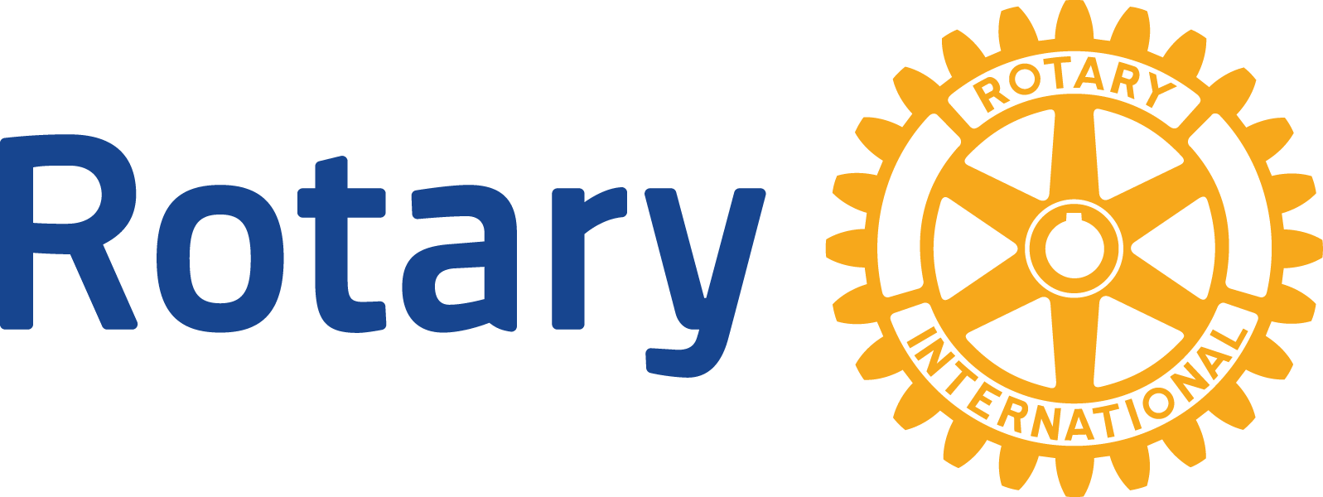
ENGLISH (EN)

Cooperating organization

MEMORANDUM OF UNDERSTANDING

An agreement between

[Name of host club or district, country], “Host Sponsor,”

[Name of international club or district, country], “International Sponsor,”

[Name of cooperating organization, country], “Organization 1,”

and [Name of cooperating organization, country], “Organization 2”

Note: The Foundation needs to receive this memorandum of understanding (MOU) in this exact form. Complete the form fields but do not edit any other text. If you aren’t sure how to complete the fields, refer to the tips at the end.

SUBJECT
Global Grant #[Grant number], [Title], in [Community], [Country], the “Rotary Grant.”

DEFINITION
A cooperating organization is any reputable non-Rotary organization that provides expertise, infrastructure, advocacy, training, education, or other support for the grant project. Cooperating organizations must comply with all reporting and auditing activities required by The Rotary Foundation and provide receipts as requested.

PURPOSE
This document establishes an agreement between the parties listed above to implement a project funded by a Grant from The Rotary Foundation. This document may also be used with other groups that are participating in the project, such as beneficiary organizations, nonprofit contractors, or government agencies.

PROJECT OBJECTIVES
All parties listed in this agreement will collaborate to achieve the following project objectives:
- [add objective]
- [add objective]
- [add objective]

HOST SPONSOR RESPONSIBILITIES
Describe the specific responsibilities of the Host Sponsor. The Host Sponsor will:
- [add specific responsibilities for this project]
- [add specific responsibilities for this project]
- [add specific responsibilities for this project]

INTERNATIONAL SPONSOR RESPONSIBILITIES
Describe the specific responsibilities of the International Sponsor. The International Sponsor will:
- [add specific responsibilities for this project]
- [add specific responsibilities for this project]
- [add specific responsibilities for this project]

ORGANIZATION 1 RESPONSIBILITIES
Describe the specific responsibilities of Organization 1. Organization 1 will:
- [add specific responsibilities for this project]
- [add specific responsibilities for this project]
- [add specific responsibilities for this project]

ORGANIZATION 2 RESPONSIBILITIES
Describe the specific responsibilities of Organization 2. Organization 2 will:
- [add specific responsibilities for this project]
- [add specific responsibilities for this project]
- [add specific responsibilities for this project]

MUTUAL UNDERSTANDINGS
All parties agree that:
- The Rotary Grant, if approved, will be awarded to the Host Sponsor and International Sponsor.
- The Host Sponsor and International Sponsor will control and manage the Rotary Grant.
- The Host Sponsor and International Sponsor will be involved in all stages of the project.
- The Host Sponsor and International Sponsor will each have a grant project management committee with at least three members, responsible for managing the project on their behalf.
- The Host Sponsor and International Sponsor and the Organizations will abide by the Terms and Conditions for Rotary Foundation Global Grants.
- The Host Sponsor and International Sponsor affirm that the Organizations are reputable and responsible and act within all laws of the project country.
- All grant funds will be received and managed by the Host Sponsor or the International Sponsor and will not be managed by the Organizations.
- Grant funds will remain in the designated Rotary Grant bank account until they are needed to pay a vendor or reimburse a purchase.
- All payments to vendors and reimbursements to Organizations will be supported by receipts, paid invoices, vouchers or written agreements.
- The Organizations may contribute funds toward the project, but The Rotary Foundation does not match these funds.
- The Organizations’ project-related documentation may be subject to independent financial and operational review by The Rotary Foundation.
- In their separate club or district qualification memorandum of understanding, the Host Sponsor and International Sponsor have agreed to:
- Ensure that all grant activities, including the conversion of funds from one currency to another, comply with local law
- Ensure that the project adheres to The Rotary Foundation’s stewardship measures and grant management practices
- Ensure that all people involved in a grant conduct their activities in a way that avoids any actual or perceived conflict of interest
- Report to the district any potential or real misuse or mismanagement of grant funds
- Cooperate with any financial, grant, or operational audits
- Maintain a standard set of accounts, which includes a general ledger and a complete record of all receipts and all disbursements of grant funds
- Disburse grant funds in accordance with the Terms and Conditions for Rotary Foundation Global Grants
- Maintain records for items that are purchased, produced, or distributed through grant activities
- Maintain a dedicated bank account to be used only for receiving and disbursing grant funds
- Have a minimum of two Rotary member bank account signatories from the sponsoring clubs or districts for disbursements
- Maintain a separation of duties for handling funds so no one person is solely in control of them
- Maintain a written plan for transferring custody of bank accounts in the event of a change in signatories
- Retain bank statements to substantiate the receipt and use of grant funds
- Retain grant documents in a location known by and accessible to club and district officers
- Retain grant documents for a minimum of five years, or longer if required by local law

CONFLICTS OF INTEREST
Any real or perceived conflicts of interest must be disclosed to Rotary grants staff during the grant application process, in compliance with The Rotary Foundation’s Conflict of Interest Policy for Grants in the Terms and Conditions for Rotary Foundation Global Grants. A conflict of interest occurs when someone is in a position to make or influence a decision about a grant that could benefit them, their family, their business, or an entity in which they serve in a paid or voluntary leadership or advisory position. This includes any instances of Rotary members acting as vendors or serving as trustees, directors, officers, or staff of one of the Organizations. If in doubt, any potential conflict should be disclosed.
Identify any real or perceived conflicts here:
[Names, roles]

MODIFICATION
Modifications to this document will be made by mutual consent of the parties. A written modification, signed and dated by all parties and approved by The Rotary Foundation, must be issued before acting on any changes.

CONTACT INFORMATION
Your privacy is important to Rotary International and The Rotary Foundation (collectively, “Rotary”) and the personal data you share with Rotary will only be used for official Rotary business, such as in relation to the Rotary Grant. Personal data collected on this form is subject to Rotary’s privacy policy.

AUTHORIZATIONS
By signing below, the parties agree to the terms of this memorandum of understanding.
Host Sponsor authorization:
Signature: |  |  |  |  |  |  | Date: |  | Date
Printed Name: |  |  | Printed Name |  |  | Position: |  | Position
Postal Address: |  |  | Postal Address
Phone: | Phone |  |  | Email: | Email

International Sponsor authorization:
Signature: |  |  |  |  |  |  | Date: |  | Date
Printed Name: |  |  | Printed Name |  |  | Position: |  | Position
Postal Address: |  |  | Postal Address
Phone: | Phone |  |  | Email: | Email

Organization 1 authorization:
Signature: |  |  |  |  |  |  | Date: |  | Date
Printed Name: |  |  | Printed Name |  |  | Position: |  | Position
Postal Address: |  |  | Postal Address
Phone: | Phone |  |  | Email: | Email

Organization 2 authorization:
Signature: |  |  |  |  |  |  | Date: |  | Date
Printed Name: |  |  | Printed Name |  |  | Position: |  | Position
Postal Address: |  |  | Postal Address
Phone: | Phone |  |  | Email: | Email

TIPS FOR COMPLETING THIS FORM

General
If you’re working with just one organization, provide information for Organization 1 only. Always include the Rotary Host Sponsor and International Sponsor.

Project Objectives
In this section, project partners outline the overall goals of the project that all partners hope to achieve together.

For example:
- Improve the quality of education students receive at Community Primary School
- Improve the quality of care for cancer patients at Community Hospital
- Increase farmers’ yields by 10% through drip irrigation

Responsibilities Sections
Meeting with all project partners to assign responsibilities and record them in writing can prevent conflicts and increase your project’s chances of success. It helps ensure that everyone agrees on the basics of the project plan and prevents confusion during implementation. When you define the responsibilities of each partner, carefully consider their resources and skills. Remember that each project has its own unique roles and responsibilities that are essential for effective implementation. List detailed and specific responsibilities for your project.

Questions to consider when determining responsibilities:
- Who will provide technical and professional services? What specific services will be provided, or what specific skills are needed?
- What types of staffing, infrastructure, or equipment is required, and who will provide those?
- Who will provide training, mentoring, education, advocacy, and financial review?
- Who will direct and coordinate local community education and public relations?
- Who will seek community support and resources for the project?
- Who will manage the grant funds and pay suppliers, vendors, and contractors?
- Will cooperating organizations submit itemized expense statements and receipts before they receive grant funds?
- Who will direct and coordinate fundraising efforts?
- Who will pay for long-term equipment maintenance, operations, programming, and staffing after Rotary Grant funding ends? (Note that Rotary members may continue to support the project, but the project should not depend solely on that support.)
- Who will prepare Rotary Grant reports? Who will collaborate on reporting?
- How will financial records be stored? Who will maintain these records? What is the document retention plan?
- Who will measure and evaluate the project’s outcomes? How will they do this? Who will collect results? How will the outcomes be shared?

Mutual Understandings
For legal reasons, the Foundation needs this section to remain as it is. It must not be added to or edited. We understand that, for certain relationships, Rotary members may need to sign a second MOU or contract to comply with local laws. Even in such cases, however, the Foundation needs this MOU to be submitted with your grant application.

AUTHORIZATIONS
Make sure that all parties have signed the MOU. If any signature is missing, it will be considered incomplete. Each sponsor and organization should decide who will represent it as a signatory.

If you have any concerns or questions, your regional grants officer can review your MOU before it is signed to make sure it’s complete.

