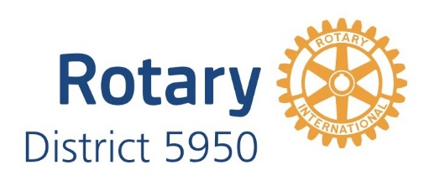
Global Grant Scholars

2025-26
Nellie Ide
Sponsor: Minneapolis University Rotary
Institution: London School of Hygiene & Tropical Medicine, UK
Degree: Masters in Public Health

Sarah Cao
Sponsor: Rotary Club of Plymouth
Institution: University of Oxford
Degree: Master of Philosophy in International Relations

2023-24
Julia De Georgeo
Sponsor: Minneapolis City of Lakes Rotary Club
Institution: London School of Hygiene & Tropical Medicine, UK
Degree: Masters in Public Health

Hope Forsman
Sponsor: Edina Rotary Club
Institution: University of Bath, UK
Degree: Masters International Relations

2022-23
Addy Cross
Sponsor: Minneapolis City of Lakes Rotary Club
Institution: University of St. Andrews, Scotland
Degree: Masters of Research in Social Anthropology

Javier Fernandez
Sponsor: Rotary Club of Plymouth
Institution: University of Birmingham, UK
Degree: Masters International Security and Terrorism

2021-22
Madeline Sladek
Sponsor: Edina Rotary Club
Institution: University of Copenhagen
Degree: Masters in Management of Innovation and Business Development
Padee Yang
Sponsor: Rotary Club of Excelsior
Institution: London School of Oriental and African Studies
Degree: Master of Science, Violence, Conflict and Development (2022)

2019-20
Claire Brady
Sponsor: Minneapolis University Rotary
Institution: London School of Economics, UK
Degree: Masters International Migration and Public Policy
Kelly Meza Prado
Sponsor: Minneapolis University Rotary
Institution: London School of Hygiene & Tropical Medicine, UK
Degree: Master of Public Health, Environment and Health Focus

2018-19
Daniela Prigozhina
Sponsor: Minneapolis University Rotary
Institution: Barcelona School of Economics, Spain
Degree: Masters in Economics

2017-18
Amal Gani
Sponsor: St. Louis Park Rotary
Institution: Utrecht University, Netherlands Degree: Masters in Public Law
Thomas Bird
Sponsor: Minneapolis City of Lakes Rotary
Institution: Central European University, Hungary Degree: Master of Public Policy

2016-17
Grace Petrie
Sponsor: Bloomington Rotary Institution: King’s College, UK
Degree: Master of Science, International Development and Emerging Economies

2015-16
Marcos Carvalho
Sponsor: Minneapolis South Rotary
Institution: University of Kent, Belgium
Degree: Masters of Arts, Political Strategy and Communication with International Migration

