

**Holistic WASH**

***WATER, SANITATION AND HYGIENE***

**A Transformative Generational Strategy**

**For Rotary Support in District 9212**

**April 2014**

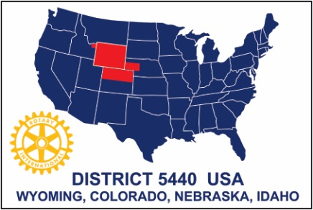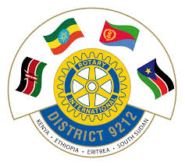

**EXECUTIVE SUMMARY**

Rotary Districts 9212, 5440 and 5450 believe that clean water, improved sanitation, and adequate hygiene (WASH), together with youth employment, are among the most important global challenges of the 21st century in developing countries. These Districts believe that Rotary can lead the mobilization of youth to dramatically improve WASH worldwide.

Rotary Districts 9212, 5450 and 5440 formed a Vocational Training Team (VTT) in 2013 to develop a WASH strategy for District 9212 in East Africa. The Strategy focuses on implementing WASH in schools and involving a large cadre of youth in training and skills development in WASH to create employment opportunities. District 9212 is composed of four countries: Kenya, Ethiopia, Eritrea and South Sudan. The VTT spent one month in Kenya consulting with local experts and traveling the country to observe needs and best practices. Kenyan team members travelled to Colorado and Wyoming to learn technologies and approaches that might be relevant to the Kenyan context and to build relationships with Rotary Districts 5440 and 5450, international non-governmental organizations (NGOs) and academic institutions.

The needs for improved WASH are immense globally and in District 9212. *Past Rotary efforts in WASH in District 9212 have not been sufficiently focused to bring about fundamental and measurable change and too many projects have been supply driven by Rotary clubs from outside the District rather than demand driven by the needs identified by Rotary clubs inside the District.* Rotary would like to identify where it can make the most difference with its technical assistance, funds and volunteer base.

Rotary clubs in D9212, D5440 and D5450 see the WASH and the Youth developmental challenge as issues to be addressed jointly and synergistically. The VTT concluded from its visits and consultations that Rotary can achieve the greatest impact in the WASH sector by addressing the following three strategic objectives:

* Strategic Objective 1: To rally the participation of Rotary Clubs and Districts to support a common WASH strategy,
* Strategic Objective 2: To create a cadre of youth trained in WASH knowledge and skills to deliver Holistic WASH, and
* Strategic Objective 3: To strive to develop Adequate WASH in every Kenyan school, and develop 5 Model Schools in every county in Kenya to promote and demonstrate WASH.

These three strategic objectives will only be successfully achieved by comprehensively and effectively communicating the needs and opportunities to Rotary and its partners.

Communication thus forms the crosscutting objective for this strategy.

The strategy introduces three important concepts regarding WASH: **Adequate WASH** means that schools have clean drinking water sufficient for students and faculty, an adequate number of toilets, a place for menstrual hygiene, hand washing facilities and hygiene education. **Model schools** refers to schools that will demonstrate to the wider community and to other schools best practices and various alternative technologies in water, sanitation and hygiene education appropriate to the local environment and culture. Model schools will link water and sanitation provision to youth empowerment, livelihoods and food security. This we call **Holistic WASH**, which combines Adequate WASH, Model Schools and Entrepreneurship.

The strategy takes future Rotary WASH initiatives to a new level. It focuses on children and youth as agents for generational change in knowledge, attitudes and practices through schools, technical training institutions and universities. It brings the latest and best practices for future Rotary support in the WASH sector. It provides an operational framework and a blueprint for action by Rotary Clubs, Districts and partners. The strategy will be implemented initially in Kenya and then carried forward to the other three countries in the District. However, Rotary in the other countries may begin applying this approach along with Kenya as early as is feasible for them to do so. ***District 9212 intends to use this strategy as a programmatic guide for all future WASH projects within District 9212.***