Global Grant Record - GG1420211
Grant Title - Kirkau Primary School WASH Model School Project

Final Report
The project objective was to provide adequate WASH (Water, Sanitation and Hygiene) for Kirkau Primary School (students and faculty). The project plans for the school to serve as a 'model school' for WASH as envisaged in the new District WASH strategy. Specifically, the school will demonstrate to the wider community and to other schools best practices and various alternative technologies in water, sanitation and hygiene education appropriate to its local environment and culture.

The project is envisaged to benefit more than 300 primary school and pre-school students in the next 5 years and other nearby schools. Residents of the community will learn of appropriate water and sanitation practices and utilize excess water for productive uses like poultry rearing and kitchen gardening.

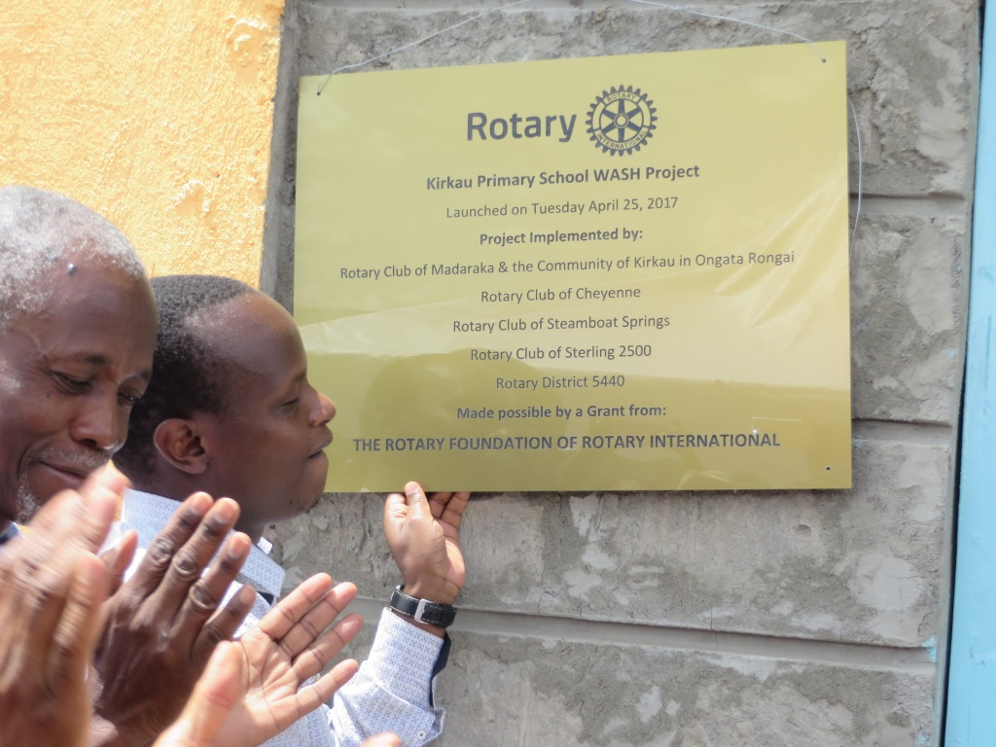
Figure 1 - Project Launch - Kirkau WASH
The project is situated in Kirkau of Oloosirkon location, 15 km East of Ongata Rongai in Kajiado County. It is 30km South of Nairobi City. The implementation was planned between Sept 2014 to Feb 2015, but due to procedural delays in accessing power supply, the project was launched on 25 April 2017. Many lessons were learned during this process.

Water
The water supply at Kirkau uses a deep drilled well (borehole) 250m deep with a yield of 7.5m³ per hour. The well is equipped with an electric submersible (grandfos) at a depth of 233m with a capacity to pump 5m³ per hour.
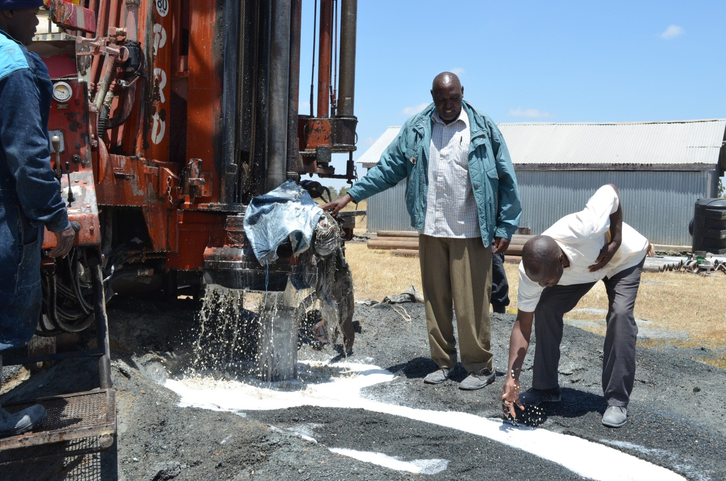
Figure 2 - Drilling in progress August 2015
The drilling was done by a reputable firm Kisima Drilling while the pump was supplied and installed by the renowned Davis and Shirtliff. The water tower houses two overhead tanks with a total capacity of 15m³.

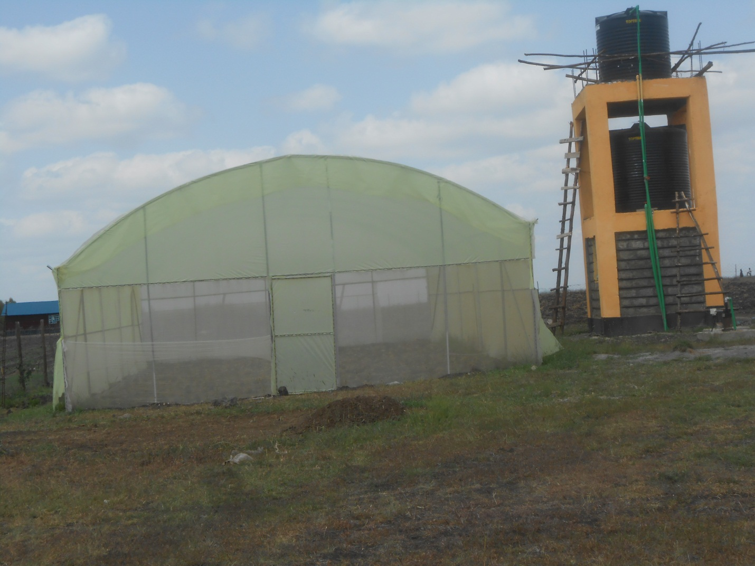
Figure 3- Water tower
The water has been piped to the abution block and to the handwashing facilities. The students, faculty, guests and Rotary Madaraka celebrated the Kirkau WASH launch on 25 April 2017.

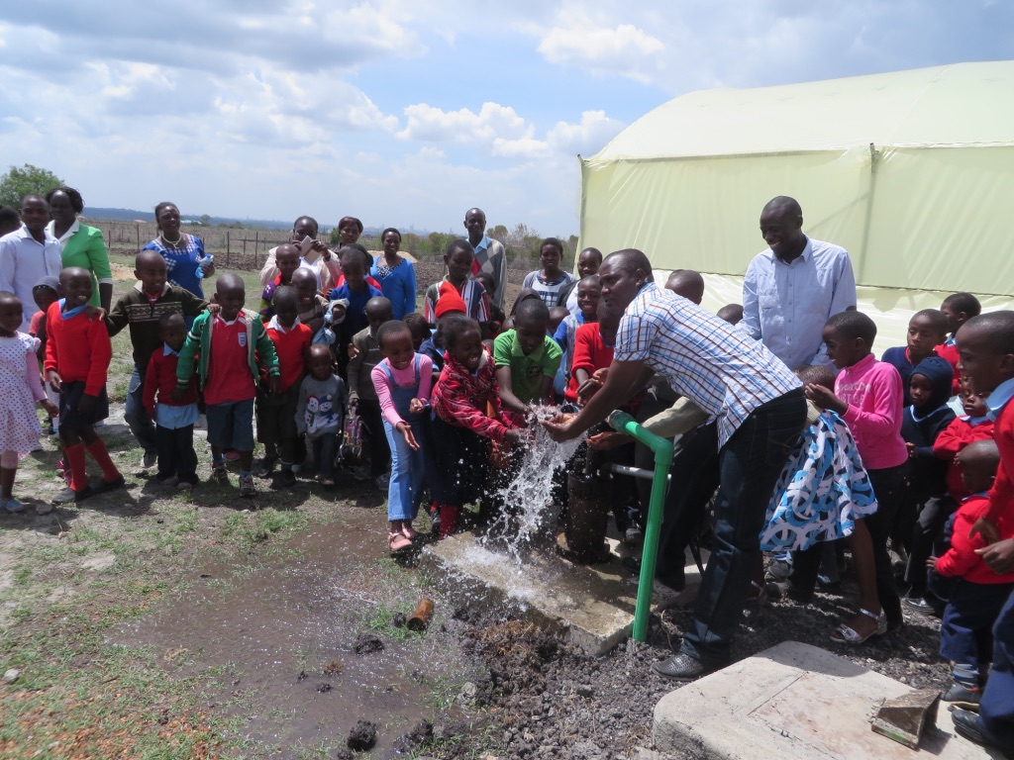
Figure 4 - Students and guests enjoy a cool splash

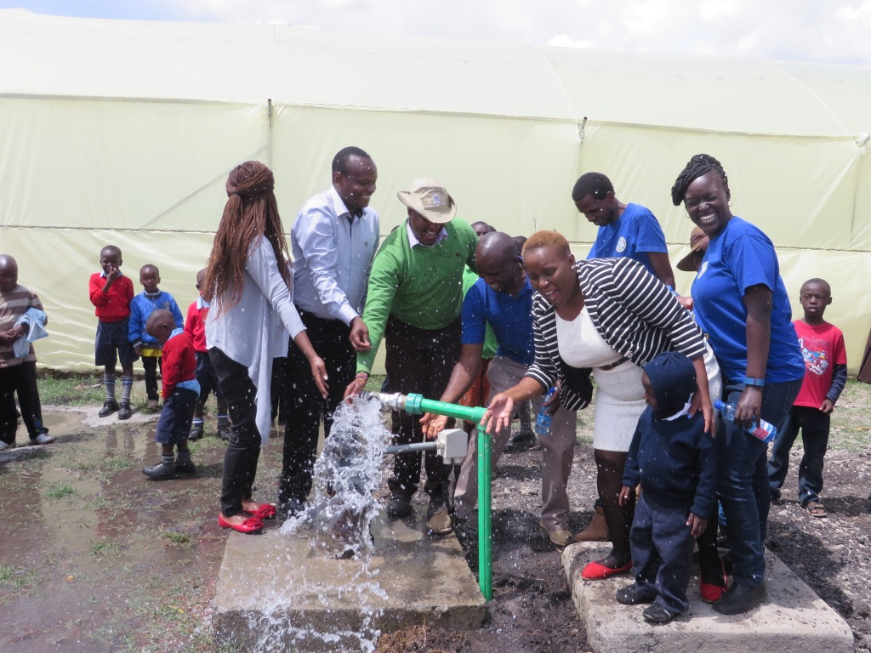
Figure 5 - Rotary Madaraka enjoys a project well completed
Sanitation
The ablution block has 6 toilets (2 for gilrs, 2 for boys, 1 each for male and female staff), one shower for boys and another for girls. A urinal is provided for boys. Two wash hand basins are installed in the male section and two in the female section of the facilities.

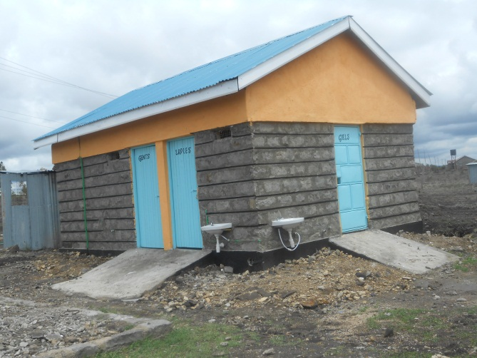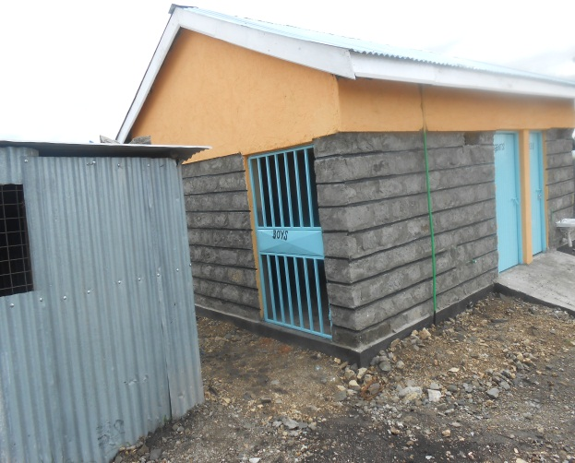
Figure 6 - An ablution block at Kirkau Primary School

Greenhouse
A metallic greenhouse measuring 8mx15m was constructed. A nursery has been raised and the plants will soon be transplanted into the greenhouse. This will improve the provision lunch in the school.

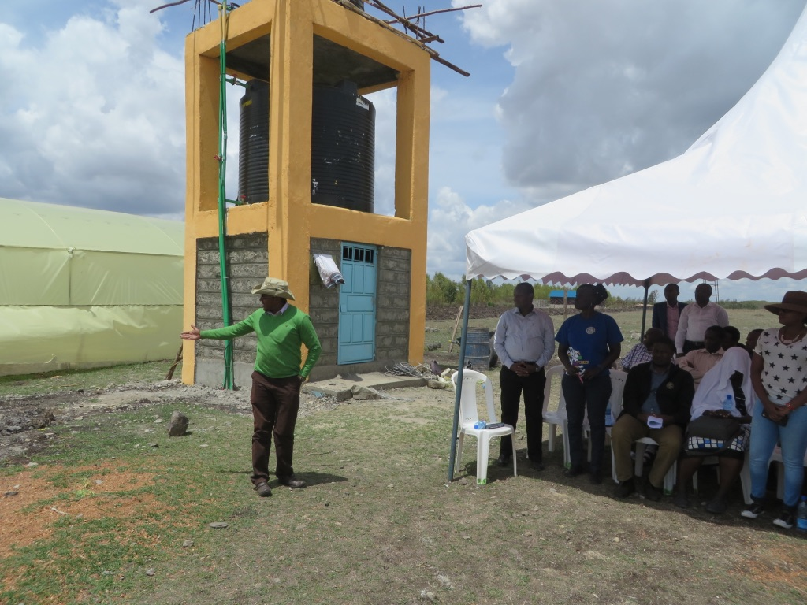
Figure 7 - Rtn Mbogo points to the Greenhouse and the well site
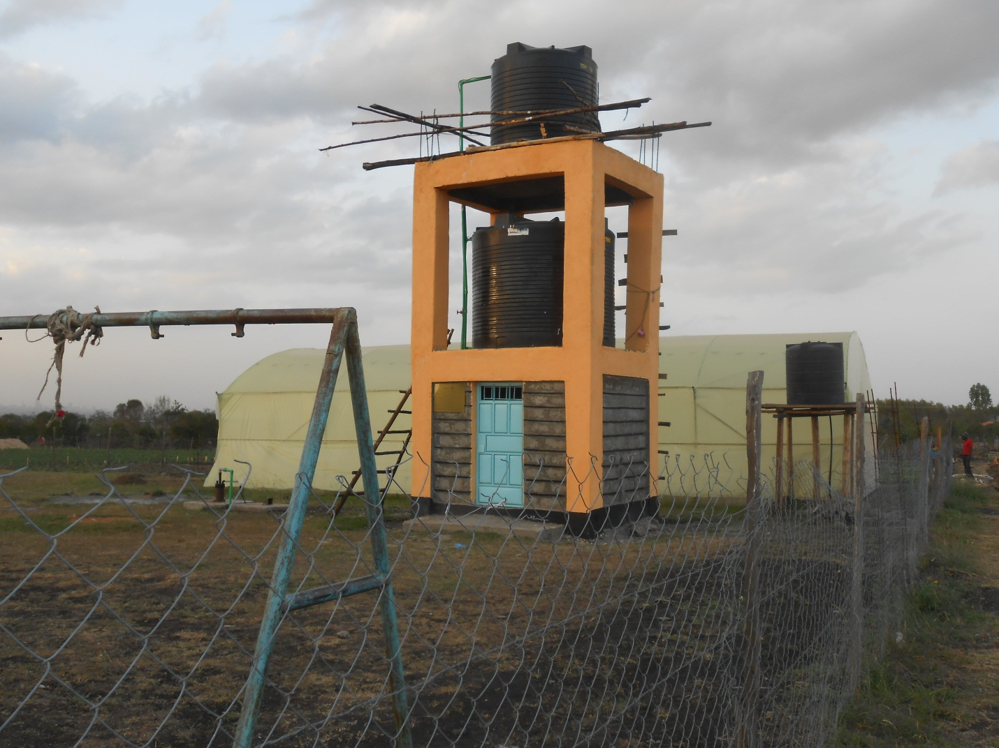
Figure 8 - Water tower and the greenhouse
Power supply
The power supply was the most challenging portion in the whole project implementation process due to the underestimate in the budget as well as the lengthy process in KPLC to allocate resources to individual requests. Finally KPLC installed a three-phase transmission line (500m) and transformer at an estimated cost of KES1.6million.

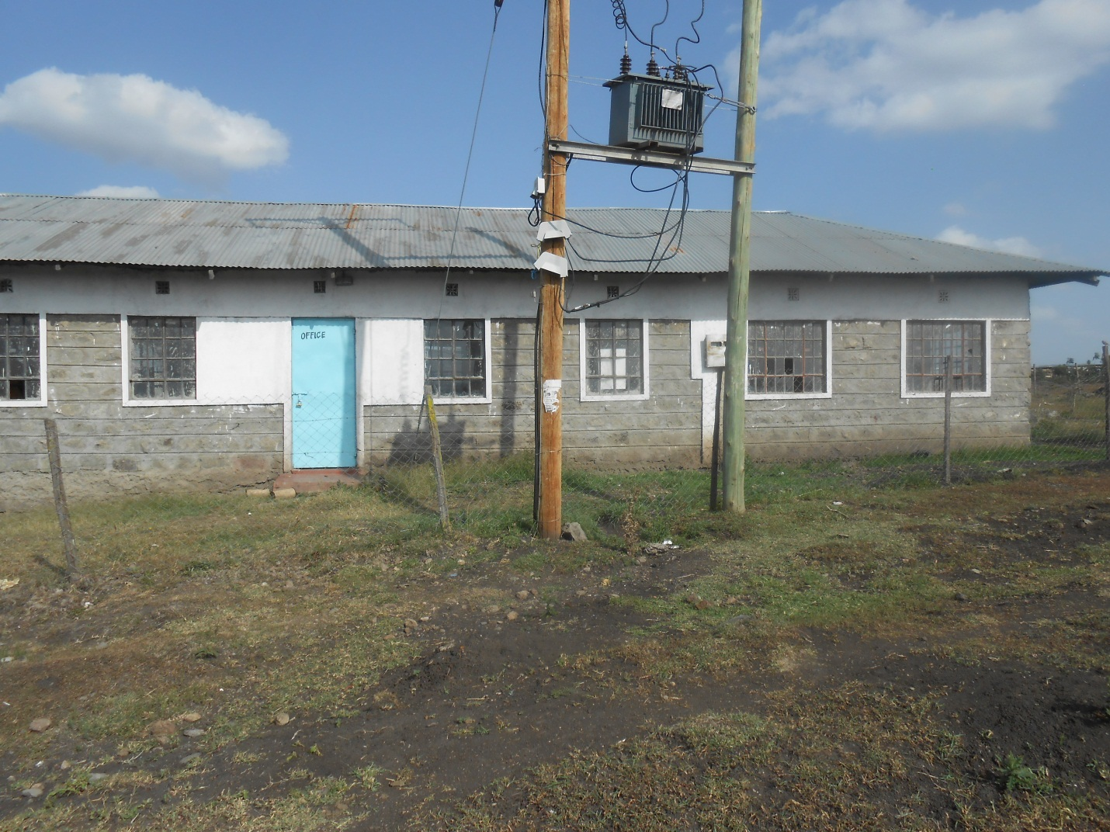
Figure 9 - Three phase transformer at Kirkau Primary School
PHAST and CHAST Training
The Rotary Club of Madaraka undertook this training at Kirkau. Students from a neighbouring school, parents and some community persons attended the training.

M&E
An M&E protocol was done during the implementation of the project.

External Review and Launch
The Kirkau WASH project was launched on 25 April 2017 which coincided with an external review by Rotary Foundation. The review was carried out in the context of training Rotary personnel in the review / evaluation protocol of Rotary Foundation, the team was led by Amanda Reid.

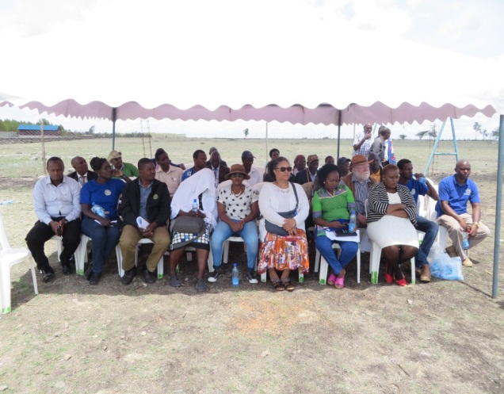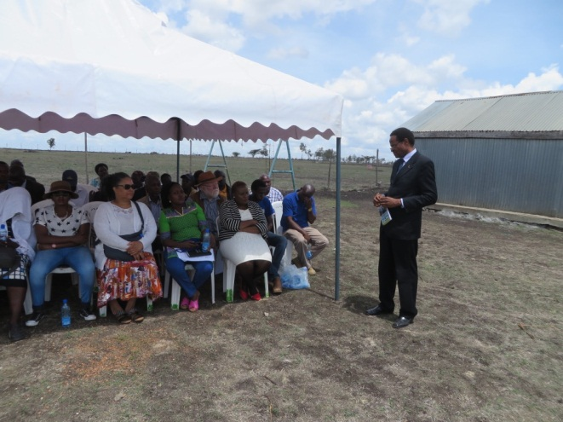
Figure 10 - Review Team

Some community gardening
The community members are now practicing micro drip irrigation to raise vegetable for own use and sale the remainder. This is creating economic opportunities for local youth.

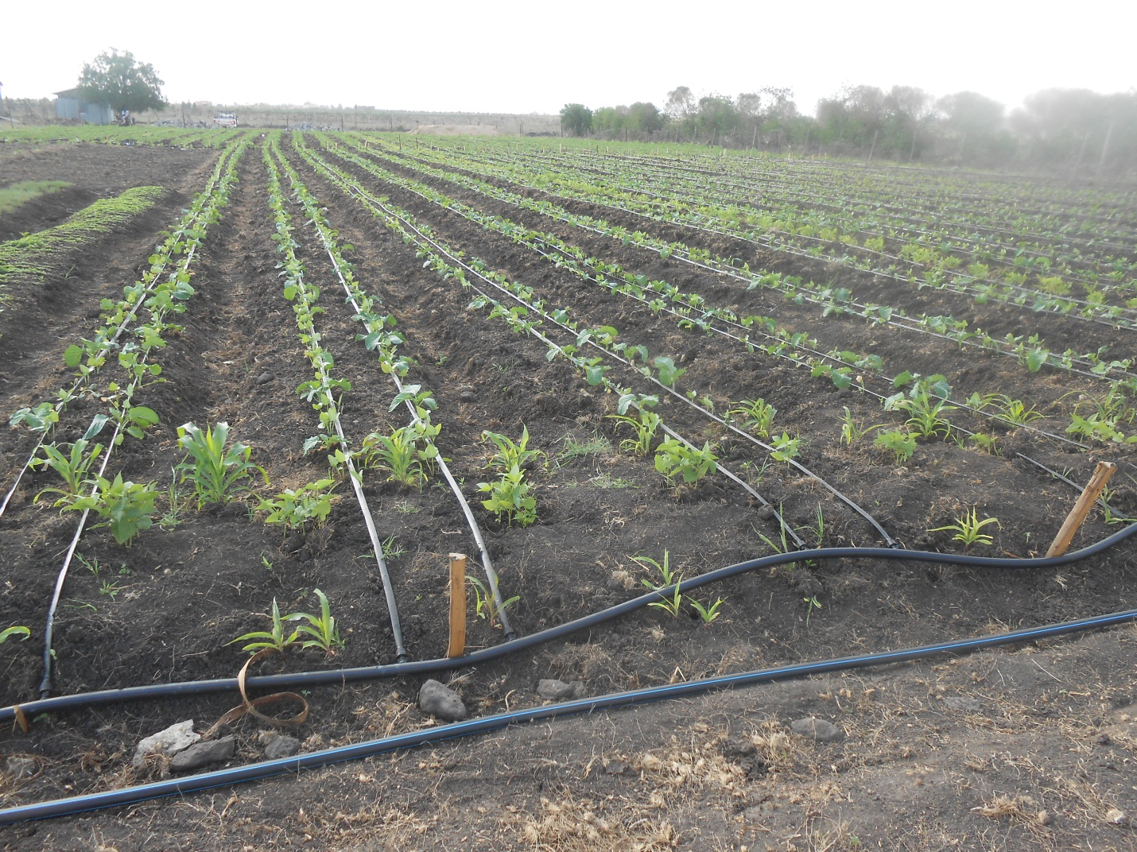
Figure 11 - A micro drip irrigation system

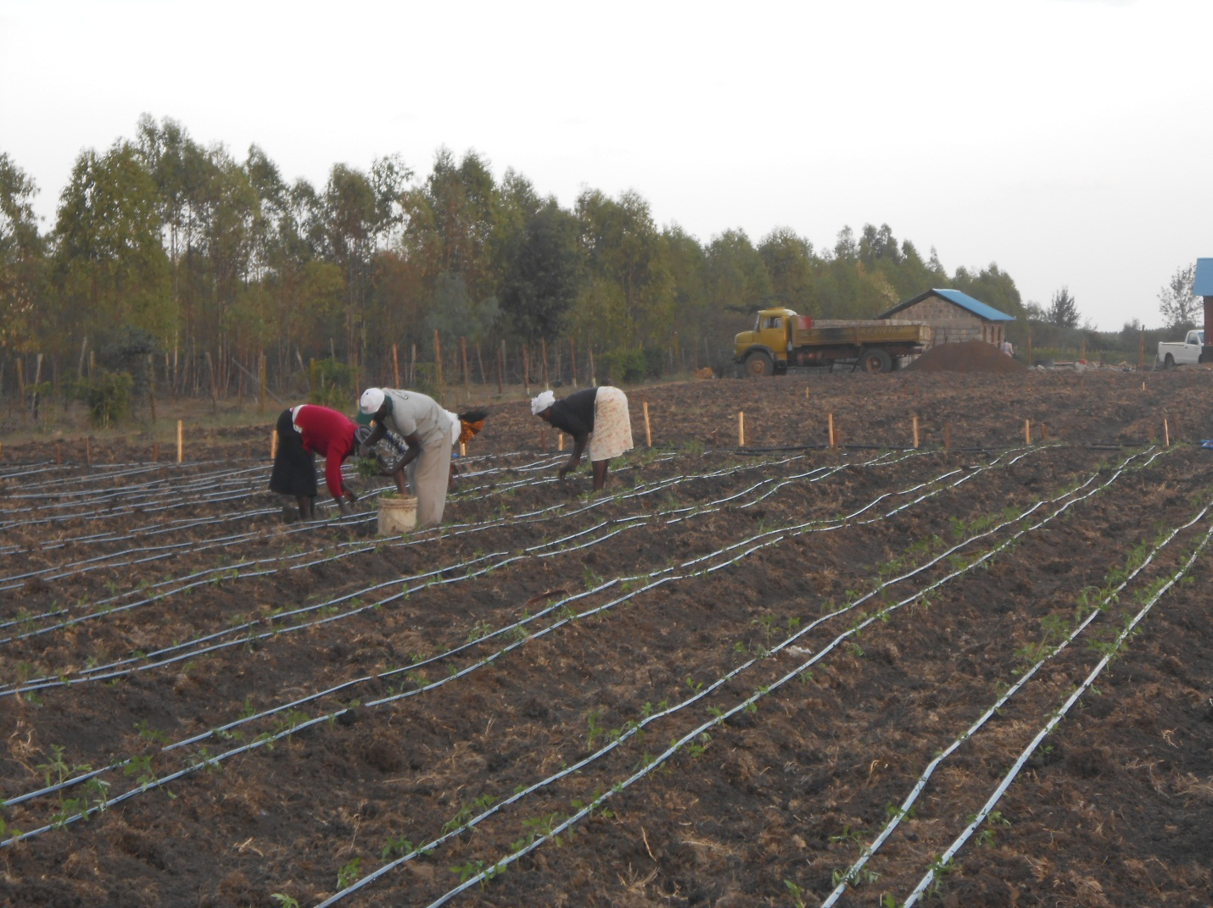
Figure 12 - The truck is delivering manure
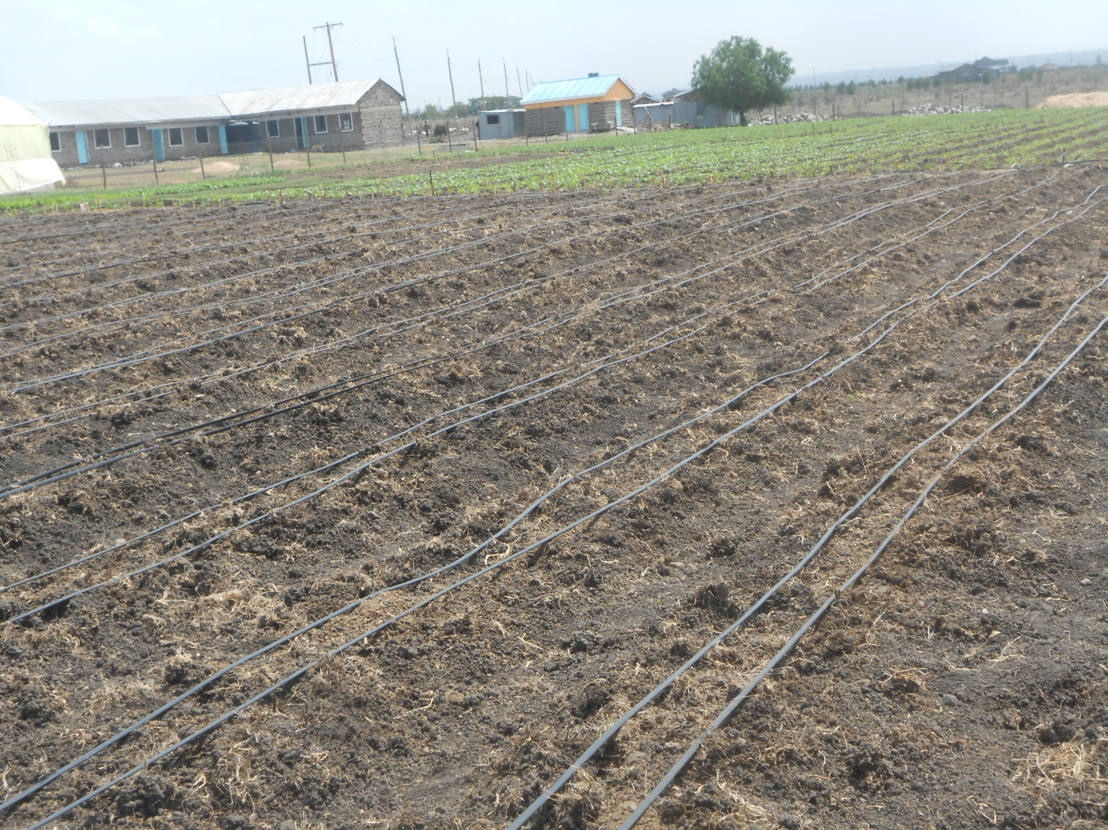
Figure 13 - Garden adjacent to Kirkau School
Project management and oversight
The project management was provided by the Rotary Club of Madaraka and coordinated at the implementation site by a local expert Isaack Oenga.

Overall comments
- The implementation of Kirkau Primary School WASH Project has been successfully completed.
- Community persons are enthusiastic as some kitchen gardening is possible due to availability of water as may be seen from pictures above. Three micro systems are in the offing.
- Water distribution beyond the school is very limited and may require additional support.

