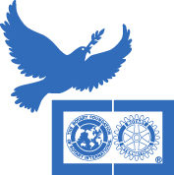

D7430 ROTARY FOUNDATION SEMINAR & PEACE FORUM
(TO BE HELD JOINTLY WITH D-7450 ROTARIANS)
On Saturday October 31st, 2015
Montco Community College
340 Dekab Pike, Blue Bell, PA 19422
(Science Center Building)
learn and hear of the many great things our foundation does including GLOBAL GRANTS & DISTRICT GRANTS:
OUR FOUNDATION DOING GOOD RIGHT HERE AND IN THE WORLD

Doors open at 7:30 am for Check in and Continental Breakfast. Program Starts at 8:00 am.
Registration Form
Name: ____________________________________________________________________

Club: ___________________________________________

Please indicate if you would like to attend District grant Certification Training after lunch from 2 – 4 PM
YES or NO
Please mail this form plus your Registration Fee of $30 (made payable to: Rotary District 7430)
To District Administrative Assistant:
Sharon Rittenhouse
259 Hawkview Ct
Mohrsville, PA 19541
e mail: Rittenhousesharon@gmail.com

