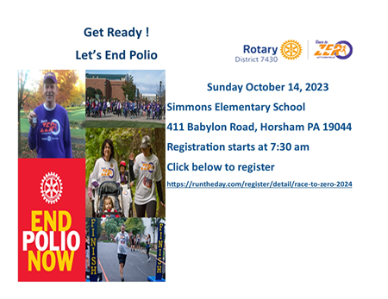

Together with your help we can end Polio. The eradication of polio is one of our longest standing and most significant efforts. Along with our partners, we have helped immunize more than 2.5 billion children against polio in 122 countries. We have reduced polio cases by 99.9 percent worldwide and we won't stop until we end the disease for good.
IF YOU WOULD LIKE TO DONATE TO POLIO PLUS PLEASE SEND YOUR CHECKS:
THE ROTARY FOUNDATION/POLIO PLUS
c/o Rotary District 7430 1341 Biafore Ave
Bethlehem, PA 18017

