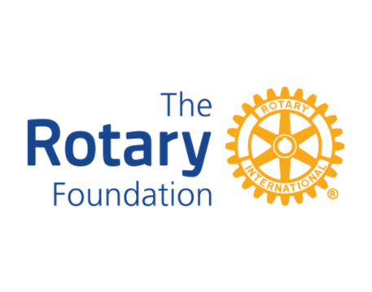

FOUNDATION EVENTS 2025 2026

STAY TUNED FOR THE POLIO WALK COMING IN THE FALL OF 2026

