Judging

Three judges, a teller and one timekeeper will be used at each level of competition. Judging will be on a 100 point system, broken down into three categories as follows:

CONTENT (0-44points) Application of the 4-Way Test, use of examples, language and vocabulary

- ORGANIZATION (0-24 points) Introduction, development, conclusion

- DELIVERY (0-32 points)
Enunciation, projection, expressiveness, rapport with the audience

Penalty Points – Any penalty points incurred will be deducted from the point total on each judges score card. (See the Rules section)

HOW TO ENTER: Contact your
high school speech teacher, principal,
or _____________________________

at your local Rotary Club or contact the District Chair, Al Engel at 973-216-1469 or alengel007@aol.com

Levels of Competition

- Local Club Level – Contests will be held in all participating Rotary clubs in the months of February and March, 2020. Participants will receive recognition and/or cash awards at each club’s discretion. (contact your local Rotary Club for details) Winners of local contests will advance to the Regional Level.

- Regional Level –Regional competitions will be held in April 17, 2021. All Participants will receive recognition certificates and the top three participants will receive cash awards. The First Place winners in each Regional contest will advance to the District Finals. The first runner-up in each Regional contest will be the alternate in case the winner is unable to compete at the District competition.

- District Level (Finals) – The Regional winners will compete at the District Conference on May 1, 2021 at the Kalahari Resort, Pocono Manor, PA. In recognition of their accomplishments, the Final contestants will receive cash prizes. The District Champion will receive a $1,000 cash award. The District Champion may also be invited to speak at other Rotary District events.

For further information contact:

Al Engel - 4WTSC Committee Chair alengel007@aol.com
Or (973) 216-1469

4-Way Test Speech Contest
2020-2021

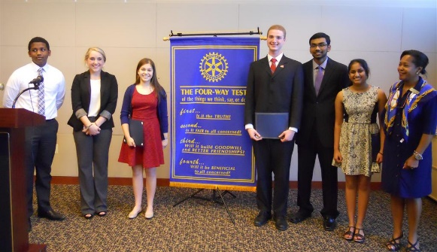
Rotary District 7430

What’s in it for me?

What are you passionate about? Could you persuade others by giving a speech?
Are you willing to challenge yourself, and others while improving on your critical thinking and ethical decision making skills?
Take a step toward becoming someone who inspires and motivates others to have a positive influence upon their friends, their community and the world at large.
While competing in a supportive, non- threatening environment you will also have a chance to earn significant prize money as well as recognition and awards which could enhance your college resume.

Eligibility

Public and private high school students in Grades 9 through 12 are eligible to enter the contest. No student may be a contestant in more than one local club speech contest in any one year.

The champion of the Final District competition is ineligible to compete in subsequent years.

Topics and Theme

Each contestant chooses the topic of his/her speech. The purpose of the speech is to persuade others while applying the principles of the Rotary 4-Way Test. The issue to be addressed should be from the speaker’s personal experience or general knowledge.

There are no restrictions regarding the choice of topic as long as it is not blatantly offensive. If a contestant or coach is in doubt about the appropriateness of a topic, he or she should check with the Club Contest Chair. The decision of the Contest Chair will be final.

The 4-Way Test
Of the things we think, say, or do:

  - Is it the TRUTH?

  - Is it FAIR to all concerned?

  - Will it build GOODWILL and BETTER

FRIENDSHIPS?

  - Will it be BENEFICIAL
to all concerned?

Rules

Length of Speech – Speeches must be no less than 5 minutes in length and no more than 7 minutes in length. Penalty points will be subtracted for time infractions at the rate of 2 points for every 15 seconds over or under the minimum or maximum.

Props – No props are to be used. Audience participation will be considered a prop. Penalty points will be subtracted for use of props at the rate of two points per infraction.

Speaker Aids – Contestants may use notes at the club level. At the regional level a single 3 x 5 card may be used. Notes may not be used at the District competition. Infractions will result in disqualification.

Order of presentation – Determined by lottery. Contestants who arrive after the competition has begun will be disqualified.

Contests may be conduct virtually in the event in-person meetings are considered unsafe due to Covid-19.

