D7430 ROTARIANS RUN & WALK
TO ERADICATE POLIO
It was sunny, blustery and cool at the 10 a.m. start of the 4th Yvette M. Palmer Purple Pinkie Day 5K Run/Walk at DeSales University on Sunday, November 3rd. Seventy runners and walkers came out to have some fun and raise some awareness and funds for Polio eradication. Yvette’s family was represented by husband Bill and his son and granddaughter, Yvette’s daughter, Kim, son-in-law Bill and Granddaughter Arista, granddaughter Kathi her husband Pete and great-grandson Bryce.
Our D7430 District Governor-Elect Gary Fedorcha was there along with Assistant Governors Bill Tuszynski and MarieAnn Thompson. The DeSales Rotaractors put on the event. Participating were six additional Rotarians from Yvette’s RC along with PDG Bill Palmer.
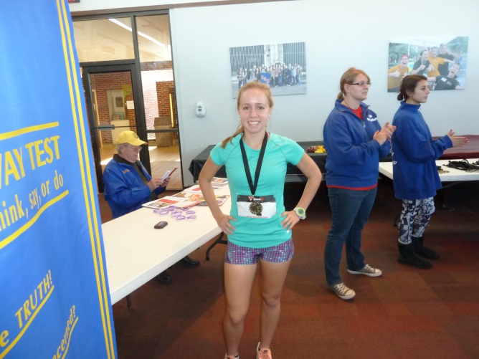
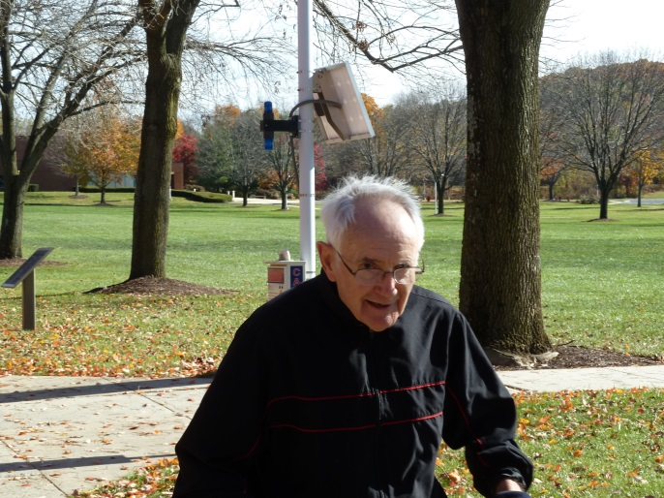
Yvette and Bill’s granddaughter, Shaina Palmer , a junior at Bethlehem’s Freedom H.S. finished in first place for the women, and second place overall. Medals were awarded for overall first 3 places by gender and then by age groups.

Finishing first in the 60 years and older group was Pottstown’s Charlie Koenig, now 81 years old. He ran it, not walked it, as he has in prior years.

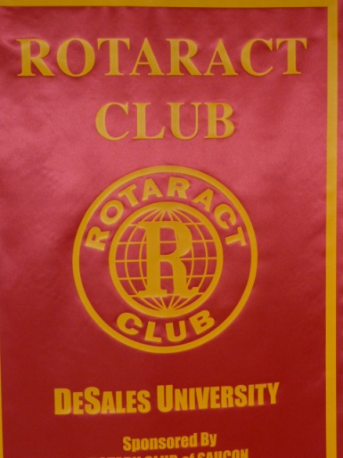
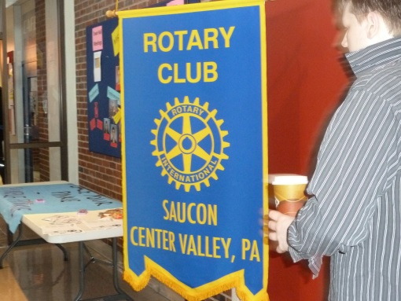
Rotaractor Kristin said that ‘We raised over $3,200 for PolioPlus. “We are extremely proud of the Rotaract Club for bringing this all together and having a successful race!” They are sponsored by the Saucon Center Valley RC.

