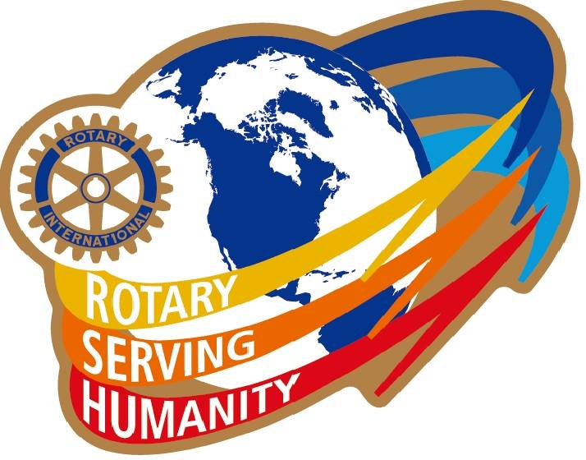
Club “Shining Star”
District Governor Award
For Achievements in 2016-17

DG Linda would like to recognize those clubs in our district that have achieved the criteria of The “Shining Star” District Governor Award for achievements in 2016-17.
To achieve this award your club must achieve 1 or both of the Mandatory Activities in Section 1 and any 6 or 7 from Section 2, (a total of 8 successfully achieved activities) by May 1, 2017.
Section 1 (One of these is mandatory)
- Have a net gain of + 1 minimum in membership from July 1 reported to RI by April 30th 2017.
OR
- Every Club Member will Support our Rotary Foundation with a contribution in their own name of at least $26.50 in our Rotary Foundation Centennial Year.
Section 2
- Support our Foundation by attaining a minimum contribution of $100 per capita.
- Meet both Club Foundation and Polio Goals for the year as entered in Club Central.
- Participate in a club or multi-club Membership Promotion Event.
- Update at least 10 goals in Rotary Club Central Including 2 in the Service Section.
- Review and Update your club Constitution and Bylaws.
- Applied, received, and completed a District Grant project in 2016-2017.
- Participate as a sponsor in the Polio Purple Pinkie 5 km Fundraiser in October.
- Conduct a 4 Way Test Speech Contest.
- Sponsor or co-sponsor 1 youth exchange Student either inbound or outbound.
- Sponsor 2 students to attend Camp Neidig in 2017.
- Involve Local Media in at least one club event, project, or Fundraiser and submit a copy of the article with this document.
- Invite & Involve at least 6 members of either a Rotaract or Interact Club to be a part of your club community service project or fundraiser
Submitted by: Rotary Club Name:

To be submitted to DG Linda NO Later than May 1st: lryoung2011@gmail.com

