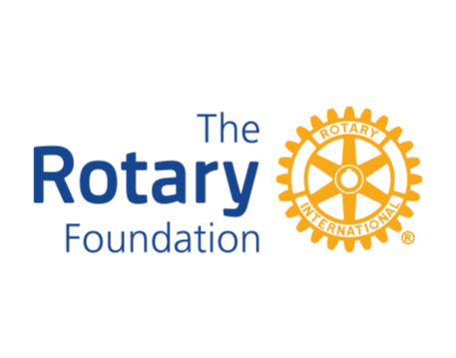

STAY TUNED FOR THE NEXT DISTRICT 7430 POLIO PLUS EVENT IN THE FALL OF 2026

