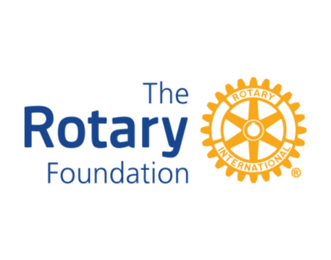

District 7430 sponsors and features a host of events to fund and celebrate our Rotary Foundation.
POLIO EVENTS:YVETTE PALMER PURPLE PINKIE 5K WALK/RACE FOR POLIO—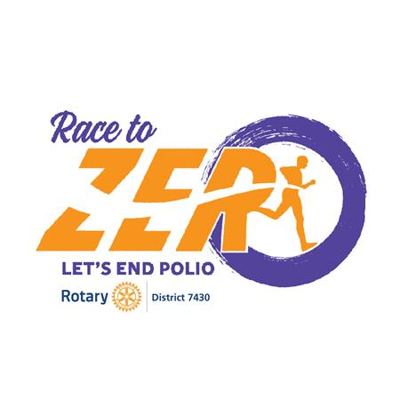
- October 2, 2021 Our Race to Zero raised nearly $40,000 with more coming in. After the Race, we enjoyed our first ever Oktoberfest with great entertainment , food and drink
- STAY TUNED TO WATCH FOR ANNOUNCEMENT FOR OUR 2022 EVENT to END POLIO NOW!
MANY WAYS TO CONTRIBUTE TO POLIO PLUS:
1. Contact your Rotary Club
2. Send check to:
ROTARY FOUNDATION
14280 COLLECTION CENTER DRIVE
CHICAGO IL 60693
MEMO POLIO PLUS DISTRICT 7430 CLUB NAME
3. GO TO MY ROTARY.ORG
TAKE ACTION
END POLIO
DONATE

