District 7430 Local “Club to Club” Friendship Exchange

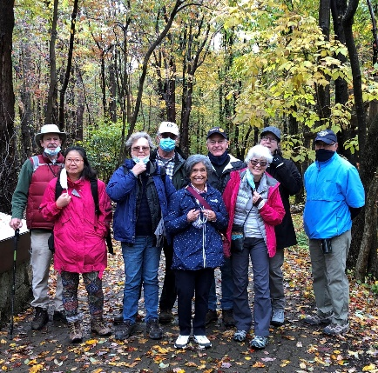

Interested in meeting other district Rotarians in a fun way and share ideas and passions for Rotary? Come join us! We’ve been to Hawk Mountain, Peace Park, Michener Museum and Longwood Gardens. Recommendations of locations or suggestions are welcome.

The next "Club to Club" meet up will be in March or April; contact coordinator Dee Eng if interested in being put on the email list for either of these events.

Contact District 7430 Friendship Exchange Committee Chair Dee Eng:deeleng@gmail.com

