International Service

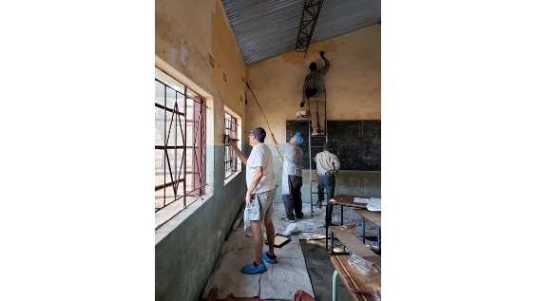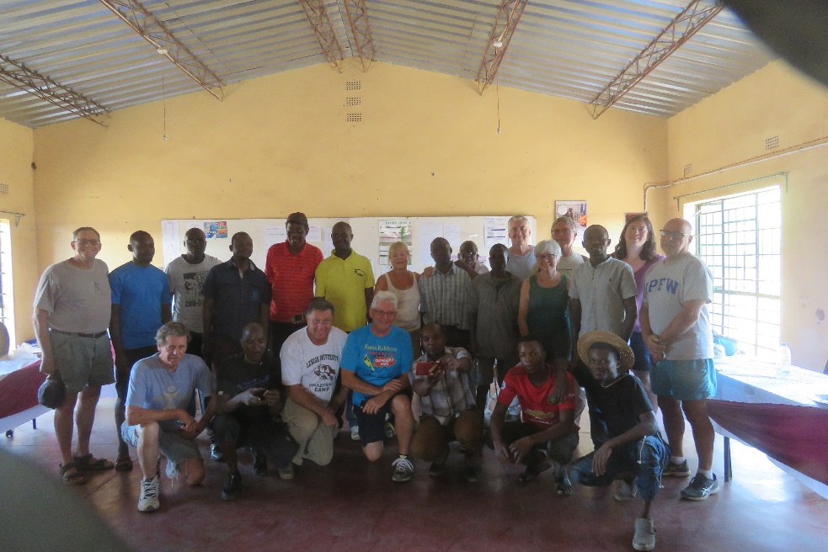

Rotary District 7430 Rotarians painting schools in Zambia.

What is it?
International Service includes service projects and activities taking place between Rotarians and others in two or more countries. It may involve projects funded by The Rotary Foundation Global Grants or by District Grants, but there are many other ways to connect internationally through Rotary.
You might attend a Rotary Convention, host a Youth Exchange Student, visit a club in another country, join a Rotarian Action Group or Fellowship, apply to be a member of The Rotary Foundation Cadre of Technical Advisors, participate in a National Immunization Day, attend a Project Fair, collaborate on a multi-country project, develop a sister-club relationship, and go on a Friendship Exchange. Looking for more ideas for engagement? Some are listed on, rotary.org

