Rotary Club Youth Service Award
A comprehensive youth program is important for a Rotary Club’s mission fulfillment and sustainability. Exposing our future leaders and citizens to Rotary ideals and providing our youth opportunities and incentives for growth and development is strongly encouraged. District 7430 has instituted an award program to recognize a club’s level of participation in established District youth opportunities as well as unique club initiatives. Below is a graphic showing the types of programs and activities which can earn credit to qualify for the District Governor’s Rotary Club Youth Service Award.
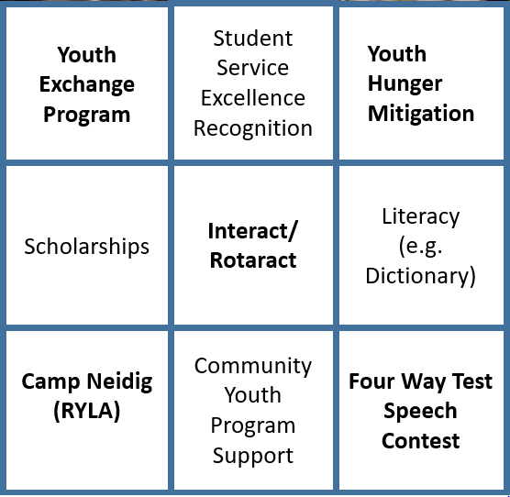
Metrics
There are nine areas or defined programs where a club can earn credit toward a youth achievement. The list includes specifically defined District programs such as Camp Neidig and more general areas where the details are more specifically defined at the club level such as child hunger mitigation. There are four levels of recognition as follows:
- Platinum – 9 items
- Gold – 8 items
- Silver – 7 items
- Bronze – 5 items
Camp Neidig (RYLA)
Sponsor at least two high school juniors for participation in this leadership development weekend held in June at a camp in the District last year (2019)
Youth Exchange
Sponsor an outbound or inbound student
Four Way Test Speech Contest
Conduct a club contest and send a winner to the Regional FWTSC contest either this year (2020) or last year (2019)
Interact/Rotaract Club
Form and charter a club:
Or, with an established club, conduct 1 or more service project.
Scholarships
Establish or have a defined program and award a substantive amount of awards for academic excellence in STEM, Communications, other (≥ $2000)
Community Youth Program Support
Conceive or support community youth leadership development programs through partnerships with organizations such as 4-H, Girl Scouts, Boy Scouts and more. OR Partner with a non-profit organization to support an important youth program in your community such as Josh the Otter, Community Bike Works, Miracle League and more.
Hunger Mitigation
Conceive and implement or support a meal or food supply program that addresses hunger/malnutrition of our youth. This can occur at the local level or be participation in a global project. Projects designed to grow or acquire and furnish the ingredients for meal preparation are all eligible for recognition.
Student Service Excellence Recognition (e.g. Student of the Month, Extraordinary Volunteer, etc.)
Working with local high school(s), recognize students for achievement in both academics and community service by inviting them to appear at club meetings to be acknowledged and receive various types of tangible award options (e.g. cash prize, award to favorite charity, etc.).
Literacy (e.g. Dictionary program)
Conceive and implement or support a program which addresses youth literacy issues and encourages reading.

