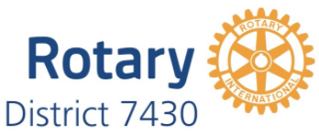
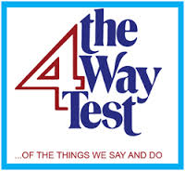
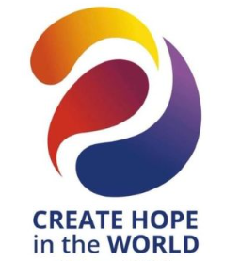

January 4, 2024
Dear Rotary Club President,
Public speaking proficiency and good critical thinking skills are important leadership attributes. Our Rotary District provides many youth programs and the 4 Way Test Speech Contest is recognized as an excellent opportunity for high school students to develop these skills and learn about our guiding principles for ethical behavior.
Attached you will find the digital file for the 2023-2024 4 Way Test Speech Contest Manual. It can also be found on the district website: https://rotarydistrict7430.org/sitepage/four-way-speech-contest/4way-speech-contest/ along with a contest brochure and a Power Point file which can be adapted for your club’s use in school presentations. This year the regional contests will be held April 6, 2024 with the District final on April 27 at the District Conference at the Wind Creek Bethlehem in Bethlehem, PA.
If your Club has participated in the 4 Way Speech Contest in the past, that’s terrific and we are grateful for your continued support of this youth program. All information you and your club 4WTSC chair need to know is in the manual noting our team has revised and simplified the Judge’s Scoring sheet. The documentation contains the new scoring sheet, and a copy is appended to this letter. We are including a document called Understanding the 4 Way Test as there have been several requests for information for non-Rotarians to understand the background and meaning of the 4 Way Test. This document may also be of value to your Club. Please provide this information to your designated Speech Contest club chair.
If your Club is considering participating for the first time and would like one of our committee members to do a program about the contest at one of your upcoming Club meetings, please contact me or your Regional Coordinator listed below at your convenience.
On behalf of the D7430 4 Way Speech Committee, thank you for your support of this initiative.
Anna Richter
Anna Richter, Chair-District 7430 4 Way Test Speech Contest
Past President Central Perkiomen Rotary Club

Region | Regional Coordinator
North: Allentown, Allentown West, Easton, Bethlehem, Bethlehem Morningstar, Emmaus, Nazareth, Slatington, Lehigh Valley Passport, Whitehall Area | Anthony Moyer  anmoyer@eastpennsd.org
West: Birdsboro, Conrad Weiser, Fleetwood, Hamburg, Kutztown, Muhlenberg, Reading, Spring Township Centennial, West Reading-Wyomissing | Carloyne Jordan  ship934me@gmail.com
South: Ambler, Blue Bell, Central Bucks, Upper Perkiomen, Saucon, Center Valley, Hatboro, Norristown, North Penn, Souderton-Telford | Sarah Tobak  sarahtoback@gmail.com
East: Doylestown-Horsham, Huntington Valley-Churchville, Morrisville, Newtown, Springfield Township/Flourtown, Warminster, Warrington, Willow Grove, Montgo-New Britain | Inge Karlberg- Stannik  frauinge@gmail.com
Central: Boyertown, Collegeville, Pennridge-Perkasie, Pottstown, Quakertown, Spring-Ford, Central Perkiomen, Harleysville | David Kaplan  rotary@davidskaplan.com

