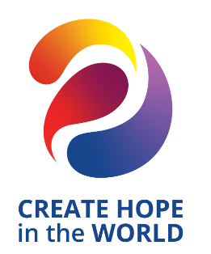

4 WAY TEST SPEECH CONTEST School Manual DISTRICT 7430

2023 - 2024
ABSTRACT
Supporting information for schools to recruit student participation in the Rotary 4 Way Speech contest. We will hold in-person contests but if this is not possible because of pandemic restrictions, contests will be conducted virtually.

Your Rotary Contact is:

________________________________

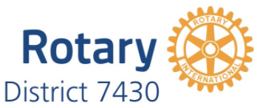

Page intentionally left blank
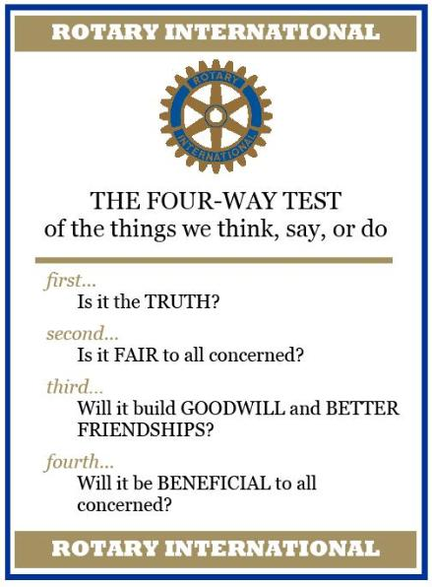

Contest Rationale 2
Contest Rules 2
Important Dates 4
Contest Personnel 5
Student Entry Form, Biography & Release 6

We are excited to partner with your school on the 4 Way Speech Contest. This endeavor is an excellent supplement to many programs within your school such as the gifted, college preparatory, speech/debate and theater. Communication and presentation skills are important, now more than ever, and this program gives students the opportunity to enhance their skills, add to their academic resume and win cash prizes.

Contest Rationale

This program aims to:
- Promote critical thinking and ethical decision making among high school students.
- Provide a forum for high school students to showcase issues that they care about while allowing them to practice their public speaking skills, encourage academic research and gain exposure to Rotary and the local club among the youth and school personnel.

Contest Rules

Eligibility: The contest is open to students in grades 9-12. Please discuss with your Rotary contact if your school has a virtual or home school program to include.
Topic: Each contestant shall choose the topic of his/her speech. The purpose of the speech is to address an ethical problem using the principles of the 4 Way Test. The problem to be addressed should be something from the speaker’s personal experience or general knowledge. There are no restrictions regarding the choice of topic as long as it is not blatantly offensive. If a contestant or coach is in doubt about the appropriateness of a topic, he or she should check with their Rotary contact. The decision of the Contest Chair will be final.
In the speech, the topic must be specifically related to the 4 Way Test. This must be addressed during the body of the speech and not reserved for concluding statements only. Each of the four parts of the 4 Way Test should be addressed during the speech. They should be specifically stated, as the intent of the speech is to use the 4 Way Test to guide one’s decision-making about an issue.
These are to be speeches and not dramatic presentations. Although enthusiasm, good eye contact, and movement are encouraged, the student should not go to extremes. Topics should be interesting and relevant to the speaker’s interests or experience.
Students who advance to the Regional and District contests may present the same speech given at the preceding level or create modified or new presentations. All speeches must be the original work of the speaker.
Length: Speeches must be between 5 and 7 minutes in length. Penalty points will be applied for time infractions at the rate of 2 points for every fifteen seconds or fraction thereof for a speech that violates these time limits. The Timekeeper will signal the 5-minute mark to the contestant.
Props: No props are to be used. Audience participation is considered a prop, and 2 penalty points per infraction will be assessed for the use of props or encouragement of audience participation.
Speaker Aids: At club contests, a lectern and microphone may be provided at the discretion of the club. At the Regional and the District Finals contest, a lectern and microphone will be provided and may be used at the discretion of the speaker.

Speaker Notes: Contestants may speak from notes at the Club level competition. At the Regional competition, only a single 3x5 card may be used. At the District final competition, notes will not be allowed. Infractions will result in disqualification! This rule should be reviewed with the contestants prior to the competition.

Important Dates

September through December
Your Rotary Club contact will contact your school regarding this year’s contest, including the date of the Club contest, contest rules and prizes. If we are in a pandemic and cannot safely conduct in-person contests, Rotary will move to a virtual format using Zoom or equivalent.
Receive posters, brochures and any other promotional material.
Student entry forms are included in this document.

January through early March
Confirm the number of student participants.
Submit student entry form(s) to your Rotary contact.
Your Rotary contact should contact you within in this time for any questions. However, if you have any questions or concerns, please contact them directly.

One week before the contest
Your Rotary Coordinator will contact you to confirm participants, student entry forms with parent signature, location including in-person and zoom.

The Day of the Contest
Speaking order will be randomly determined and given at the contest.
We wish your students the very best as they present.

If a student from your school wins the Club contest, the Regional Coordinator will contact them for participation in the Regional speech contest held on Saturday morning, 10AM, April 6, 2024 at a location determined by your Regional Coordinator.

The winner of each regional contest will compete at the finals at the Rotary District Conference, Saturday April 27, 2024, held at the Wind Creek Bethlehem in Bethlehem, PA.

Contest Personnel

School Facilitator
A School Facilitator is either a school faculty member or administrator who is the liaison with the Club Contest Chair. The School Facilitator takes an active role in recruiting students and preparing them for the contest by reviewing the rules and dates of the contest with the students. If needed, the School Facilitator would be in charge of an in-school run-off contest in order to reduce the number of Club contestants to six.

Students/Contestants
Contestants must be in grade 9-12 at a public, private, charter or parochial school or is home-schooled in the club’s geographic area.

Judges
There will be three judges who will evaluate each speech based on content (44 points), organization (24 points) and delivery (32 points). Judges will also deduct any penalty points (e.g. use of props, contest introducing themselves, etc.).

Teller
The Teller is responsible for collecting the Judges’ scoring sheets along with the Timekeeper record. The Teller will then tabulate and calculate the overall scores and determine the finish order of the contestants.

Timekeeper
The Timekeeper will monitor the length of the speech and seated front and center during the contest and will use a hand signal to indicate the 5 minute mark to the speaker. The timekeeper will deduct two points for each 15 seconds or fraction thereof, under the 5-minute minimum or over the 7-minute maximum.
The judges and teller will be introduced at the end of the contest.

Student Entry Form, Biography & Release
Rotary District 7430 4 Way Test Speech Contest

Name of School: _______________________________________Grade: _______
School Contact Person:
Student’s Home Address: ____________________________________________

Student’s Telephone Number: Email: _____________________

Student’s Goals, Hobbies, Special Interests:

I declare that the research and content of my speech are mine and mine alone. I understand that my sponsoring Rotary Club and/or Rotary District 7430 may video record my speech presentation in whole or in part and use it to promote future contests within Rotary.

Student’s Signature:________________________________________Date:_________________
Parent/Guardian Name (Printed): __________________________________________________

Parent/Guardian Signature:___________________________________Date:__________________

PLEASE SUBMIT THIS COMPLETED FORM TO THE SCHOOL FACULTY MEMBER/ADMINISTRATOR SERVING AS THE LIAISON FOR THE SPEECH CONTEST.

SCHOOL LIAISON: PLEASE SUBMIT THESE FORMS TO THE CHAIRPERSON OF THE 4 WAY TEST SPEECH CONTEST OF YOUR LOCAL ROTARY CLUB.

WIN $1,000
And earn a strong credential for your college/employment application
What is your ethical dilemma?
In a 5 to 7 minute speech, could you persuade others of your conclusion
while affirmatively answering these questions?
- Is it the Truth?
- Is it Fair to all concerned?
- Will it build Goodwill and Better Friendships?
- Will it be Beneficial to all concerned?

Freshman through seniors are eligible for cash prizes!

The Clubs of Rotary District 7430 (Southeastern PA) are holding speech contests at the local Club level in February and March 2024. The winners will compete in regional level contests on April 6, 2024. The District final will take place on April 27, 2024. Prizes of $1,000 (1st) $500 (2nd), $350 (3rd) $250 (4th) and $150 (5th) will be awarded at the final while local and regional contests also pay cash prizes. Contact ___________________________for details.

