ROTARY DISTRICT 7430
DISTRICT GRANT ENTRY INSTRUCTIONS
The following are instructions for applying for and entering Rotary District 7430 as well as pictures.
- In order to be able to enter and apply for grants, the Club must have an up to date MOU each year. MOU form is found by logging into Rotary District 7430—On the home page: go to Foundation, click on Grants,-- MOU is on the left—click. President and PE sign and return to Peter Clayton, Stewardship Chair: peter clayton super_limey@yahoo.com.
Only trained club members may enter grants.

STEP 1: Sign into RotaryDistrict7430.org
On the home screen top right Press “member area”. That will open to the administration area.
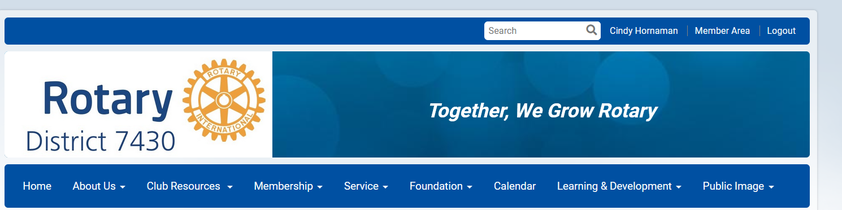

STEP 2: Member area opens
On the left is ‘GRANTS’—click on grants
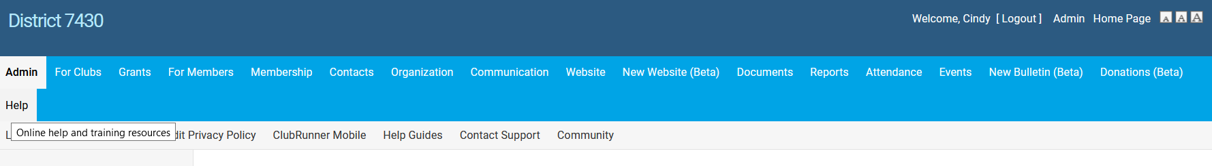

STEP 3: CLICK ON SUBMIT A GRANT REQUEST
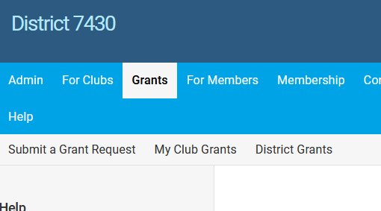

STEP 4:
CLICK ON SUBMIT A GRANT REQUEST—IF YOU CAN’T GET IN AT THIS POINT,-- EITHER YOUR CLUB HAS NOT SIGNED AN MOU OR YOU ARE NOT TRAINED. PLEASE CONTACT, BONNIE, CINDY OR PETER.
ENTER THE NAME OF THE PROJECT- SELECT THE APPROPRIATE ROTARY YEAR, DESCRIPTION OF THE PROJECT AND TOTAL BUDGET, PRESS SUBMIT
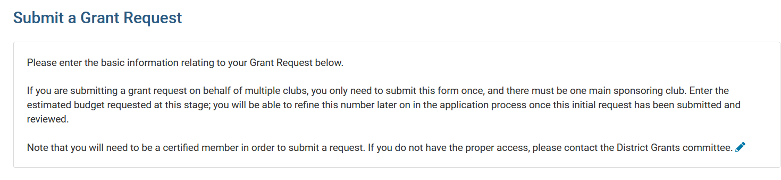
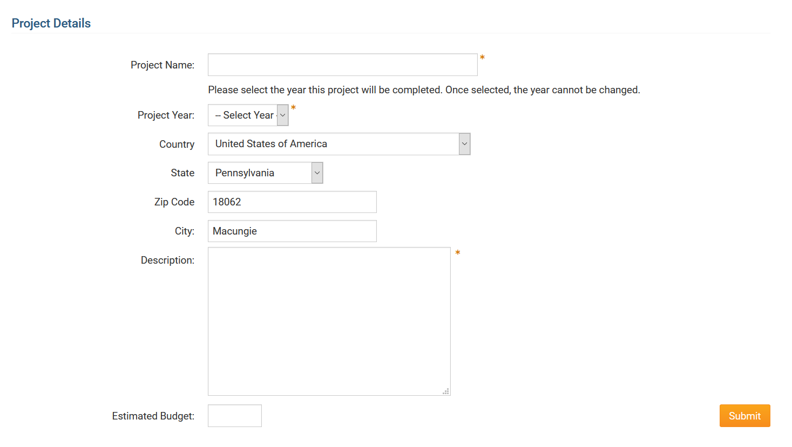

STEP 5: YOU ARE NOT DONE—NOW YOU HAVE TO COMPLETE THE ACTUAL APPLICATION
GO BACK INTO GRANTS—AND NOW CLICK ON :” MY CLUB GRANTS”. CLICK ON YOUR GRANT
FIRST CLICK SECOND CLICK. THIS WILL NOW OPEN THE GRANT APPLICATION

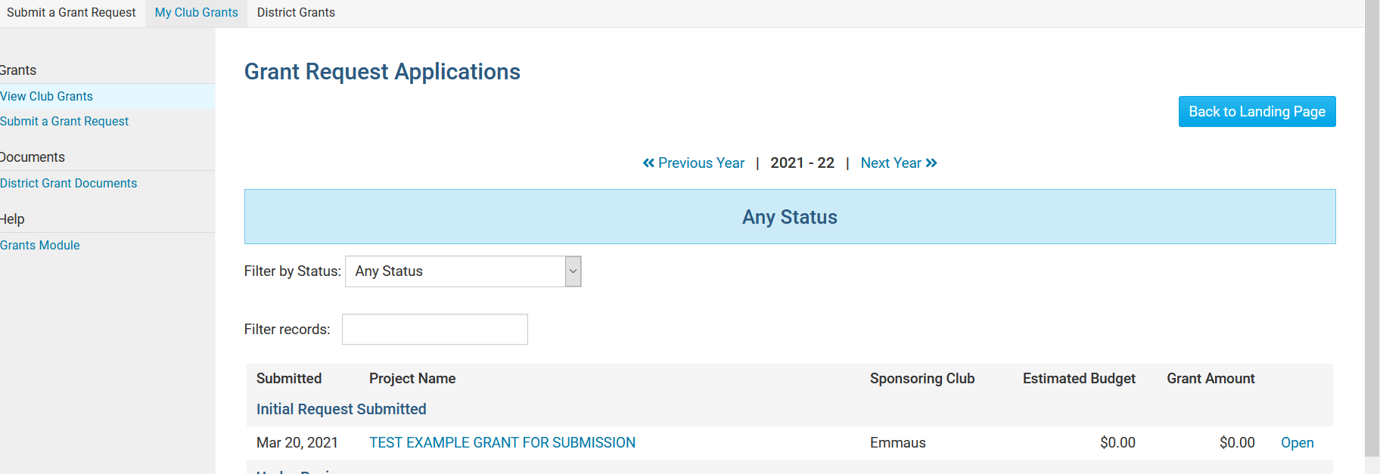

BELOW WILL ALREADY SHOW UP WHEN YOU PRESS THE TITLE OF THE GRANT SCROLL DOWN TO ADD PARTNERS OR OTHER CLUBS IF APPLICABLE

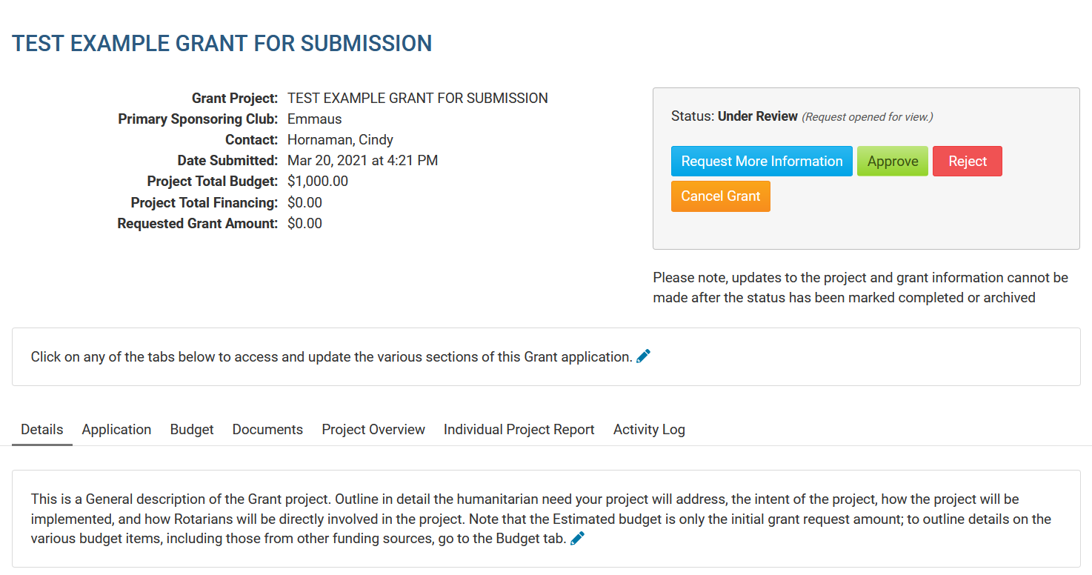
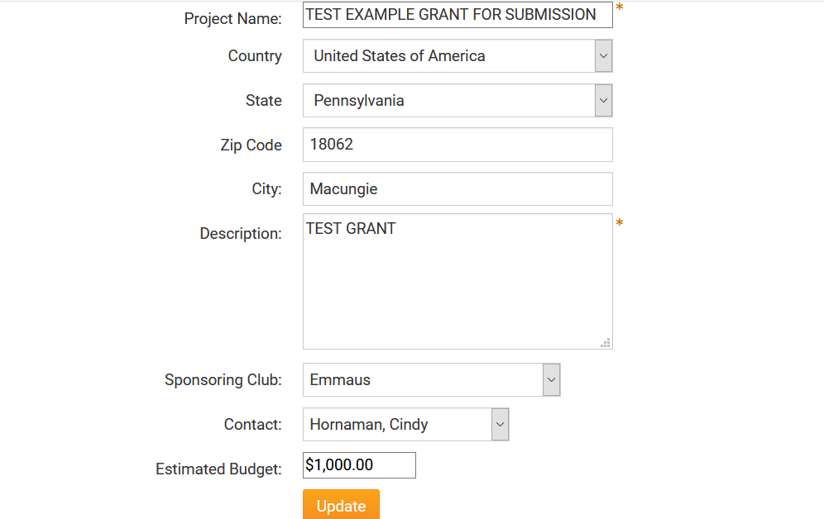
YOU CAN UPDATE NUMBERS AND DESCRIPTION ANYTIME AND JUST PRESS UPDATE

IF YOU HAVE OTHER CLUB PARTNERS- CLICK ON ADD CLUB AND ANY OTHER PARTNERS—PRESS SAVE EACH TIME

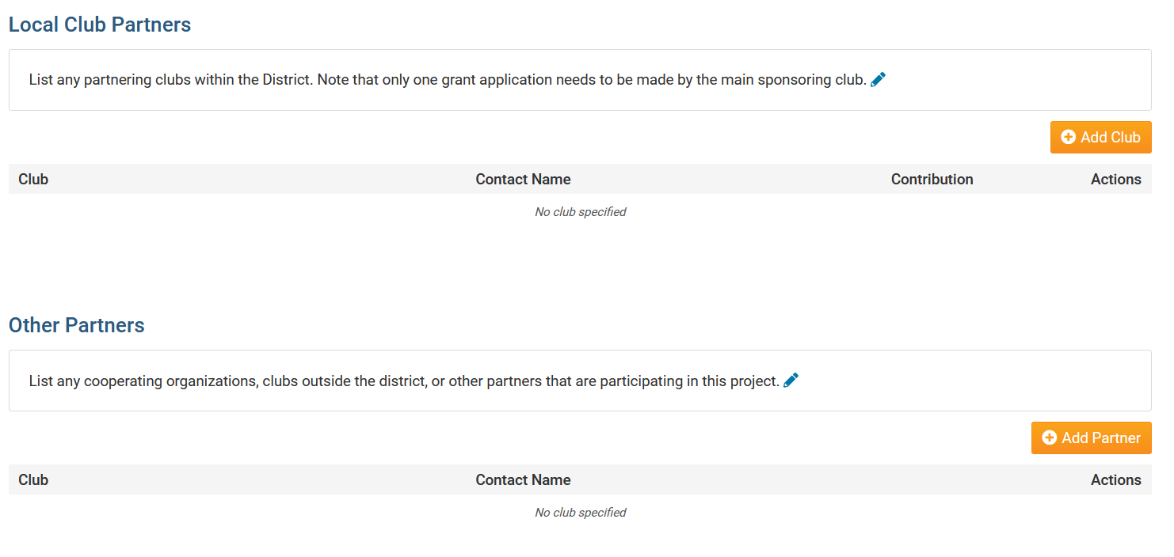

NOW CLICK ON APPLICATION

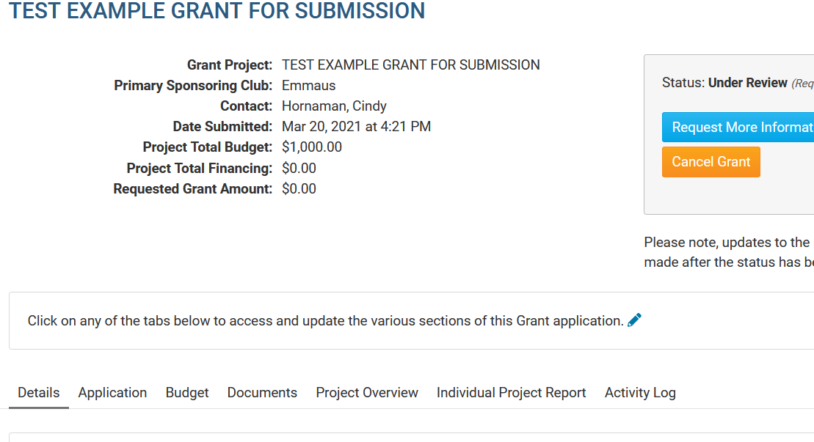

COMPLETE EACH OF THE 5 SECTIONS—PRESS EDIT TO OPEN EACH SECTION. A BOX LIKE A WORD DOCUMENT WILL OPEN. YOU CAN EVEN USE A WORD DOCUMENT AND CUT AND PASTE YOUR INFORMATION INTO THE APPLICATION.
FIRST SECTION: GENERAL DESCRIPTION. Be sure to include the names and e-mail addresses of three committee members of your club and what their role will be. Also include the area of focus your grant will serve. PROVIDE DETAILS NOW OF THIS PROJECT.. BE SURE TO PRESS AVE TO SAVE THIS SECTION OF THE DOCUMENT

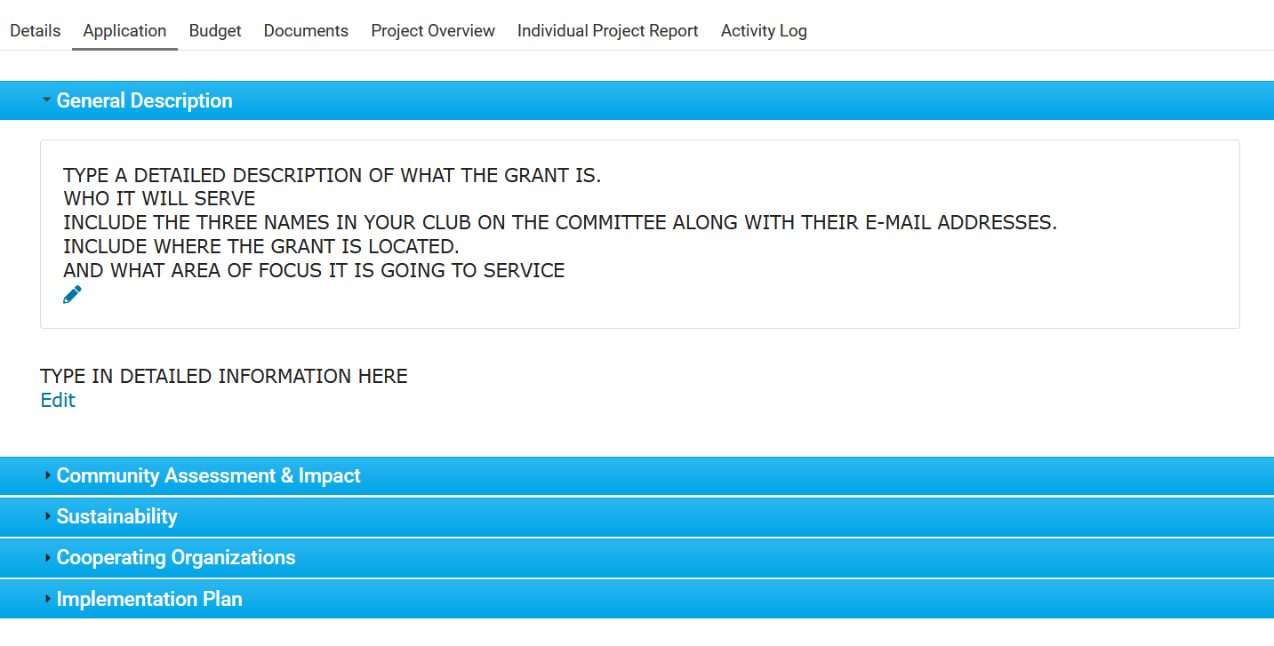

GENERAL DESCRIPTION—CLICK ON EDIT—A WORD TYPE DOCUMENT APPEARS—FILL IN INFO- PRESS SAVE EACH TIME.
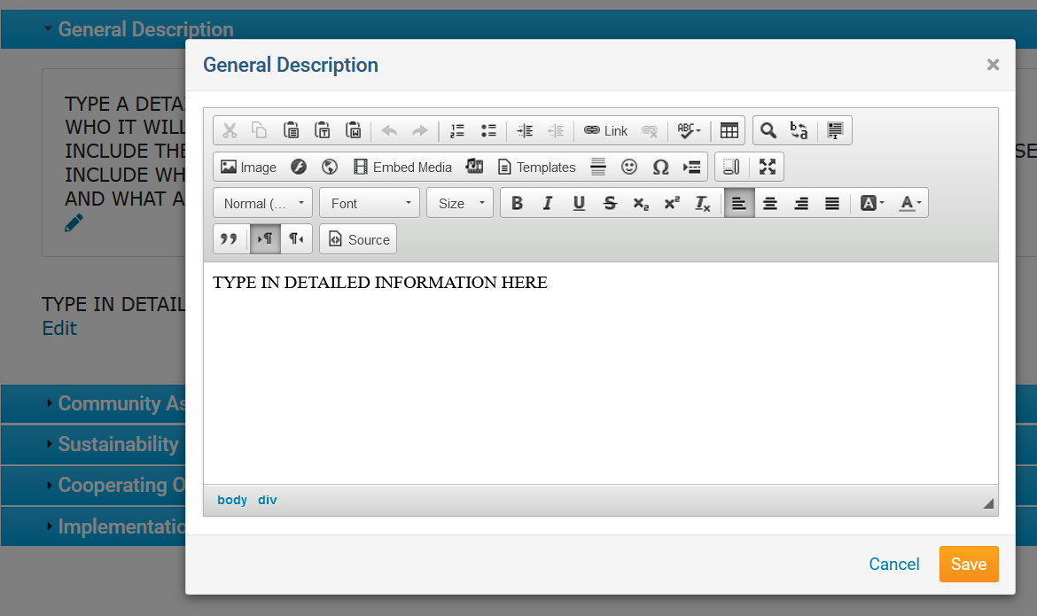

COMMUNITY ASSESSMENT—CLICK ON EDIT—A WORD TYPE DOCUMENT APPEARS—FILL IN INFO-PRESS SAVE
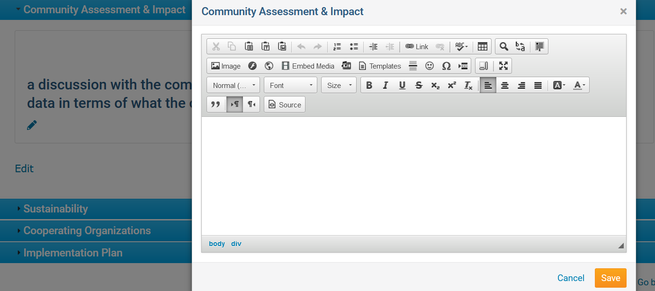

SUSTAINABILITY-CLICK ON EDIT—A WORD DOCUMENT APPEARS—TYPE IN INFO—PRESS SAVE

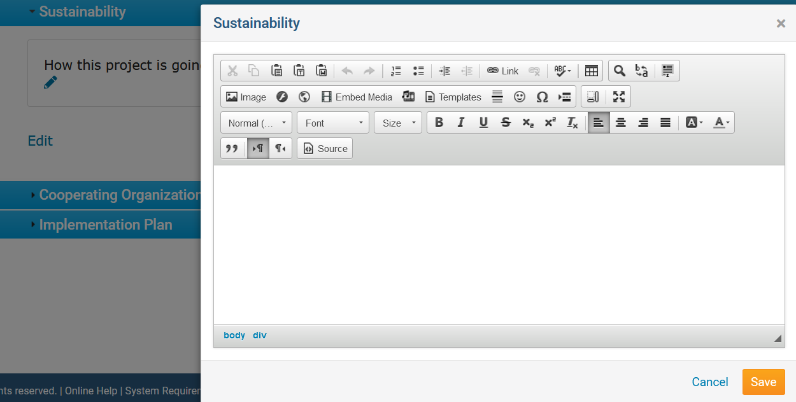

CLICK ON COOPERATING ORGANIZATIONS CLICK ON EDIT—A WORD TYPE DOCUMENT APPEARS—FILL IN THE INFORMATION IF APPLICABLE PRESS SAVE

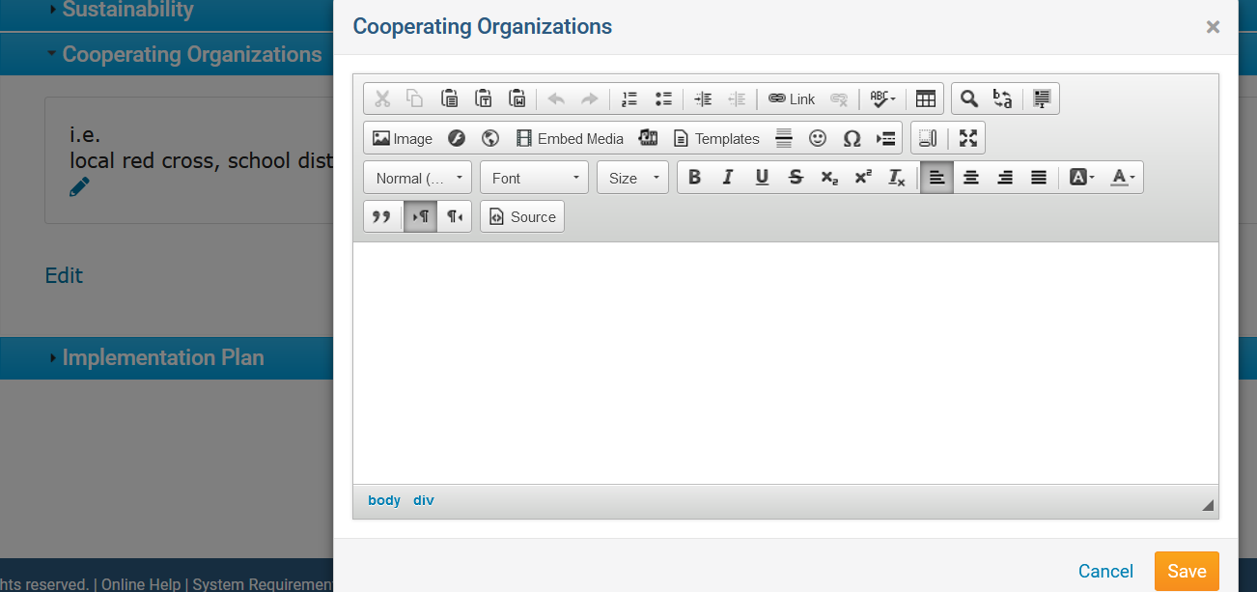

CLICK ON IMPLEMENTATION PLAN. CLICK ON EDIT. A WORD TYPE DOCUMENT APPEARS—FILL IN THE INFORMATION. -I.E. TIMETABLES OF COMPLETION OF STEPS—PRESS SAVE.

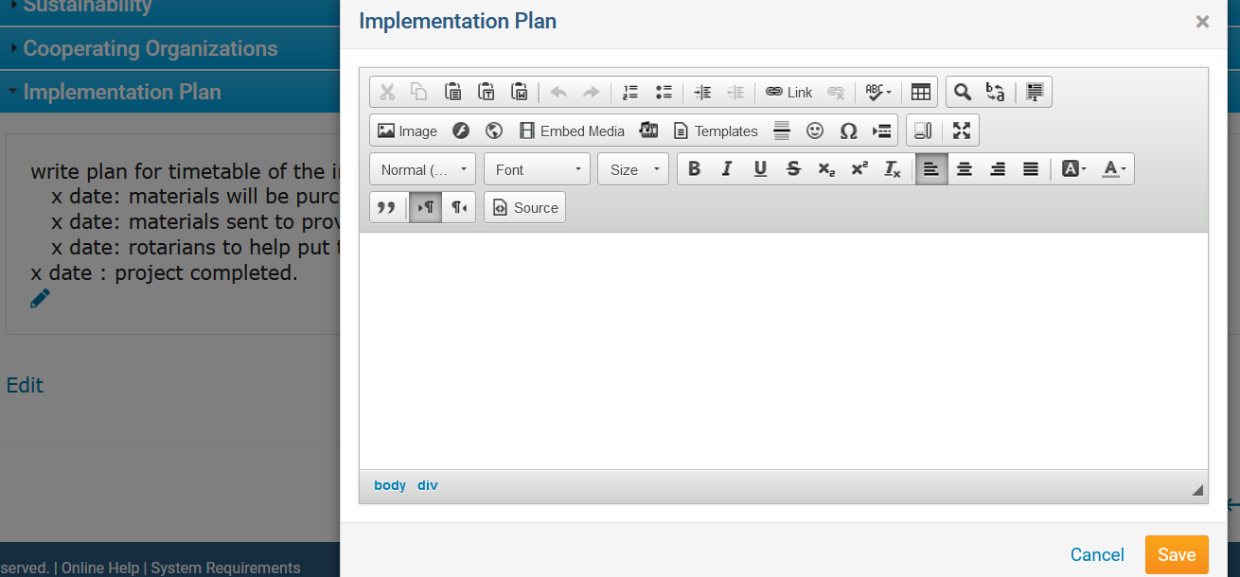

STEP 6: BUDGET
SCROLL BACK UP TO THE TABS OF THE APPLICATION AND CLICK ON BUDGET
OPEN THE “BUDGET” TAB TO COMPLETE THE “EXPECTED EXPENSES” AND “EXPECTED INCOME” FIELDS.
PLEASE KEEP IN MIND THESE TWO FIELDS MUST EQUAL. EXPENSES MUST EQUAL INCOME.
OPEN THE “+” ADD A BUDGET ITEM BY PRESSING THE +
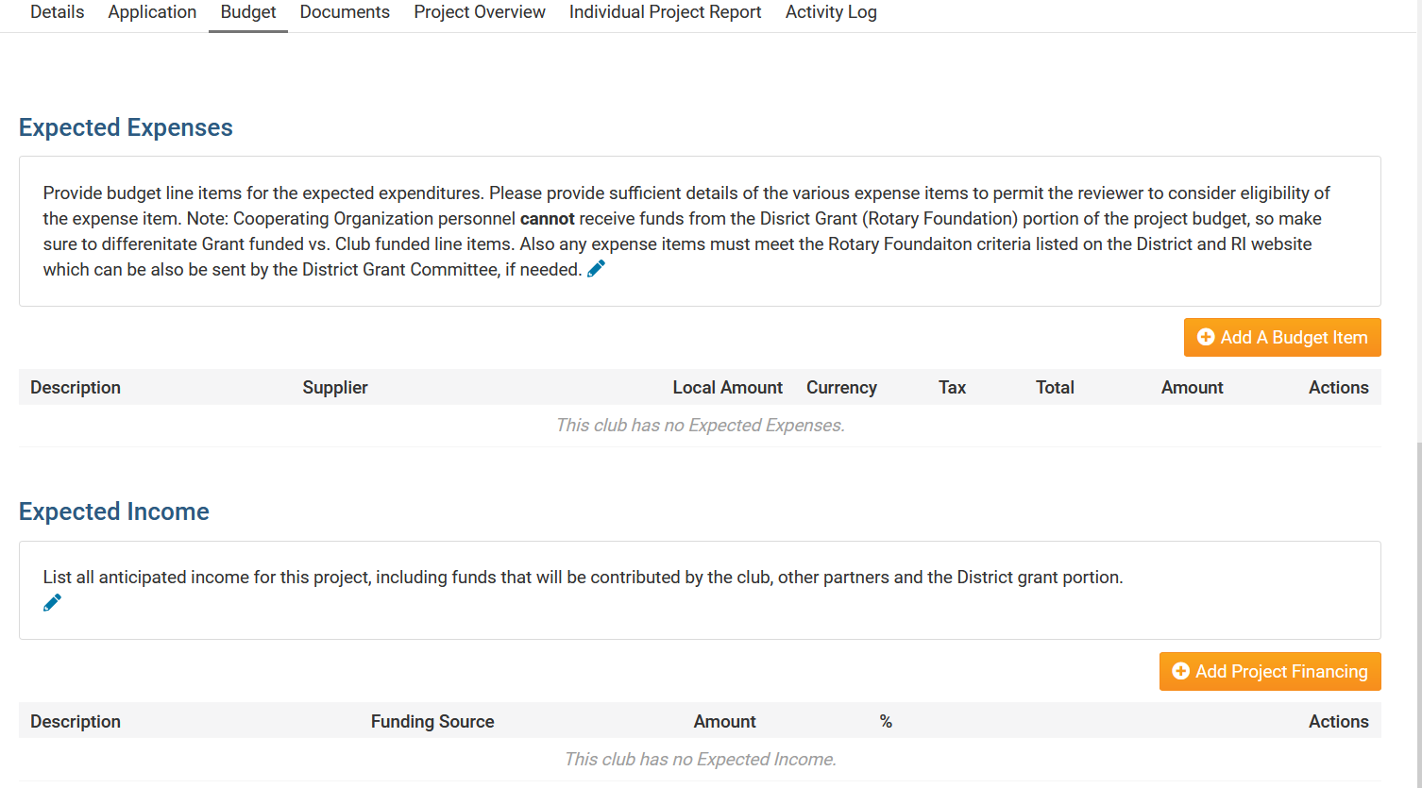

COMPLETE THE FIELDS WITH AS MUCH INFORMATION AS POSSIBLE AT THIS TIME. THIS IS AN ESTIMATE AND MAY CHANGE AS THE GRANT PROGRESSES. BE SURE TO PRESS “CREATE” TO SAVE EACH ITEM. YOU MAY ADD AS MANY ITEMS AS NEEDED FOLLOWING THE SAME STEPS. ONCE THE EXPENSES ARE COMPLETE. SCROLL DOWN TO EXPECTED INCOME.

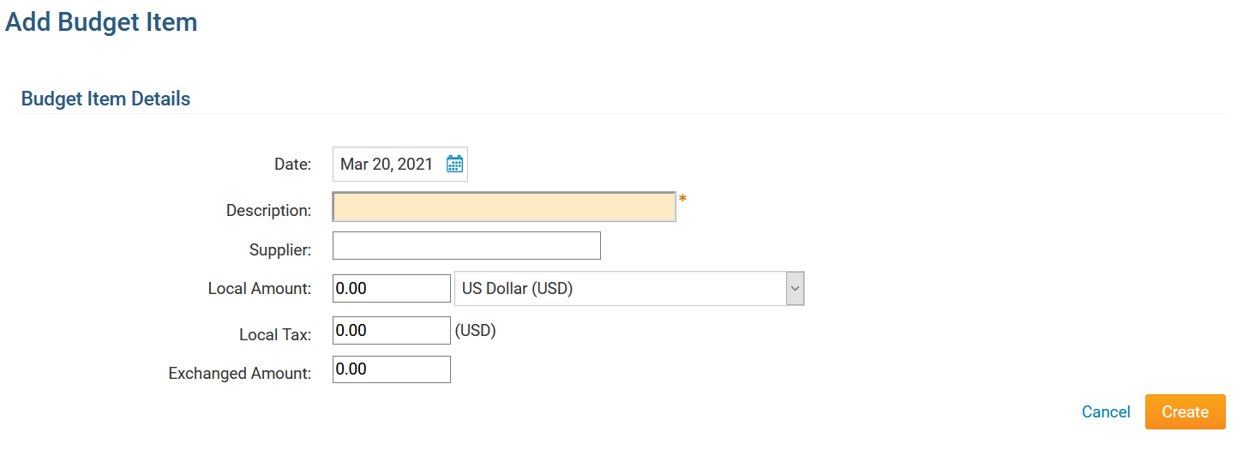

EXPECTED INCOME- TO ADD INCOME PRESS + ADD PROJECT FINANCING TO OPEN THE FINANCING OPTIONS. USUALLY THERE ARE TWO ENTRIES—ONE INCOME FROM THE DISTRICT GRANT AND ANOTHER INCOME FROM THE CLUB CONTRIBUTION—IF YOU ARE RECEIVING FINANCING FROM OTHER ORGANIZATIONS AND OTHER ROTARY CLUBS—EACH ONE OF THE ENTITIES NEEDS TO HAVE A SEPARATE ENTRY.
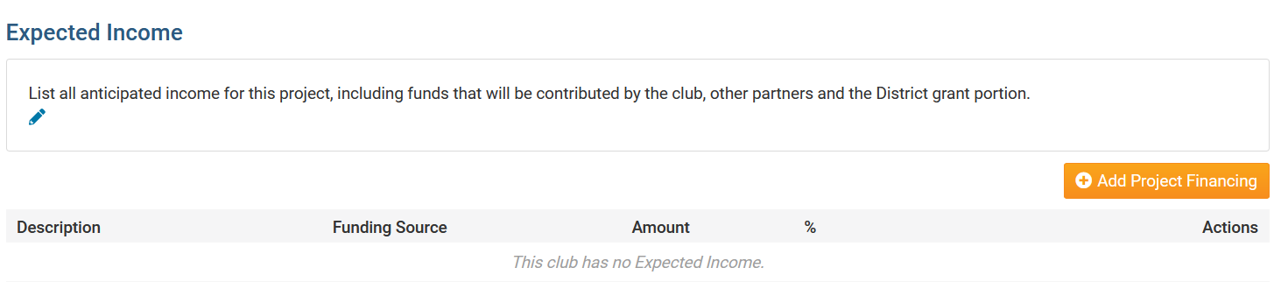

COMPLETE THIS SCREEN TO ADD FUNDING INFORMATION. THIS IS WHERE YOU REQUEST THE GRANT AMOUNT YOU ARE APPLYING FOR. BE SURE TO PRESS “ADD” TO SAVE YOUR INFORMATION. AGAIN FOR EACH TYPE OF FINANCING YOU ARE REQUESTING – A NEW ENTRY MUST BE MADE
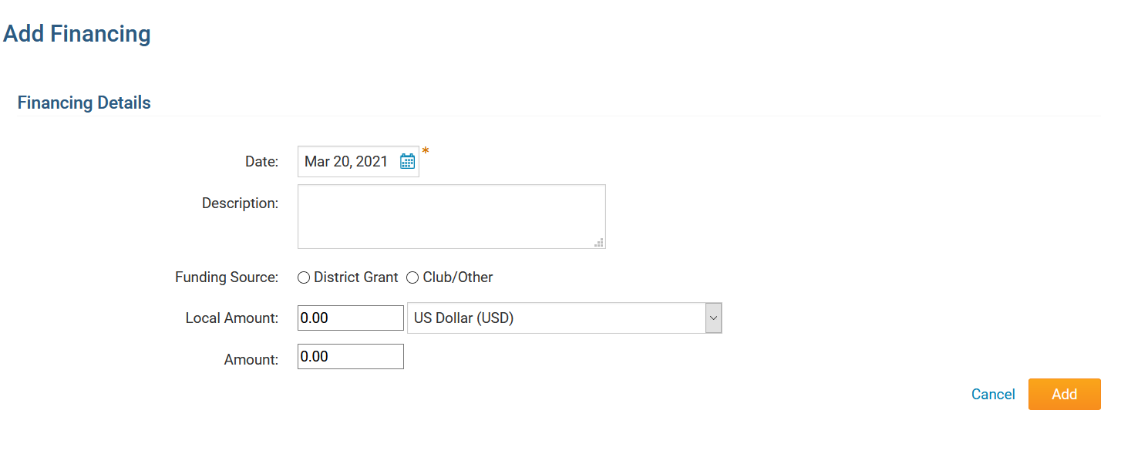

PLEASE REMEMBER—THE EXPENSES MUST EQUAL THE INCOME!

NOW YOU ARE DONE WITH YOUR GRANT APPLICATION
WOULD YOU LIKE TO SHARE THE APPLICATION WITH YOUR COMMITTEE OR YOUR CLUB. SCROLL UP TO THE APPLICATION SECTIONS—CLICK ON PROJECT OVERVIEW
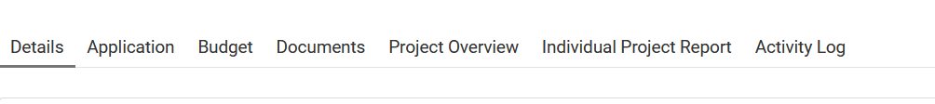

THE SUMMARY OF YOUR WHOLE PROJECT WILL SHOW UP—YOU CAN PRINT IT. YOU CAN SAVE IT AS A .PDF AND YOU CAN SHARE IT WITH YOUR COMMITTEE/CLUB AS APPROPRIATE.
