District Grant Application (2022-2023)

Rotary / Rotaract Club:
(Satellite Clubs: See Qualification Criteria and enter both host and satellite club names)

ELIGIBILITY CHECKLIST

(Note that if your responses are not all in the right-hand column; you may not be eligible for a grant.)

NO YES
- Have your President Elect 21-22 and Vice President or Club Foundation Chair 21-22 signed and submitted a Memorandum of Understanding (MOU)?

- Have two members of your club completed the Grants Management Seminar?

- Have you recorded an Annual Fund giving goal for your club on Rotary Club Central on the RI website? www.rotary.org

- Have you recorded the name of your Club Foundation Chair on the RI website?

- Have you paid all your District & RI dues that are currently due and payable?

- Have you filed final reports for any District grant you have received or any Global Grant (if you are the Host Club), and returned all unused funds?

  - Is your club current with all interim reporting requirements?

- Is the project new to your club?

- Is your Rotary club leading the implementation of the project?

- Will your club be contributing at least $500 to the project?

- Is the project free of any conflict of interest or the appearance of any conflict of interest?

- If you do not receive this grant award, will you do the project anyway?
.
- And finally, have you signed this application?

If any of your responses are NOs, please explain below:

Project Title
Project Summary
Briefly summarize goals and activities
Project Location | City: | State: | Country:
Project Criteria
Explain how this is a Rotary Led Project.
Area of Focus
Check the primary area the project
will address. |  | 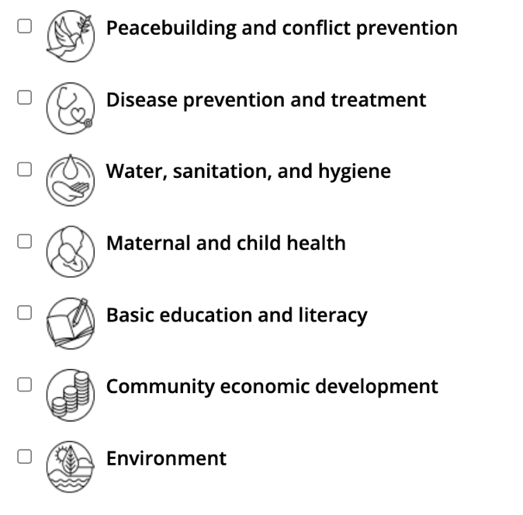
Project Description
Describe the project in detail. Include how this project will be SUSTAINABLE.

Community Need
What is the need and how was it determined?
Beneficiaries

How will this project meet the identified need of the community?

Who will benefit by the completion of this project?

How many people in the community will benefit?
Project Duration | Approximate Start Date: End Date:  (prior to May 30, 2023)

Rotarian Involvement  Rotarian involvement is important.  Describe how this project will involve the members of your club. | How many active Rotarians are in your club? How many will be involved and what will they do?
Public Relations  How will the project and Rotary involvement be promoted and publicized?  If this is an  International project, be sure to describe how Rotary’s involvement is being promoted in that community. | Describe in detail your PR plan for this project.
Partners  if applicable | Rotary Club(s):  Partner Organization(s):

Project Budget Summary  Required |  | Total Budget Amount:
 |  | Less Club Contribution:
 |  | Less Partner Contribution:
 |  | Grant funds requested:
Project Budget Detail - A detailed budget of expenditures is required.
Note: Funds may not be used to reimburse outside providers.

Travelers: Please note that if travel expenses are included in this grant application, the travelers must adhere to The Rotary Foundation procedures and guidelines and District 7780's Rotary Foundation Sponsored Travel Policy and Guidelines. Please explain in detail below how each traveler's professional expertise and/or personal knowledge will advance the success of this grant.

Reporting | Reporting – clubs receiving District Grants are required to submit:  - Progress report by February 1 of the calendar year following receipt of the grant (i.e. approximately six months after receipt of funds) unless a final report has already been submitted. (2/1/2023)  - Final report is due no later than May 30 of the calendar year following receipt of the funds. (5/30/2023)
By signing this application, we agree to the following:
- All information in this application is, to the best of our knowledge, true and accurate, and we intend to implement the project as described in this application.
- The club agrees to undertake this project as an activity of the club.
- RI, TRF and District 7780 may use information contained in this application to promote the project by various means such as The Rotarian, the RI International Convention, District Newsletter, etc.
- To the best of my knowledge and belief, except as disclosed herewith, neither I, nor any person with whom I have or had a personal or business relationship, is engaged, or intends to engage, in benefiting from grant funds or has any interest that may represent a potential competing or conflicting interest. A conflict of interest is defined as a situation in which a Rotarian, in relationship to an outside organization, is in a position to influence the spending of TRF grant funds, or influence decisions in ways that could lead directly or indirectly to financial gain for the Rotarian, a business colleague or his or her family, or give improper advantage to others to the detriment of TRF.
- Our club accepts responsibility for submitting all required reports when due, including substantiation of all project expenditures.
Project Coordinators  must be active members of your club | Primary Contact:  e-mail: phone:  Committee Member:  e-mail: phone:  Committee Member:  e-mail: phone:

Signatures | Club President 2021-22  President-Elect 2021-22 | Date:  Date:
Instructions | Deadline to submit this application is June 1, 2022. Send completed (pages 1-7) & signed application via e-mail as a PDF document to grants@rotary7780.org  Your application will be reviewed by the district screening committee (appointed club foundation chairs) in June and recommendations for grant awards will be made to the district foundation committee for final approval in July.  Because emails can get lost or filtered, call the district grants chair to confirm receipt if you are close to the deadline and have not yet received acknowledgement.  Notification of the committee’s decisions will be made to all clubs submitting grant applications by the District 7780 Foundation Chair.

Please retain a copy of this completed application for your club’s records.

District Grant Application for Rotary year 2022-2023 grants Updated February 1, 2022

