Club Secretaries Guide to Clubrunner
Clubrunner has facilities to make several of the tasks done by the Secretary easier. These tasks include the following
- Adding a member
- Maintaining member information (Profile)
- Club attendance and reporting
- Exempt members
- Member leave of absence
- Member termination
- Update club executives and directors
To do the tasks with Clubrunner it is crucial that Clubrunner have the required member information. Thus the first task must be done before all others.

Adding a Member
A member should be added as soon as they are voted into the club so that functions such as attendance can be completed. To add a member only a few pieces of information is required and will be shown below. It is recommended the new members profile be edited immediately after adding them to include all information. To facilitate this I recommend that a

Maintaining Member Information
The member profile stores mandatory and optional information. Many of the field may be maintained by the member themselves which relieves some of the work from the Secretary. However the Secretary or designated assistant should load all of the initial information.

The following is intended as an explanation of what I have figured out about how Clubrunner works. I think I have figured out the attendance numbers, at least the ones that count.

From the Active members list in Clubrunner today we have 50 active and 2 honorary members which makes sense. The first figure below is from the Active members list. The 50 active is 46 non-exempt plus 4 exempt.

Figure 1

From the “Input current year attendance” selection I have the following:
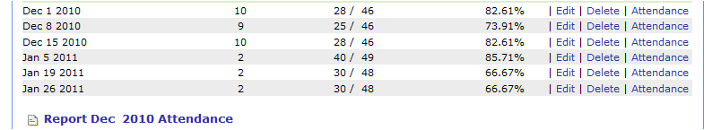
Figure 2

We haven't changed the number of members since Dec 1 when Fawn was terminated. So you might wonder why does the number of members here change from 46 to 49 and then 48? The answer is that in December I was recording the attendance using the spreadsheet you sent and I had no information on the attendance of exempt members as they were simply marked "EX", whether they attended or not, so we show 46. Then in January you started doing the entry and you marked exempt members as present when they were at the meeting since you had that information. Three exempt members attended on Jan. 5 (49=46+3), and two on Jan 19 and 26 (48=46+2).

Clubrunner has the inclusion of exempt members set up correctly per the Rotary standard club constitution Article 9, section 5 which states:

[3](b) the age of the member is 65 and above and the aggregate of the member’s
years of age and years of membership in one or more clubs is 85 years
or more and the member has notified the club secretary in writing of
the member’s desire to be excused from attendance and the board has
approved.
Section 4 — RI Officers’ Absences. A member’s absence shall be excused if the
member is a current officer of RI.
Section 5 — Attendance Records. In the event that a member whose absences
are excused under the provisions of subsection 3(b) or section 4 of this article
attends a club meeting, the member and the member’s attendance shall be
included in the membership and attendance figures used to compute this
club’s attendance.
According to this exempt members should be included if they attend.
A little test of this below in figure 3. For Jan 26 I temporarily marked an exempt member present and you can see 30/48 in Figure 2 has changed to 31/49 in Figure 3.
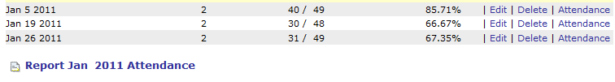
Figure 3

Honorary members are not counted in attendance, which is correct and as expected.

Rotary calls for the monthly percentage reported to be the average of the weekly and this is being correctly calculated.

Clubrunner does the calculation with the formula shown below in figure 4 for the January month end report.
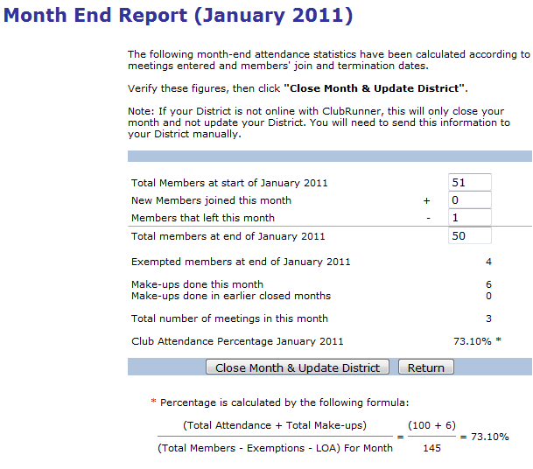
Figure 4

Note that the report says the district will receive it electronically so as these are sent you do not need to send by the manual method.

The only thing I do not yet understand are the numbers for the total members at the start and end of the month circled in red. If the count was active members only, both should be 50. But as you see they show 51 at the start minus 1 leaving (Warren) with 50 at the end of the month. That seems to say they are counting honorary members which would mean the numbers should be 53 at the start and 52 at the end. I am waiting for an explanation of this from Clubrunner. The important part, the percentage attendance is correct.

To generate the above monthly report click on "Report Jan 2011 Attendance" shown in figure 5 below.
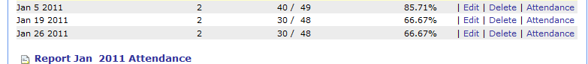
Figure 5

The other piece of the operation here is to add meetings. This is done from the same screen that you start with for attendance.
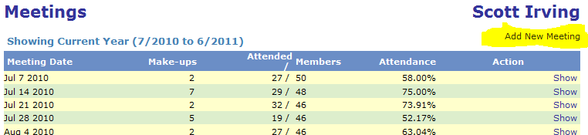
Figure 6

Clicking the "Add New Meeting" button above in figure 6 gets you to the following where you can add a new date.
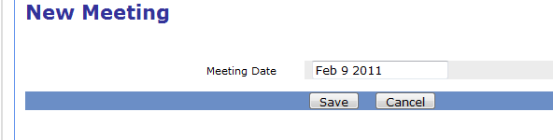
Figure 7

Exempting a member from attendance
On the Admin menu select “Member Attendance Exemption” 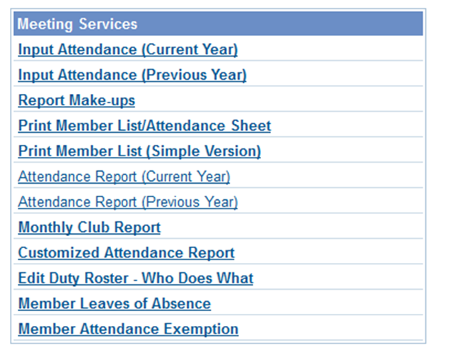
Once you select this you get the menu below and you can select “Mark new exempted member”.
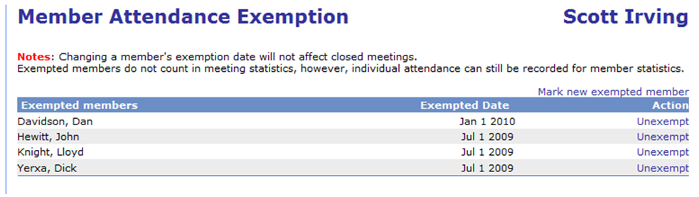
Then you can just select the member and add the date.

