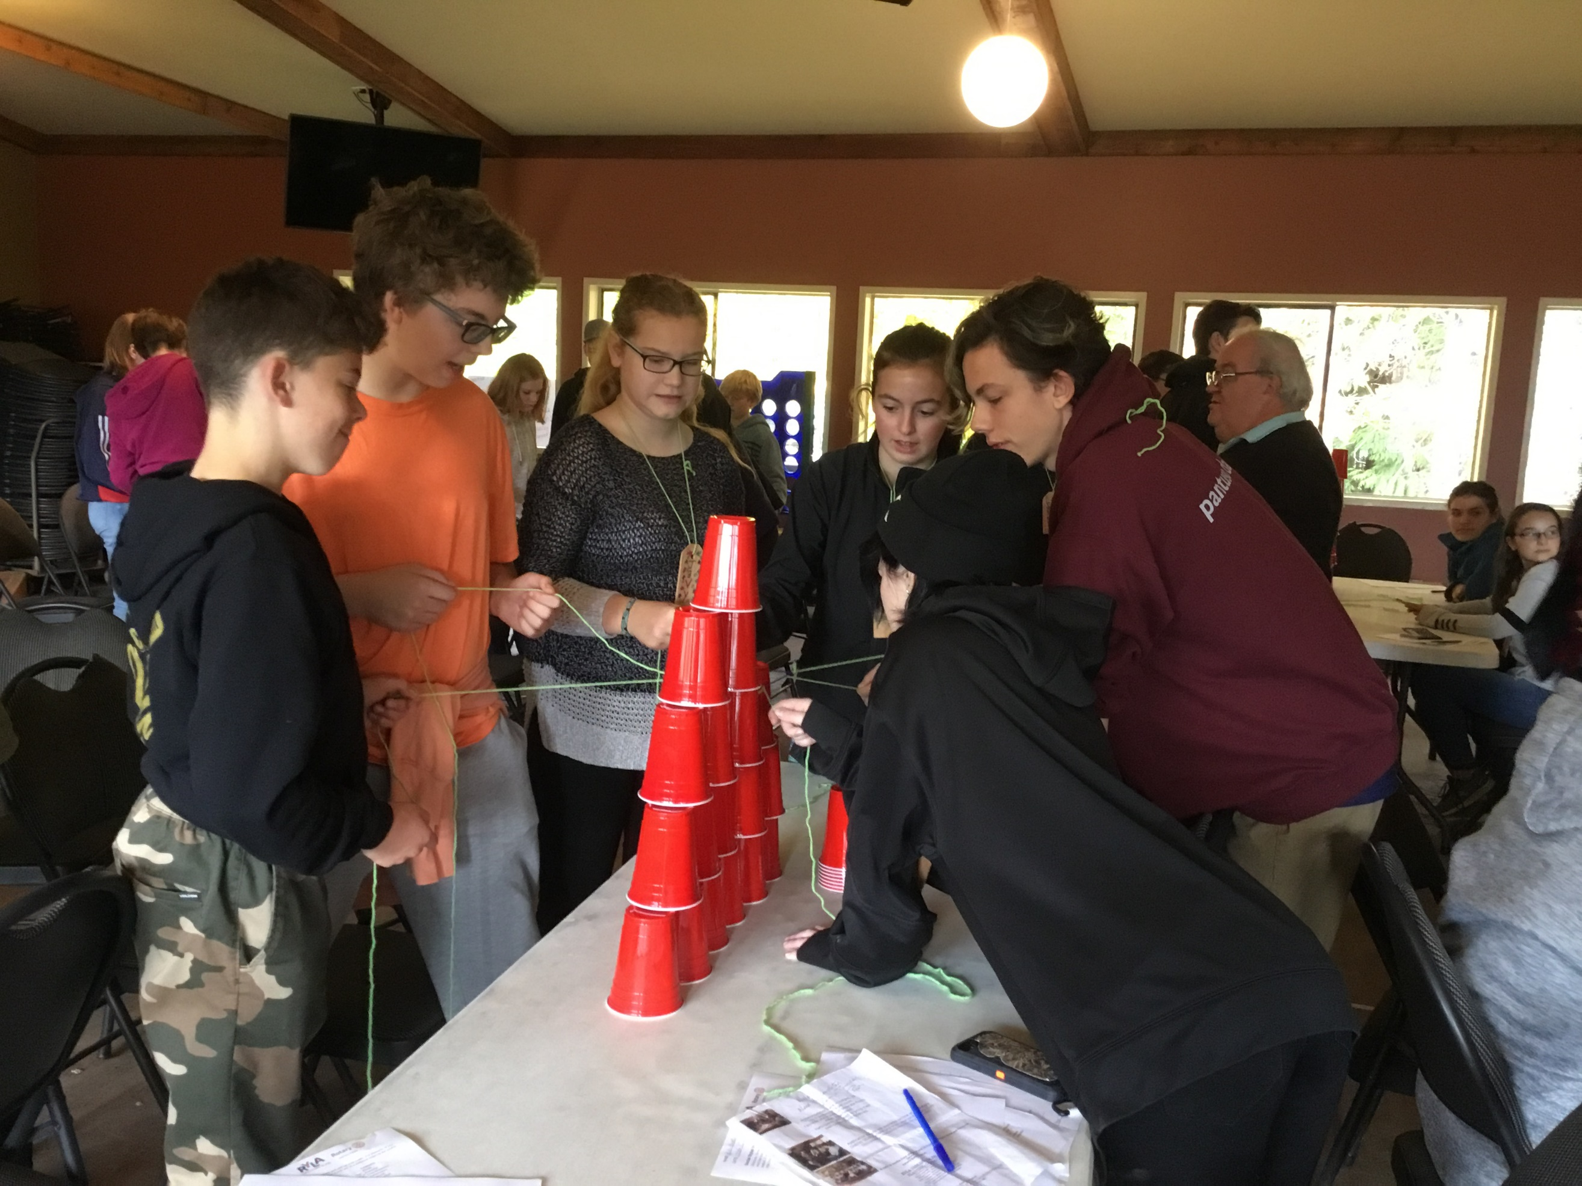

Accommodations are in lodges, up
to 7 participants per room.
Females and males on separate floors.
Adult supervision.
Participants will need to bring their
own bedding and toiletries.
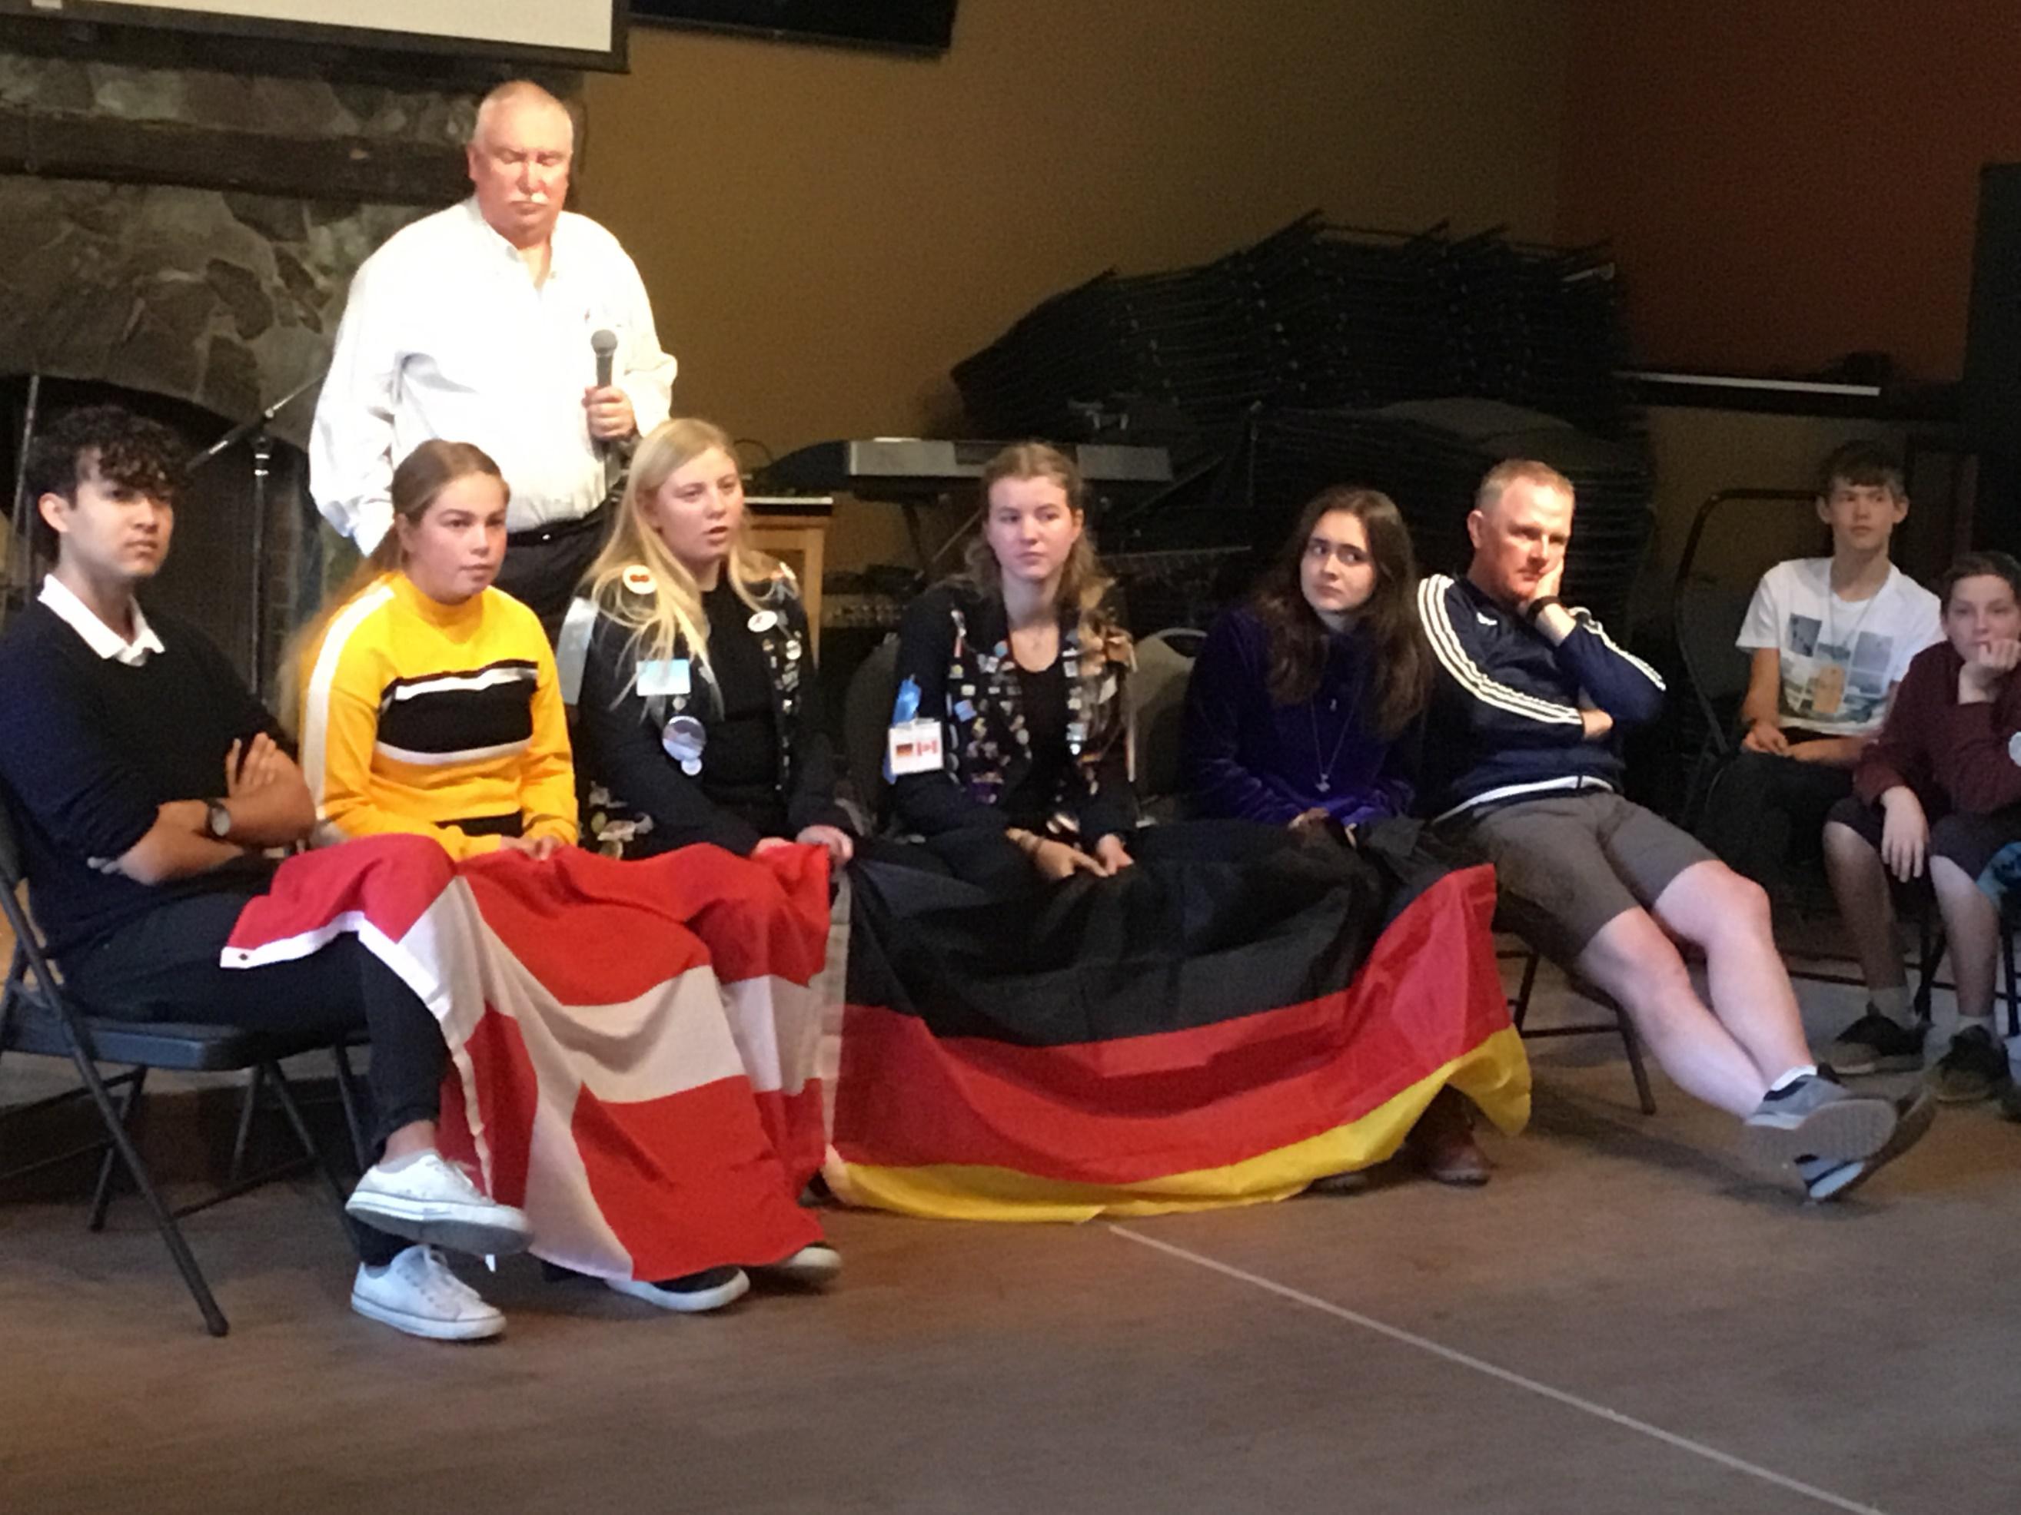

Application details are available on-line at the Rotary District 5020 website and from your local Rotary Club.
All student expenses associated with this event are supported by the student’s local Rotary Clubs.
https://portal.clubrunner.ca/50092/sitepage/ryla-vancouver-island

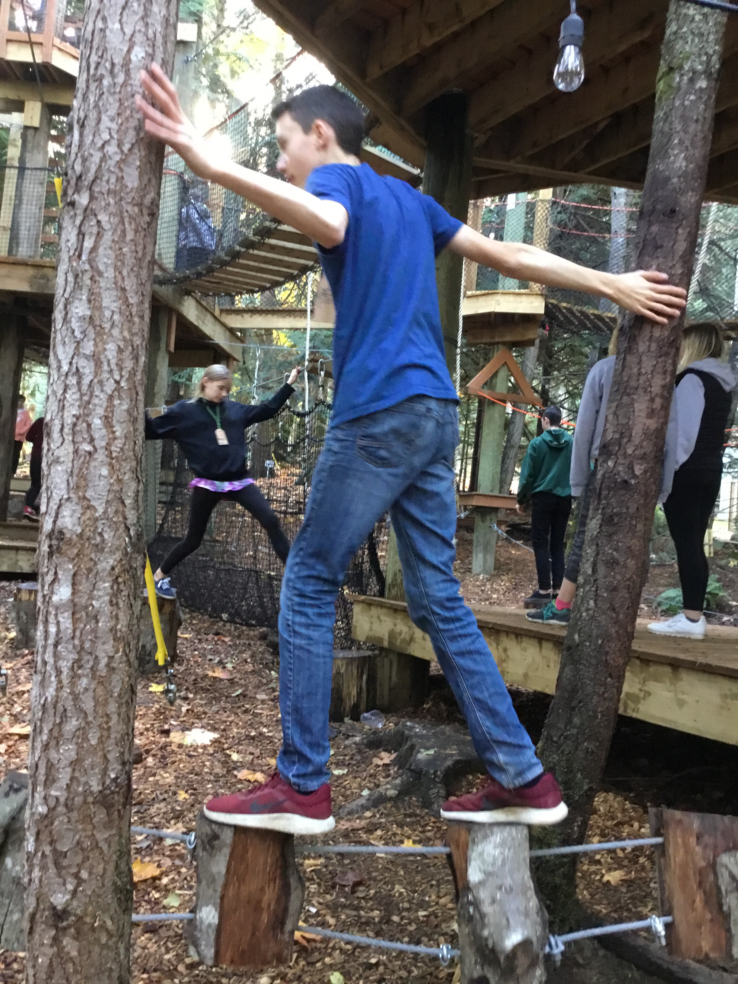

A leadership training weekend for youth from grades 8 to 10 from Washington State and Vancouver Island in
Rotary District 5020.

For brochures, application forms, other information go to:
https://rotary5020.org/sitepage/ryla-vancouver-island
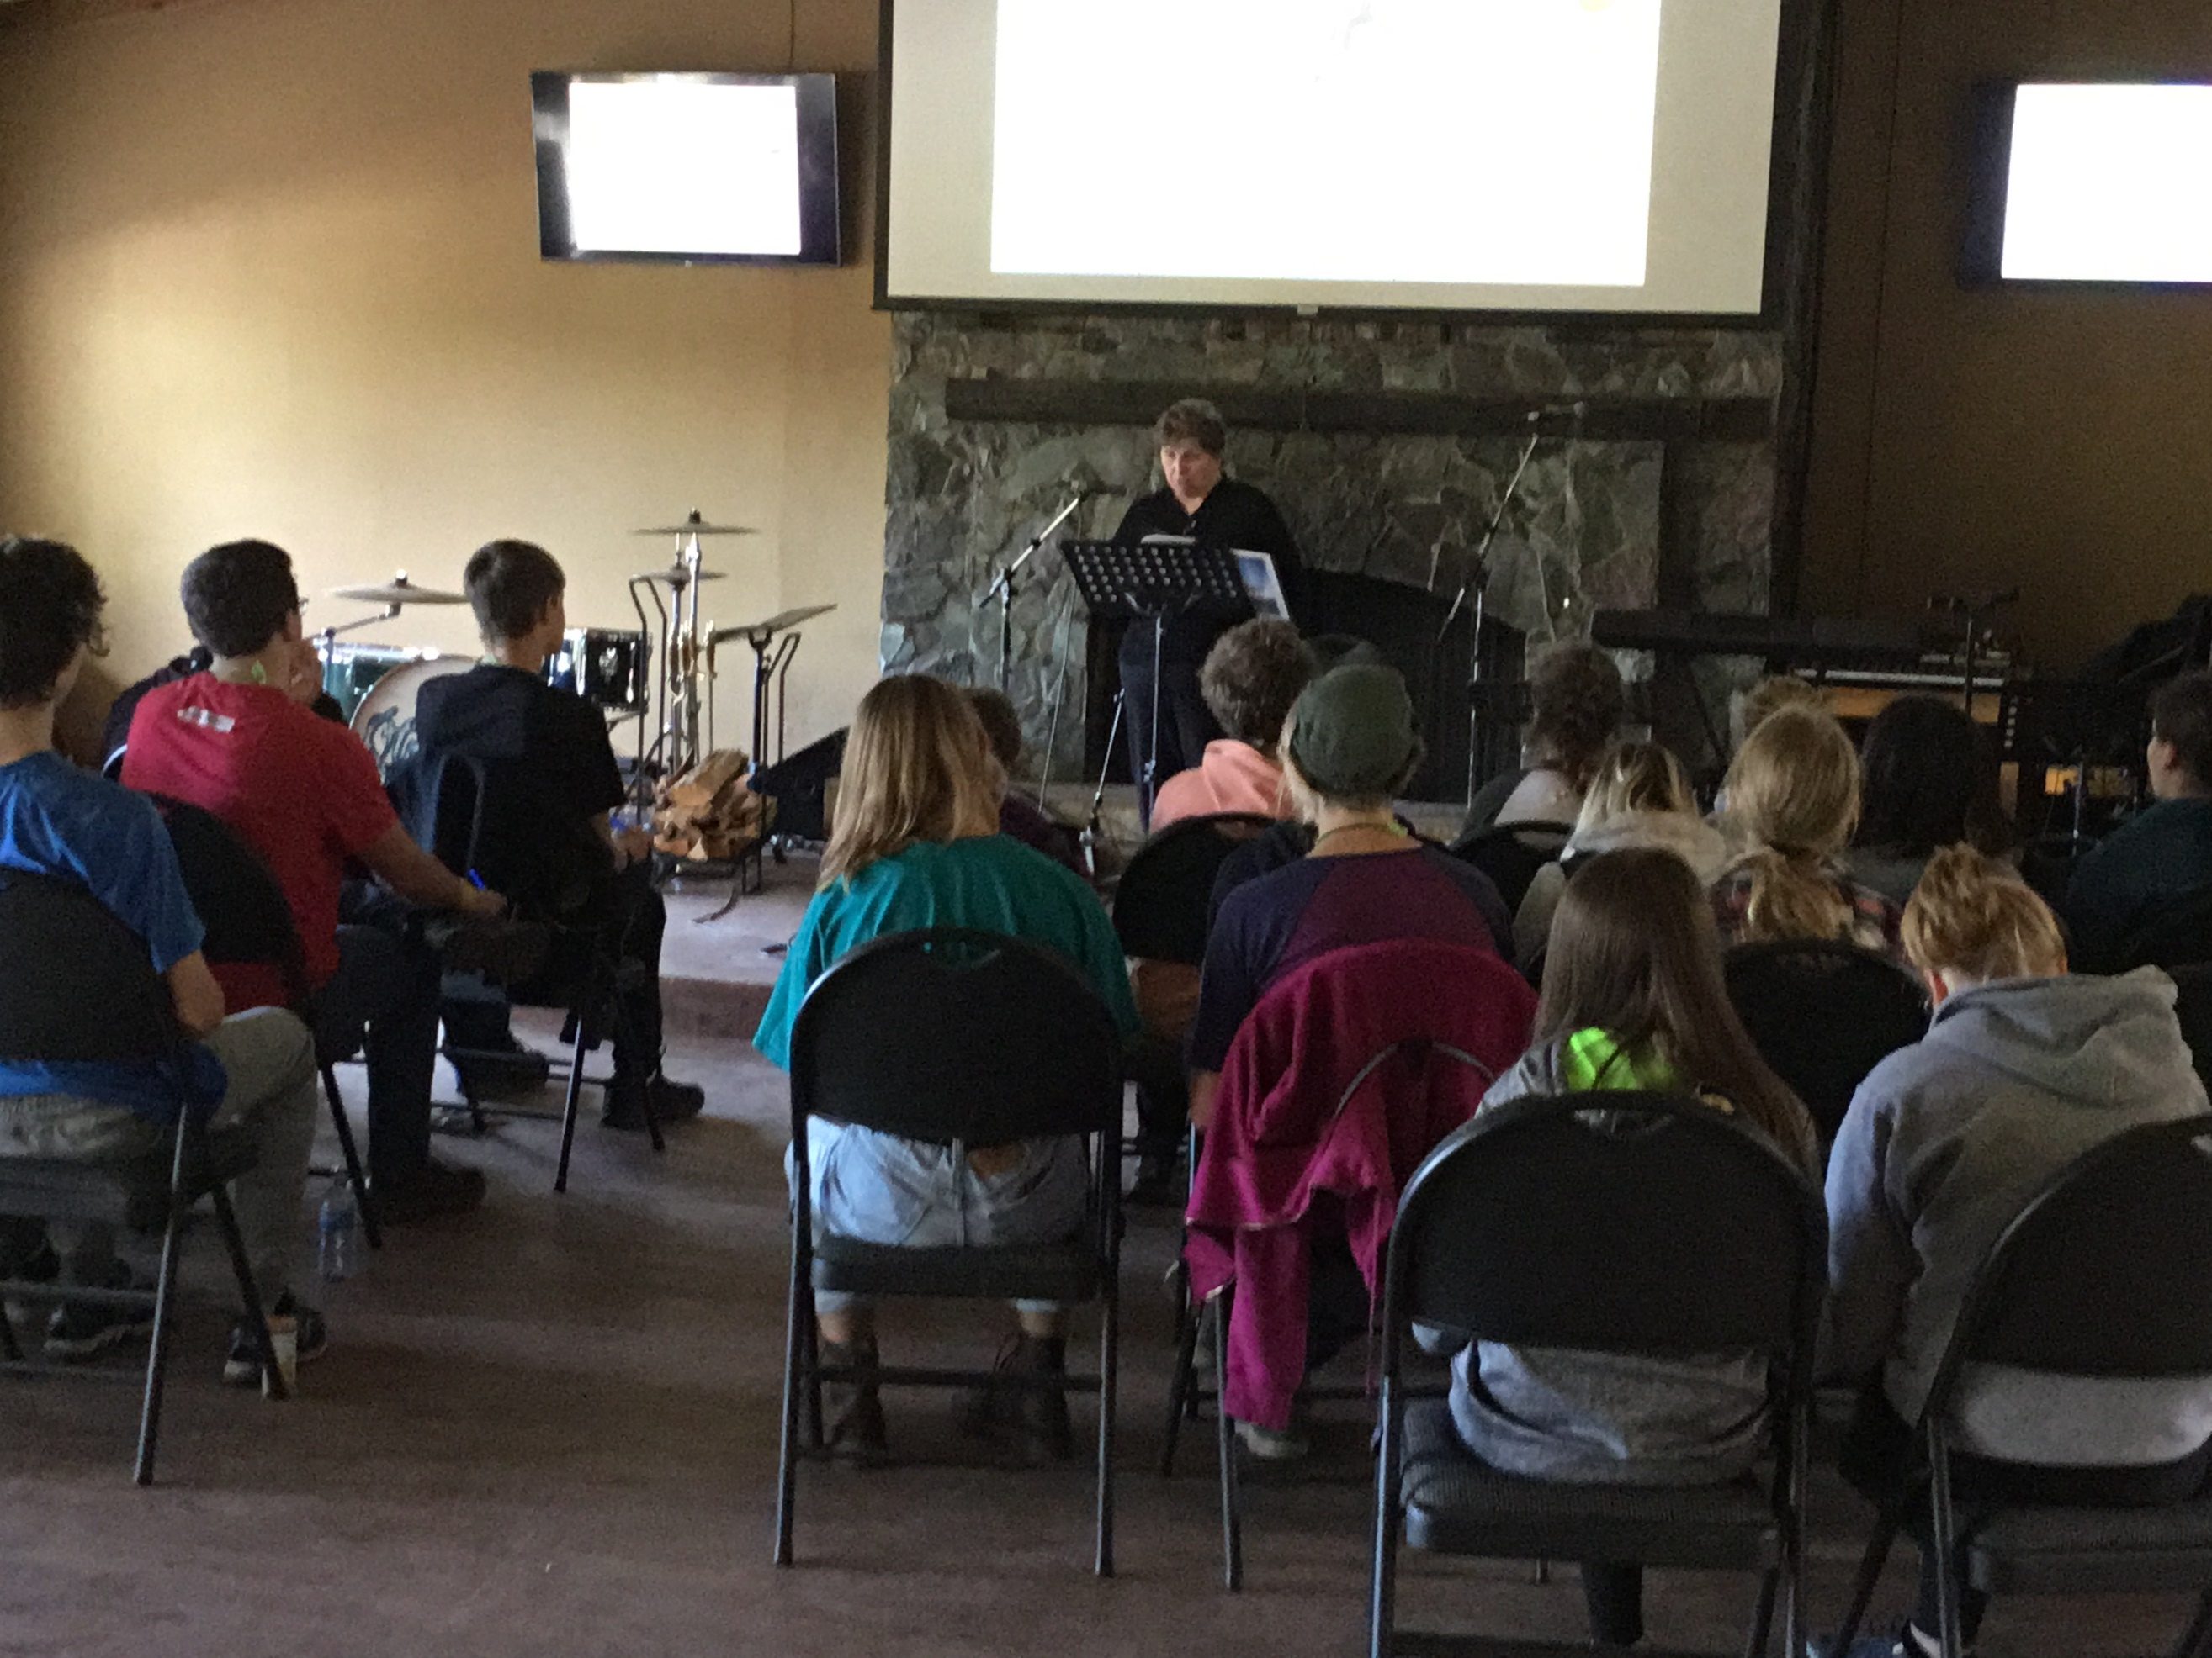

Rotary International
District 5020
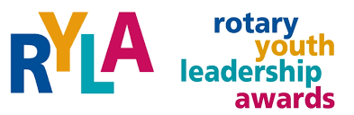
VANCOUVER ISLAND 2019

ROTARY
YOUTH
LEADERSHIP
AWARDS
November 15-17, 2019
Camp Qwanoes
1148 Smith Road, Crofton, BC, V0R 1R0
We are pleased to offer
ryla Vancouver island

Registration Deadline
November 1, 2019

Friday, November 15, 2019
11:00 – 12:30
Registration; room, assignments,
sports activities
12:30-1:15 lunch

1:30-2:45 What makes a leader?
Michael Furlot, Rotarian

2:45-3:15 snack and activity break

3:15-3:45 Polio Plus and Beyond
Joan & Terry Toone, Rotarians

3:45-5:00 sports activities
Team building

5:00 – 5:15 settling in getting to know
your cabin mates

5:15 Welcome to Coast Salish Traditional Territory

5:30-6:15 Dinner

6:30-7:30 First Nations Presentation
Presenter from the
Nanaimo Aboriginal Cultural Centre

7:30-7:45 activity break

7:45-8:45 Dr. Ed Nicholson, Rotarian
8:45-9:30 Getting acquainted
Opportunity for anybody who has musical instruments to practice together.

9:30-10:00 Team Time
10:30 Lights Out

Saturday, November 16, 2019
8:00-8:45 Breakfast
8:45-10:45 Self-Empowerment
Where excellence in leadership begins. Christina de Souza
10:45-11:15
Break and activity

11:15-12:30 Social Styles Awareness
Learn to identify the traits you were born with.
Joan Ryan, Rotarian

12:30-1:15 lunch

1:30-2:45 sports activities
Team building
2:45-4:15
The Gift of Rotary Youth Exchange;

4:15-5:15 talent show

5:30-6:15 Dinner

6:30-7:30 Painting hour
7:30-9:30
4-Way Test Skits,
9:30-10:00
Team Time
10:30
Lights Out
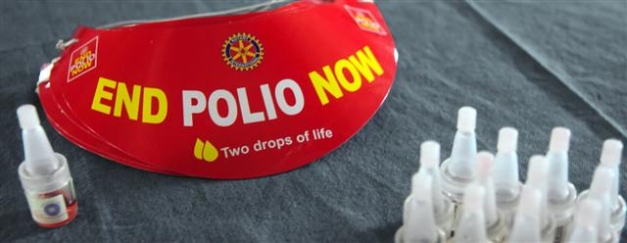

Sunday, November 17, 2019
8:30-9:15
Breakfast
9:15-9:45
Pack up and vacate rooms
9:45-10:45
Closing Ceremony, group photos, etc.
11:00 Departure Time

YOUR RYLA VI TEAM:

Participants will be assigned to a team for the weekend, every effort will be made to ensure teams include youth from various communities and if possible both countries.
(Canada and the United States)
During the weekend the teams will get to know one another, explore ideas together and create a painting that will become part of a larger collage at the closing ceremony.
