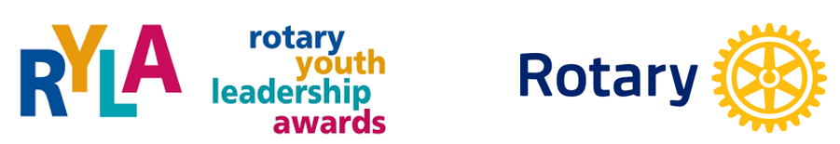

ROTARY YOUTH LEADERSHIP AWARDS
Vancouver Island

November 15-17, 2019

Camp Qwanoes 1148 Smith Road,

Crofton, BC, V0R 1R0
We are pleased to offer RYLA Vancouver Island Number 4
An opportunity to develop and/or enhance leadership abilities to 80-100 more teens with our support.

A leadership training weekend open to youths from grades 8 to 10 throughout Rotary District 5020.

All student expenses associated with this event are supported
by the student’s local Rotary Clubs.

Cost per student $275.00 Canadian

For more information contact:
RYLAVI chairperson Joan Ryan RYLAJoan@shaw.ca
Call or text 250-713-5549

For more information or access forms go to
https://rotary5020.org/sitepage/ryla-vancouver-island

