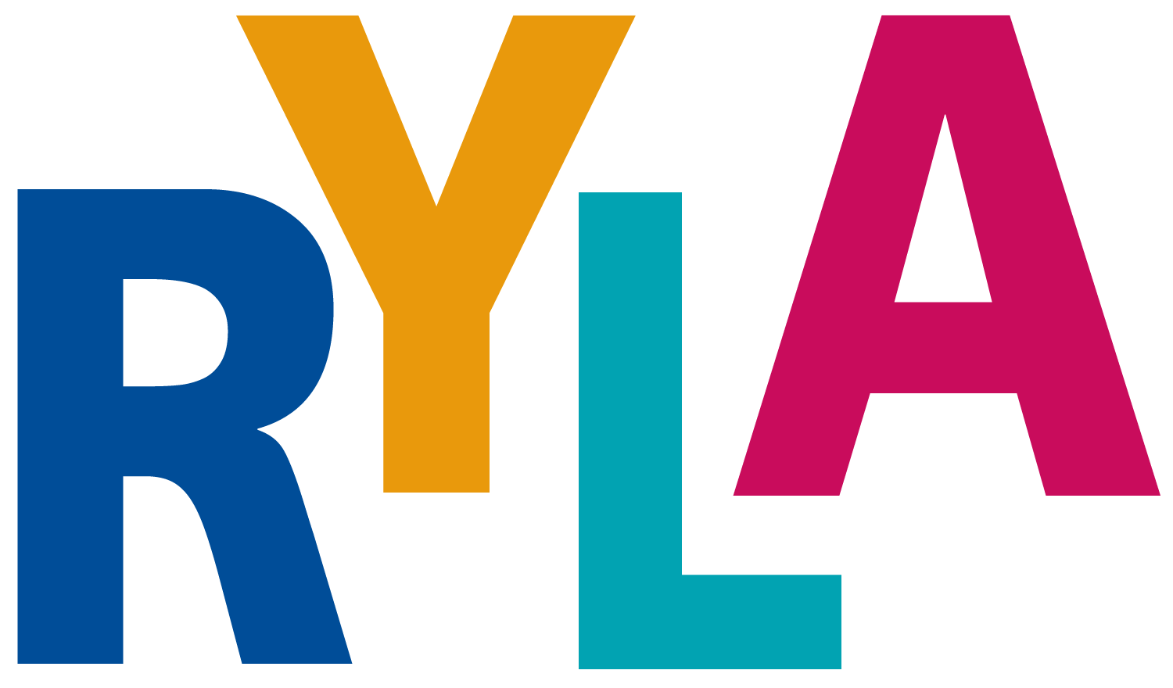
District 5020

Vancouver Island, November 15-17, 2019

APPLICATION for RYLA VI – Rotary Youth Leadership Awards Vancouver Island

To be completed by sponsoring rotary club for each student

- Sponsored by Rotary Club of

- Rotarian Contact

- Telephone Email

Name: | Name on badge: |  |  | Gender
Address:

Province/State |  |  | Postal Code/Zip Code:
Cell Phone: |  |  | Age at start of event:
Email address: |  |  | High School
Interact Club Member Yes No |  |  | T-shirt size:
Next of Kin: |  | Email:
Home phone: |  | Cell Phone:

Yes, I want to attend RYLA. I understand that I will be bringing personal belongings and that neither Camp Qwanoes, Rotary District 5020 nor the RYLA Vancouver Island Committee are responsible for any items lost or stolen while attending this conference.

(Signed)

- Rotary Club Representative, please ensure the items at the top are completed.

PLEASE NOTE: THIS FORM ALONG WITH THE PARTICIPATION RELEASE FORM MUST BE COMPLETED AND RETURNED AS SOON AS POSSIBLE TO EITHER YOUR SCHOOL COUNSELOR OR ROTARIAN REPRESENATIVE.

Family Doctor Telephone#
(Canadian Students) Provincial Medical Plan Number / / _/

(USA Students) Medical Plan Carriers Name
Plan # Telephone #

Out of Country Medical Coverage Carriers Name

Plan Number
Out of Country Medical Plan Carriers Telephone Number

Dietary Needs, Allergies, etc.

_

Medical Conditions

_

Prescription medicines you will have with you _

_

Special Assistance or any other information _

_

In the event of an emergency, I authorize the above camp staff and/or Camp Qwanoes and/or BC Emergency Services to arrange for emergency transportation and/or emergency medical care.
In Case of Emergency, please notify:

Name Number Relation
Name Number

Relation

Signature of Participant Date Printed Name

(Signature of Parent/Legal Guardian) Date Printed Name
*Parent or legal guardian must also sign for participants under 18 years of age

