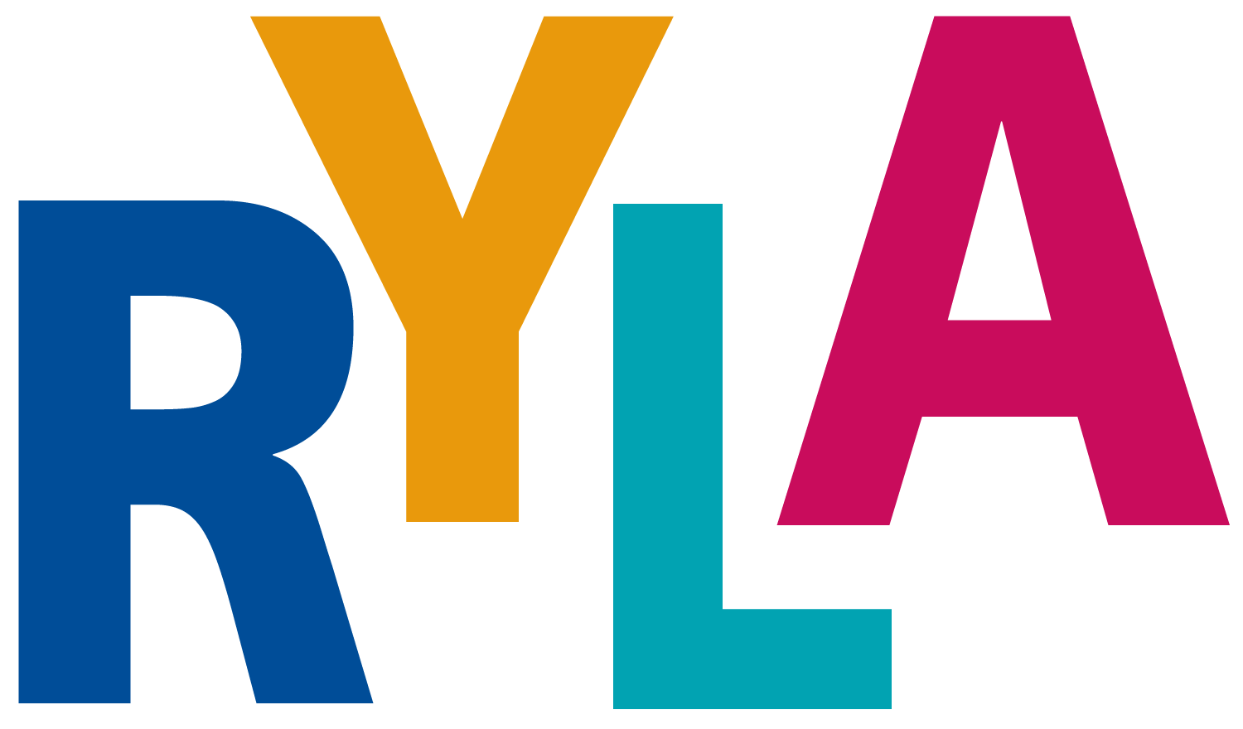
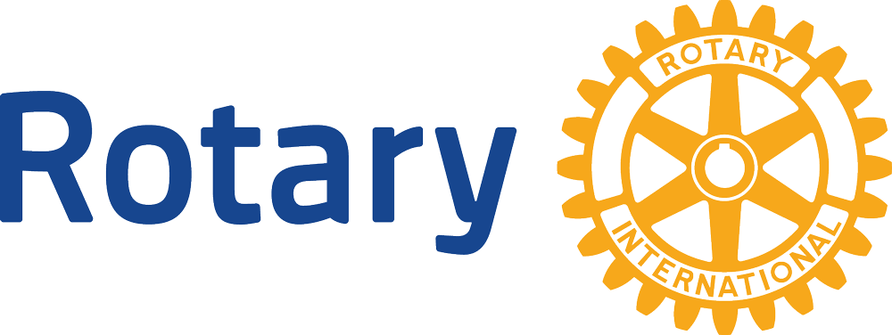
District 5020

Vancouver Island, November 15-17. 2019

TO: School principals/school counselors

FROM: Rotary Club of

SUBJECT; RYLA VI (Rotary Youth Leadership Awards, Vancouver Island) Conference

The Rotary Club of seeks your help in identifying and nominating qualified and interested candidates to attend RYLA VI at no cost to the student or the school.

RYLA is an intensive leadership training conference and workshop. The program has been carefully designed to provide basic leadership training and experience for young people from Western Washington and Canada. The program will include lectures and discussion periods with skilled and prominent leaders, as well as recreation, good food, and fellowship.

We seek student applicants, Grades 8-10; in high school, who have demonstrated a desire and some ability as a responsible leader of others. These students don't necessarily have to be the student body president, or those who hold other student body leadership positions. What we do suggest is that those selected for RYLA have high character and a constructive attitude, and are in a position to learn and benefit from this experience. (Possibly mention former RYLA participants attending from your school.)

Please help us by selecting qualified people, have them fill out the application, return it to you and then forward the applications to ______________________ Rotary Club. The RYLA secretary will then forward more detailed information to the selected student(s).

The Camp Qwanoes consent form will be given to the successful students after you have made the selection. The completed form will need to be handed in at registration.

