Criteria for the 2023-2024 Literacy Recognition
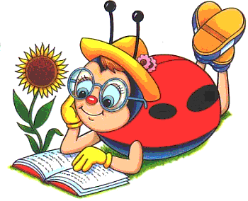

Theme: “Not Your Grandmother’s Literacy”

Categories: Ideas/Suggestions
Do a total of 5 different things, which may include:
- General Ideas
Attending the Seminar,
Show how your club observed September 8th, either as the International Day of Reading or
recognizing the month of September as Literacy Month.
Using an idea from the Children’s Agenda Website, thechildrensagenda.org

- Birth to 4 years old
Volunteer at a Day Care or Library
Baby Bags with book and brochure
Individual book shelf with books
Give needy parents financial aid (scholarship? Assistance?, etc?) to help with day care expenses.
Your own idea___________________________________________________

- Ages 5-12
Provide Books and Healthy Snacks for the weekend
Blue Book Shelf
Place books in Food Pantry, Community Centers, Laundromats
Create a Reading corner for a classroom
Treasure boxes
Throw a Literacy based Party for your School or Library
Your own idea___________________________________________________________

- Ages 13 and above
Author visit
Little Library
Bring/Send some teens to the Teen Book Festival
Scholarships
Periodical subscription
Word Search books in large print for Senior Centers or Nursing Homes.
Your own idea_______________________________________________________________

- International
Books for the World
School Supplies

Name of Club _____________________________________________________________________
Contact person____________________________________________________________________
Form must be submitted by March 31, 2024. Send to: JoAnn Terry, 100 McAuley Drive, Apt. 150, Rochester. NY 14610, or email @ joannterry7@gmail.com
Please use the back of this form if you need more room

