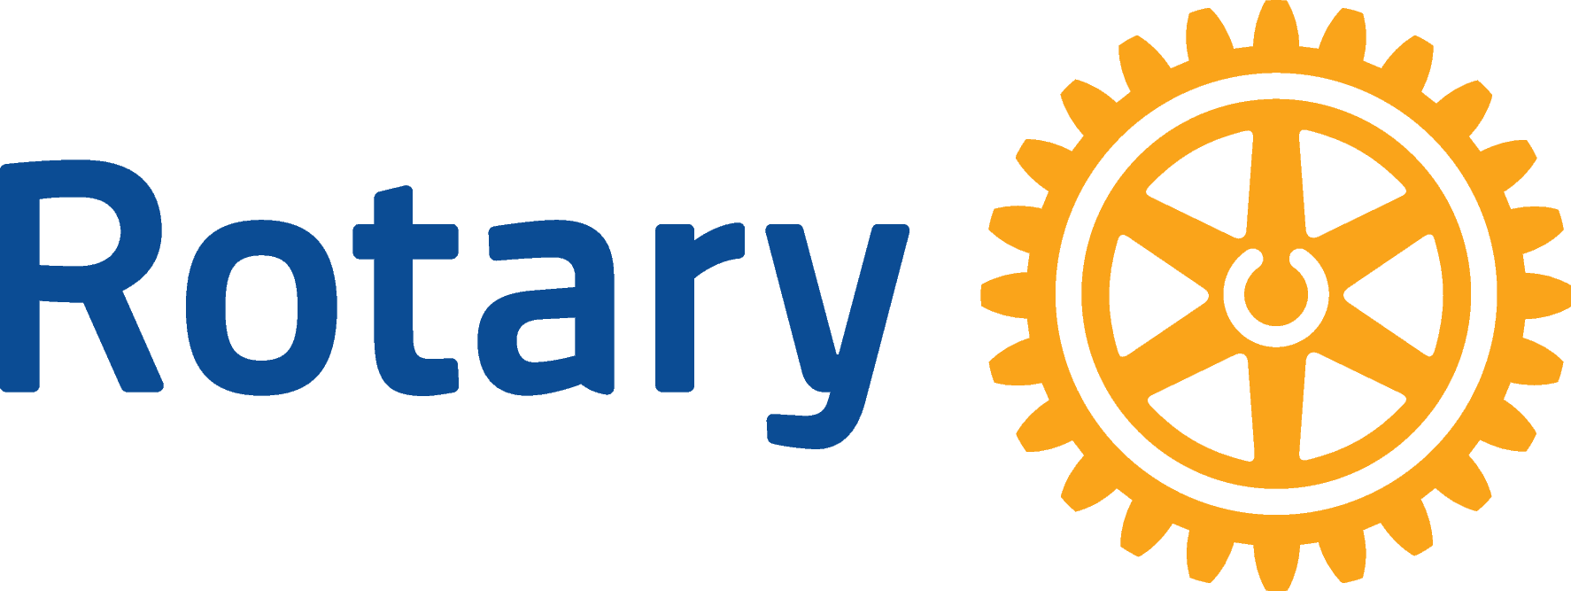
ENGLISH (EN)

GLOBAL GRANTS COMMUNITY ASSESSMENT RESULTS
Assessing the strengths, weaknesses, needs, and assets of the community you plan to partner with is an essential first step in designing an effective and sustainable project. See the Conducting Community Assessments handbook for full instructions and helpful tips.
Use this form to report the findings of your community assessment to The Rotary Foundation when you apply for a global grant for a humanitarian project or vocational training team. Complete a separate form for each community that will be involved in the project (e.g., school, health care system, town, or city), using information that is both current and specific to that community.

Note: Rotary’s Grants staff is updating several of the documents that support your global grant application, including this form. Please complete this brief survey to provide feedback about the form.

OVERVIEW
In 100 words or less, describe the problem you identified in the community.

Note: Include the causes of the problem you plan to address through this project.
Click or tap here to enter text.

Why did you decide to focus on addressing this problem?
Click or tap here to enter text.

What other needs exist in the community?

Note: Based on your assessment, what other related needs have been identified but will not be addressed by your project? For example, perhaps many in the community lack clean water but your project, which aims to address a shortage of low-cost health care, won’t be able to address that.
Click or tap here to enter text.

What other organizations are working in the community on issues that are not related to the problem you identified, and what services are they providing?
Click or tap here to enter text.

Who conducted the community assessment and when? What methods were used?

Note: List the names and roles of the people or organizations who conducted the assessment, and who they consulted. For example, entrepreneurs, community health workers, members of the community, hospital staff, local government officials, teachers, or school administrators. Describe the methods used with each group (community assessments, interviews, focus groups, etc.), and include dates.
Click or tap here to enter text.

Note: Answer the questions on the following pages only for the area of focus that most closely aligns with your project’s goals.

BASIC EDUCATION AND LITERACY
Describe the community and institutions where your project will take place. Include any relevant information about the area.

Note: Describe the setting (e.g., rural village, urban area, school, refugee camp, health care facility).

Tell us about the people that the project will help.

Note: Include information such as age ranges, education levels, gender identity, ethnic or social groups, and disability status. Highlight any particularly vulnerable groups.
Click or tap here to enter text.

Based on the community assessment, describe how the problem you identified is currently being addressed or mitigated. What are the key challenges?

Note: For example, list any specific challenges that may affect students’ ability to attend school or to learn, such as poverty, long distances to school, language barriers, disabilities, or social stigmas.
Click or tap here to enter text.

What are the community’s strengths and resources?

Note: Describe the learning resources that are relevant to the project and are currently available in the schools or the community. These could include people, textbooks, educational technology, classrooms, teaching materials, and facilities.
Click or tap here to enter text.

What resources are lacking?

Note: Describe the needed learning resources that are not currently available in the schools or the community. These could include people, textbooks, educational technology, classrooms, teaching materials, and facilities.
Click or tap here to enter text.

Are any similar programs or initiatives being implemented in the community by non-Rotary entities, government agencies, or nongovernmental organizations (NGOs)? How will these similar initiatives enhance your project’s effectiveness?

Note: Describe how you plan to coordinate with other organizations, if you do.
Click or tap here to enter text.

COMMUNITY ECONOMIC DEVELOPMENT
Describe the community and institutions where your project will take place. Include any relevant information about the area.

Note: Describe the setting (e.g., rural, urban, or displaced communities). Include any notable characteristics of the area (e.g., climate-vulnerable, post-conflict, informal economy). Describe the main local economic activities.
Click or tap here to enter text.

Tell us about the people that the project will help.

Note: Include information such as age ranges, education levels, gender identity, ethnic or social groups, disability status, and socioeconomic classification. Highlight any particularly vulnerable groups.
Click or tap here to enter text.

Based on the community assessment, describe how the problem you identified is currently being addressed or mitigated. What are the key challenges?

Note: Describe the current opportunities for skills training, employment, entrepreneurship, education, and access to markets, if relevant. Include supporting data like rates of poverty or joblessness.
Click or tap here to enter text.

What are the community’s strengths and resources?

Note: Describe the economic resources that are available to the community. Include, for example, any efforts to increase income, vocational training, job placement services, renewable energy, or economic investments.
Click or tap here to enter text.

Are any similar programs or initiatives being implemented in the community by non-Rotary entities, government agencies, or nongovernmental organizations (NGOs)? How will these similar initiatives enhance your project’s effectiveness?

Note: Describe how you plan to coordinate with other organizations, if you do.
Click or tap here to enter text.

ENVIRONMENT
Describe the community and institutions where your project will take place, if applicable. Include any relevant information about the area.

Note: Describe the setting (e.g., rural, urban, underserved, or displaced communities) and habitats (e.g., water, soil conditions, climatic conditions). Describe the ecosystem (e.g., forest, wetland, agricultural land, urban area) and how people engage with the ecosystem.
Click or tap here to enter text.

Tell us about the people or places that the project will help.

Note: Describe the people (e.g., community members, farmers, etc.) and how the ecosystem might benefit (e.g., increased biodiversity, increased number of species, protected habitat). Include information such as people’s age ranges, education levels, gender identity, ethnic or social groups, disability status, and socioeconomic classification. Highlight any particularly vulnerable groups.
Click or tap here to enter text.

Based on the community assessment, describe how the problem you identified is currently being addressed or mitigated. What are the key challenges?

Note: Describe, for example, the condition of the local ecosystem, how resources are being used, or pollution levels. Include supporting data like deforestation rates, water quality, or carbon emissions.
Click or tap here to enter text.

What are the community’s strengths and resources?

Note: Describe existing programs, cultural norms, traditional ecological knowledge, institutions, or mechanisms that are in place to address ecosystem challenges or promote environmental sustainability. Include any efforts to address environmental issues, such as pollution, water scarcity, loss of biodiversity, or displacement caused by damage to the environment.
Click or tap here to enter text.

Are any similar programs or initiatives being implemented in the community by non-Rotary entities, government agencies, or nongovernmental organizations (NGOs)? How will these similar initiatives enhance your project’s effectiveness?

Note: Describe how you plan to coordinate with other organizations. Include any collaborative ecosystem management plans, legal agreements or mediation, government initiatives, environmental committees, or religious or cultural leaders who will be involved in dialogue.
Click or tap here to enter text.

DISEASE PREVENTION AND TREATMENT / MATERNAL AND CHILD HEALTH
Describe the community and institutions where your project will take place. Include any relevant information about the area.

Note: Include where you’ll work, such as a hospital, health center, another part of the health system, or elsewhere in the community.
Click or tap here to enter text.

Tell us about the people that the project will help.

Note: Include information such as age ranges, sex, gender identity, or pregnant or new mothers. Highlight any particularly vulnerable groups.
Click or tap here to enter text.

Based on the community assessment, describe how the problem you identified is currently being addressed or mitigated. What are the key challenges?

Note: Describe the prevalence and impact of the disease or health issue (e.g., HIV, malaria, malnutrition, cataracts) in the target population. Include supporting data such as infection rates, mortality rates, or related health indicators.
Click or tap here to enter text.

What are the community’s strengths and resources?

Note: Describe the health care workers in the community (e.g., doctors, nurses, midwives, community health workers, and village health teams), as well as the health facilities, supply chains, local organizations, and other assets that can contribute to the success of the project.
Click or tap here to enter text.

Are any similar programs or initiatives being implemented in the community by non-Rotary entities, government agencies, or nongovernmental organizations (NGOs)? How will these similar initiatives enhance your project’s effectiveness?

Note: Describe how you plan to coordinate with other organizations, if you do.
Click or tap here to enter text.

PEACEBUILDING AND CONFLICT PREVENTION
Describe the community and institutions where your project will take place. Include any relevant information about the area.

Note: Describe the setting (e.g., community, school, refugee camp). Include factors such as the setting being a postconflict zone, an urban area with high youth violence, a family or community setting, or an area where there are disputes over natural resources.
Click or tap here to enter text.

Tell us about the people that the project will help.

Note: Include any political, religious, or social tensions that are relevant to the peacebuilding effort. Highlight any particularly vulnerable groups.
Click or tap here to enter text.

Based on the community assessment, describe how the problem you identified is currently being addressed or mitigated. What are the key challenges?

Note: Describe the social dynamics, risks to peace, and any history of violence, tension, or unrest. Include supporting data on factors such as crime, conflicts or displacement.
Click or tap here to enter text.

What are the community’s strengths and resources?

Note: Describe existing programs, cultural norms, institutions, or mechanisms that are in place to address conflict or promote peace. Include any peacebuilding efforts, legal or mediation structures, government initiatives, community peace committees, or religious or cultural leaders who are working for peace.
Click or tap here to enter text.

Are any similar programs or initiatives being implemented in the community by non-Rotary entities, government agencies, or nongovernmental organizations (NGOs)? How will these similar initiatives enhance your project’s effectiveness?

Note: Describe how you plan to coordinate with other organizations, if you do.
Click or tap here to enter text.

WATER, SANITATION, AND HYGIENE
Describe the community and institutions where your project will take place. Include any relevant information about the project area.

Note: Describe whether the area is a formal or informal settlement, school, refugee camp, health care facility, household, or watershed or basin. Provide the name of the community or institution, the administrative district, or watershed that it is a part of, and whether the areas are urban or rural. Provide relevant climatic and environmental information.
Click or tap here to enter text.

Tell us about the people that the project will help.

Note: For example, are they school-aged children, women and girls, or health care workers? Include demographic details such as population size, age ranges, numbers of males and females, average household income, and any special vulnerabilities.
Click or tap here to enter text.

Based on the community assessment, describe how the problem you identified is currently being addressed or mitigated. What are the key challenges?

Note: Describe the current water, sanitation, and hygiene service levels, addressing criteria such as access, availability, water quality, availability of gender-specific toilets, functionality of facilities, handwashing stations with soap, and fecal sludge management. Include any issues (e.g., poor management, financial challenges, lack of government support) or service gaps or behavior changes that would benefit the community.
Click or tap here to enter text.

What are the community’s strengths and resources?

Note: Describe the community’s assets, such as people, behaviors, financing, and infrastructure. Examples: engagement of local government, existing community water points, a national hygiene curriculum. Include any recent improvement in the percentage of the population or districts with improved water, sanitation, and hygiene services. Describe knowledge, attitudes, and cultural norms regarding water, sanitation, and hygiene.
Click or tap here to enter text.

Are any similar programs or initiatives being implemented in the community by non-Rotary entities, government agencies, or nongovernmental organizations (NGOs)? How will these similar initiatives enhance your project’s effectiveness?

Note: Describe how you plan to coordinate with other organizations, if you do.
Click or tap here to enter text.

