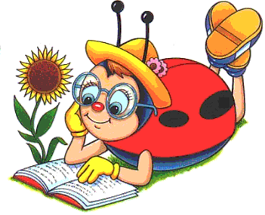
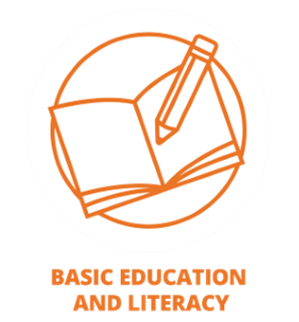
Theme: Helping Adults to Teach Other Adults
Must Complete 5 Different Projects to Qualify

General Ideas and Suggestions:

1. Attend the Seminar in September
2. Show how your club observed Literacy Month in September; March is National Reading Month
3. Make Treasure Boxes, make a “Free Little Library”
4. Place books in a Food Cupboard, Community Center, Laundromat or Homeless Shelter
5. Award Scholarships
6. Give large print books and/or activity books to Senior Centers or Nursing Homes
7. Give to Books of the World
8. Provide School Supplies, Books and Snacks (Back Pack Program)
9. Read to children at a school or library
10. Consult best seller lists/NYT, Barnes & Noble, Washington Post, Book Page, etc.
11. Any other projects or events that your club accomplished or participated in.

_______________________________________________________________________
_______________________________________________________________________
_______________________________________________________________________
_______________________________________________________________________
_______________________________________________________________________
_______________________________________________________________________
_______________________________________________________________________
_______________________________________________________________________
_______________________________________________________________________
_______________________________________________________________________

Name of Club:

_______________________________________________________________________
Contact person w/email:

_______________________________________________________________________

