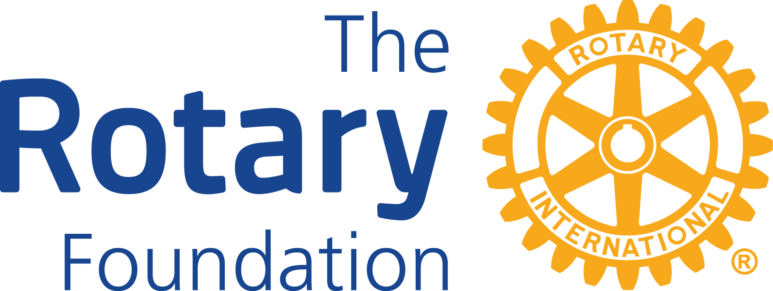

DISTRICT 9705 DISTRICT GRANT APPLICATION FORM
ROTARY/GRANT - YEAR 2024-25

PROJECT TITLE/NAME
(Max 7 words)
ROTARY CLUB NAME

PURPOSE OF DISTRICT GRANTS
- District grants fund short-term (max one year) local or international projects and activities that support the Foundations Mission of ‘Doing Good in the World’.
- Clubs are generally expected to contribute financially to the project in addition to the District Grant Funds. Grant funding is not restricted but usually in the range of $500 to $5,000.
Clubs can use district Grants to fund a variety of activities, including:
- Humanitarian projects, including service travel and disaster recovery efforts
- Community
- Vocational Training of any team size or time span
- Travel costs to and participating in Rotary projects fairs to find project partners
- Scholarships for any level, length of time, location or area of study
Grants should respond to an identifiable community need and align with one or more “Area of Focus”.
Areas of Focus | Select (x) Area(s) applicable
- Peace and conflict prevention/resolution
- Disease prevention and treatment
- Water and Sanitation
- Maternal and child health
- Basic education and literacy
- Economic and community development
- Environment
DESCRIBE THE PROJECT/PROJECT OBJECTIVES (Briefly describe WHAT the Project will achieve)

OUTLINE THE BENEFITS OF THE PROJECT (Briefly describe WHO benefits)

PROJECT BUDGET, AGREEMENT, AUTHORIZATION AND CONTACT DETAILS

Project Funding (Budget) |  | Amount $AUD
- District Grant (funds requested)
- Club Funds (committed)
- Other Funds (pls specify)
Total Project Costs $
Note: Projects to commence after 1 July and be completed by 30 June of the Grant/Rotary Year
Proposed Project Start date:

Estimated Completion date:

Additional Remarks (if necessary add further information below or on a separate sheet)

CLUB AGREEMENT
This Agreement is between the club and the district and acknowledges that the club will undertake measures to ensure the correct implementation of grant activities and proper management of Foundation Grant funds.
Club District Grant Project
Co-ordinator Name (Primary Contact)
Contact Numbers (Home/Mobile)

Email Address

Club President Club President Elect
Name | Name
Signature | Signature
Note: The report should be typewritten, all sections completed. Print application, have your Club President and President Elect sign it, then scan the form and all your supporting documentation into your computer and send electronically to the email address of the Grants Coordinator shown below.
Applications need to be received by 31 May 2024
Send your Application to the District Grants Chair Phil Armstrong at: philaarmstrong@gmail.com
Ph: 0418 259 963 with a copy to District Rotary Foundation Chair: John McKenzie: johnmckenzie9700@gmail.com

Additional Information:
Successful clubs will be advised in writing by the Grants Chair and a copy of the Final Report Form will be attached so Clubs understand what is required at the end of the project before any grant funds can be reimbursed to the Club.

