Our range of Gift cards will enable you or your Club to make a meaningful gift that will help our Rotary Foundation to do good in the world.
The Rotary Club can use the gift cards as a THANK YOU card for their guest speaker.
A Rotarian can use the gift card for any occasion. To receive your gift card, simply make a contribution to The Australian Rotary Foundation Trust and tell us the denomination and quantity of cards that you require.
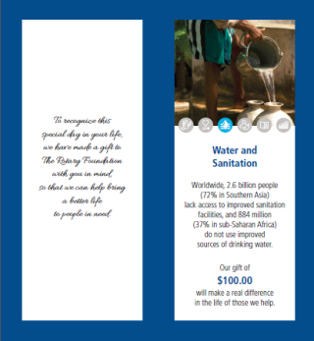

The Gift Cards reflect each of The Rotary Foundation Areas of Focus with a different value for each area of focus – see next page
Area of Focus | Card value | Pack | Contribution | Tick Area
Basic Education and Literacy | $25 | 10 x $25 | $250
Disease Control & Prevention | $50 | 10 x $50 | $500
Maternal & Child Health | $75 | 10 x $75 | $750
Water and Sanitation | $100 | 10 x $100 | $1,000
Economic and Community Development | $250 | 2 x $250 | $500
Peace and Conflict Resolution | $500 | 1 x $500 | $500

First Name………………………………………..………………….Last Name……………………………………………………………………………………
Home Address………………………………..………………………………………………………………………………………………………………………….
State……………………………..Post Code……………………….Country………………………………………………………………………………………
Rotary Club……………………………………………………………Club Number……………………………………..District……….……………………
Personal Contribution, Member Number………………..…………………………………..
Credit Card MASTERCARD ☐ VISA ☐ Cheque ☐
Name on Card ………………………………………………………………………………………………………………………………………………….
Card No:__________/_________/_________/___________ Expiry Date:………………….CVN:……………………………
Signature:……………………………………………………………………….………………………….Date:…………………………………………….
Personal Contributions to The Australian Rotary Foundation Trust are tax deductible
The Rotary Foundation Gift Cards
Basic Education and Literacy – Pack of 10  $25 per gift card |  |  | Disease Prevention & Treatment – Pack of 10  $50 per gift card
Economic and Community Development – Pack of 2  $250 per gift card |  |  | Maternal and Child Health – Pack of 10  $75 per gift card
 |  |  |  | 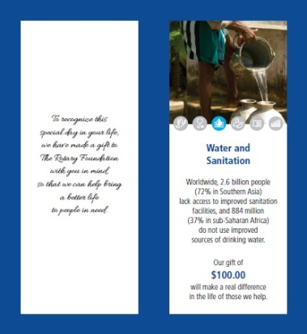
Peace and Conflict Resolution – Pack of 1  $500 per gift card |  |  | Water and Sanitation – Pack of 10  $100 per gift card

