

|  |  |  |
| --- | --- | --- |
|  | **ROTARY DISTRICT 9700 PROBUS NEWSLETTER**  From the Rotary District Probus Chairman  March 2015  ACTIVE RETIREES ***– Tomorrow’s Vision for PROBUS*** |  |

Dear Probus friends,

The month of March will see clubs have their Annual General Meeting (AGM). It may be useful to have the Probus Club Handbook on hand at your AGM to discuss the duties and responsibilities of various Committee Members. It would be recommended that each newly elected officer receive a print out of these duties as their portfolio.

There may be some clubs who will struggle to fill committee positions at their AGM. I ask you to call either me or PSPL to seek further advice as to what options your club has. In the past clubs have simply wound up, however there are other options like amalgamation with another club, re-birthing of your club or changing to a combined club if you are currently in a single gender club.

A lot of work is undertaken to start new clubs and I ask you explore all options by discussing them with either myself or PSPL before giving up on your club.

IT’S NOT TOO LATE TO BOOK….

ANZAC TRIBUTE TRAIN

In April 2015, The Ghan will make a special journey from Darwin to Adelaide.

The Ghan’s ANZAC tribute is a four day commemoration of the efforts of Australian servicemen and women in all major conflicts. A chance to reminisce with mates, make new friends, listen to guest speakers and performers. Learn of the historic links between The Ghan and the Australian Armed Forces. Enjoy the comforts of The Ghan from the privacy of your platinum or gold service cabin while the magnificent Australian outback glides past your window. Bask in the unrivalled splendour and culinary delights of the Queen Adelaide Restaurant and relax in the Outback Explorer Lounge.

Visit: <http://www.probussouthpacific.org/0f56c6cd/An_ANZAC_tribute#sthash.nOo0D3Xz.dpuf>

ACTIVE RETIREESTM MAGAZINE

As your RDPC, recently PSPL provided me with the Active RetireesTM magazine subscription rate for each Probus clubs in the district. Thank you to those clubs that support the Probus organisation by their 60%-100% subscription rate. For those clubs with lesser subscription rates I ask that this decision be re-visited to ensure each member is receiving value for their annual membership fee and that members are kept informed with Probus matters both locally and across our nation. The beginning of the Probus new year is an opportune time to display copies of Active RetireesTM magazine at your monthly meeting and to profile the contents of bi-monthly feature articles, news and competitions.

Probus club members are encouraged to contribute articles and photographs and clubs are encouraged to utilise the magazine as a membership development tool for new members. Active RetireesTMmagazine supports the image of Probus as an organisation which has status, dignity and respect.

ACTIVE RETIREES e-newsletter

The e-newsletter sign up is now live on the PSPL website. Each month our complimentary Active Retirees e-newsletter will feature articles and stories of interest along with special offers.

Invite your members to individually sign up and enjoy the experience. <http://www.probussouthpacific.org/forms/display/newsletter-signup>

PROBUS INFORMATION DAYS

Regrettably no Club in the District has been able to hold a Probus Information Day so far this year. Indeed, as far as can be ascertained, there have been no such Information Days held in the District for some time. This is a great pity, because in the past and elsewhere in Australia and New Zealand, many new Clubs have been formed as a result of spreading the word in this way. PSPL subsidises the activities and I have sent a request in to the District 9700 Rotary Board that they also set aside some funds for a Probus Information Day.

On the plus side, Forbes Men’s and Ladies Clubs will be holding a Probus Friendship day in Forbes on Tuesday 12th May. Recently, Committee Secretary Bruce Howard (ph 02 6851 4414) has sent registration sheets and excellent information on Forbes and district to all Clubs. Forbes is a delightful spot, nestling on the lovely Lachlan River and it has a very interesting, heritage town layout, scenic attractions, including the new Motor Museum, and above all, a magnificent bushranger history from the gold era – actually, in the local cemetery Ned Kelly’s sister’s grave is close to the grave of Ben Hall (to stop you guessing, Frank Gardiner, one of Hall’s better known gang members, is not actually related to me; when you come to the Friendship Day if you ask me I’ll tell you of the close but not that close connection to my side of the family though!).

There will be another Probus Friendship Day in Cootamundra in 2016. Both Forbes and Coota are fairly close to the geographic centre of District 9700 so most Clubs will have to travel less than about 300 kms, which is useful.

PROBUS TRAVEL INSURANCE

Visit the Probus website or call PSPL today to get a quote.



**How to access quote for Probus Travel Insurance**

Visit the Probus South Pacific Limited website to obtain quotes online.

<http://www.probussouthpacific.org/pages/travel_insurance_about_pspl_travel_insurance>

PROBUS CHRISTMAS IN JULY 2015 ON NORFOLK ISLAND:

CHANGE TO PROGRAM DUE TO UNFORSEEN CIRCUMSTANCES

The event is being hosted by Trade Travel who have a great line-up of Australian and New Zealand entertainers booked for your enjoyment - **Normie Rowe**, **Suzanne Prentice, John Rowles** and a **Legends of Rock Night** featuring Buddy Holly, Johnny O’Keefe and Elvis Presley; hosted by rock historian Glen A Baker. We recognise the sad loss of author Colleen McCullough. Colleen’s family have agreed to host an afternoon tea and exclusive tour of her property. *Don’t miss it!*

Contact Trade Travel 1800 034 439 E: [groups@tradetravel.com](mailto:groups@tradetravel.com)

Bottom of Form

NATIONAL PHOTOGRAPHIC COMPETITION 2014 - 2015

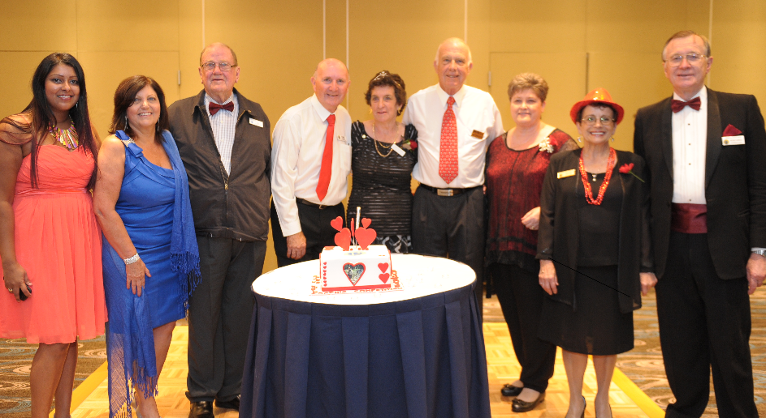Congratulations to Joan Rawson from Probus Club of Upper Yarra (VIC) on winning the first prize for the 2014 – 2015 National photographic competition.

Joan has won a Mediterranean cruise for 2 people to the value of $18,000. Our thanks are extended to Cruise Traveller for their generous prize.

I encourage all Probus club members to get snapping – the 2015-2016 theme will be: **PROUDLY PROBUS** – Friendship, Fellowship and Fun!

The Challenge - anyone can be a winner and maybe it’s time your club started a camera club.

NEW PROBUS PARTNER

WELCOME TO NEW PARTNER

The PSPL Board has approved an exclusive partnership with Covad (pronounced ‘covered’), a web-enabled aggregator of private health cover that enables you to better compare and choose the most cost-effective, private health insurance for your individual needs, from a selection of registered health funds. For more details visit: [www.probus.covad.com.au](http://www.probus.covad.com.au) or call 1300788 467

MESSAGE FROM PSPL

ANNUAL CAPITATION FORMS

Your annual capitation forms need to be returned to PSPL prior to 30th April, 2015 to ensure your correct details are entered in the 2015 – 2016 Annual Directory. The capitation forms were posted in December, 2014; if for any reason you require another copy, please download from the secured administration section of the Probus website or contact PSPL staff.

PRESIDENT KIT

During April your club will receive a President’s kit containing useful information to assist the incoming President in their role.

PROBUS CLUB HANDBOOK

PSPL is in the process of printing the 2015 Handbook. Additional Copies will be available through PSPL for purchase or you will be able to download the PDF file from the secured administration section of the Probus website. Two complimentary copies will be included in the President Kit.

NEWS SNIPPETS

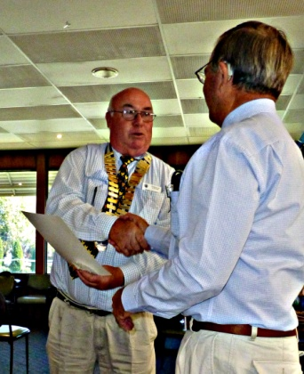Blayney Probus Club recognised their 30th birthday with a truly stellar celebration on Thursday 19th March. More than 50 members, guests and widows of former members celebrated the Club’s 30th Birthday and witnessed President Graham Mendham hand over the Collar of Office to new President Greg Hooper at a superb dinner at the Blayney Bowling Club. **And six new members were inducted.**  In one go this was a membership increase of nearly 20%!

I was honoured to be the guest speaker at the celebratory dinner and I also attended

and enjoyed the Annual General and Changeover Meeting held before hand. This is a Probus Club that really does promote friendship, fellowship and fun!

**Immediate Past President Graham Mendham congratulates new President Greg Hooper**

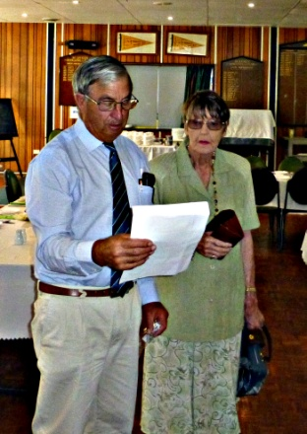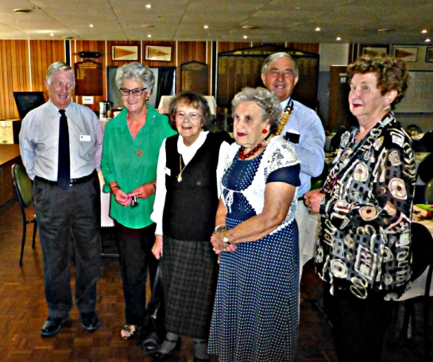Out-going President, Graham Mendham, “celebrates” the closing of his outstanding year by inducting six new members – five in the first round and shortly afterwards one who was unavoidably detained in transit. On the left hand side of the page, but not in order, they were, Robert May, Nola Sparkes, Valerie Bloomfield, Juliet Cook and Norma Patrick, with a proud President Graham standing in the back. On the right hand side of the page are President Graham and new member Betty Radburn. Well done Graham, Secretary Eddie LePoidevin, Treasurer Peter Pollard, and the hard working Committee. Well done Blayney Probus Club!

Congratulations new Probus members all!

******************************************************************************************

PLEA TO ALL DISTRICT 9700 PROBUS CLUBS from RDPC HENRY

One of my roles as Rotary District Probus Chair (RDPC) is to act as a conduit between the Probus Clubs in the Rotary District 9700 and both Probus South Pacific Ltd and each of the individual Clubs in the District. Because the District extends from Henty in the south west, way past Leeton and Griffith to Hillston in the north west, east past Peak Hill to Molong and Orange to Bathurst, then and back to the south west around Boorowa, Wagga and all the other Clubs in between down to Henty again, I need information and your good news to spread to all. The District covers three or four distinct geographic and economic regions and unless I can put info, especially photographs, in this periodic *Newsletter,* our Probus members in, say, Henty just do not get to hear the great news from, say, Hillston, Manildra, Temora, Forbes and so on (and vice versa!). Club *Newsletters/Bulletins* are the best way to let me know so that in turn, I can pass it on.

******************************************************************************************

SPREAD OUR MESSAGE: GENERATE MORE MEMBERS: FORM NEW CLUBS: TRY MEETING TIMES AND ACTIVITIES

Pease extend the hand of friendship to others in the community who may not have as yet experienced the True Spirit of Probus. In the meantime, continue to enjoy the benefits of Probus by focusing on the many avenues of fun, friendship and fellowship in our organisation. Please feel free to contact me on 0417 223 539 should you need any assistance in this.

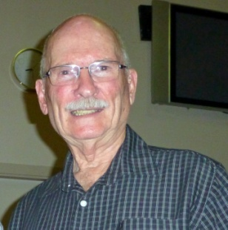Probus is truly the social club of choice in retirement – *enjoy!*

Until my next *Newsletter,*

RDPC Henry

02 6922 3539; 0417 223 539

[henrygardiner@bigpond.com](mailto:henrygardiner@bigpond.com)

Box 692 Wagga Wagga 2650

**PROBUS is PROUD to be A Community Service Activity of Rotary Clubs.**