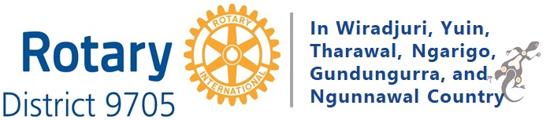

District 9705 EnviroClub Awards

Application Form
Rotary Club Name

Name of 2022/23 Club Envoy
Name of 2022/23 Club President
Date application submitted
Project No. | Project Name  (Over 12 months to 1 May 2023) | Project Leader
1
2
3

Project No 1 - Name of Project

Project Description (200 words max, 11pt text)

Project Impacts | Information
Community consultation

Club Member Engagement and Involvement

Effectiveness and impact

Beneficiaries

Communication

Lessons learnt

Project No 2 - Name of Project
Project Description (200 words max, 11pt text)

Project Impacts | Information
Community consultation

Club Member Engagement and Involvement

Effectiveness and impact

Beneficiaries

Communication

Lessons learnt

ADD EXTRA PAGES FOR MORE PROJECTS – ONE PROJECT/PAGE

