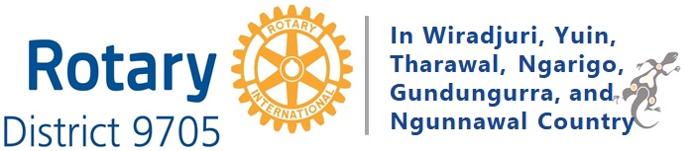

District 9705 EnviroClub Awards

Year 1 - 2022/23

Project Ideas for Clubs

Here are just a few of the many ES project ideas for your club to consider:

Biodiversity
- Participate in tree planting events
- (District-wide) instigate a programme in conjunction with a scientific or conservation organisation to conserve endangered Australian biota within the District.
- Encourage schools to work together, for example, students from a secondary school could assist children from a primary school to plant trees in parks or bushland reserves. Such activities are best done in coordination with the relevant local government ES department.
Circular Economy
- Collect unwanted clothes, toys, or household goods to donate to a Rotary opportunity shop
- Organise a clothing swap day
- Get involved in the Return and Earn Scheme and partner with a group to collect plastic bottle caps and transport these to a recycling centre
- Collect unwanted hospital or school equipment and ship these to needy communities in Australia and overseas
Climate
- Install renewable energy systems in schools or community centres in developing countries Support projects that build water tanks for homes in developing countries
- (District-wide) support LGAs to equip EV infrastructure in regional centres
- Work with a local school to support students to monitor the energy performance of their school or assess its carbon footprint or to measure its water usage
Food Security
- Build a vegetable garden at your local school
- Sell bee friendly plants at local markets and encourage support for bees and other pollinators. Celebrate World Bee Day.
Pollution
- Organise a major clean-up of a beach or creek and involve the local community.
- Participate in annual Clean Up Australia events
Sustainability
- Conduct community/club seminars on contemporary environmental issues, such as recycling or the use of plastics
- Organise or participate in a community environmental festival (perhaps as a cluster project)
- (District-wide) develop a District-wide model for managing sustainability fairs.
- (District-wide) establish a promotional platform for key environmental speakers, to raise broader community awareness.

Go to the ESRAG or ESRAG Oceania websites for more ideas:
www.esrag.org
www.esragoceania.org

