GG2099775 Melusi “Phela Hantle” Project
Progress Report – December 2021 report
“Time and health are two precious assets that we don’t recognize and appreciate until they have been depleted.” – Denis Waitley

This month’s report hosts a special feature article written by Dr Edith Mntla, from the University of Pretoria’s Community Orientated Primary Care Unit, celebrating World AIDS Day in Melusi the 1st of December 2021. Read the details in the newsletter attached at the end of the report.
The program activities and interventions continued to support maternal and childcare. Themes for December complimented the theme for World Health AIDS. Topics discussed with patients included:
* Encouraging testing for HIV, TB and COVID_19
* Reasons to be vaccinated against COVID_19
* What do to when I test + for COVID – how and why should one isolate?
* Adherence to treatment if I test HIV+
* Universal precautionary measures to protect myself against sexually transmitted diseases

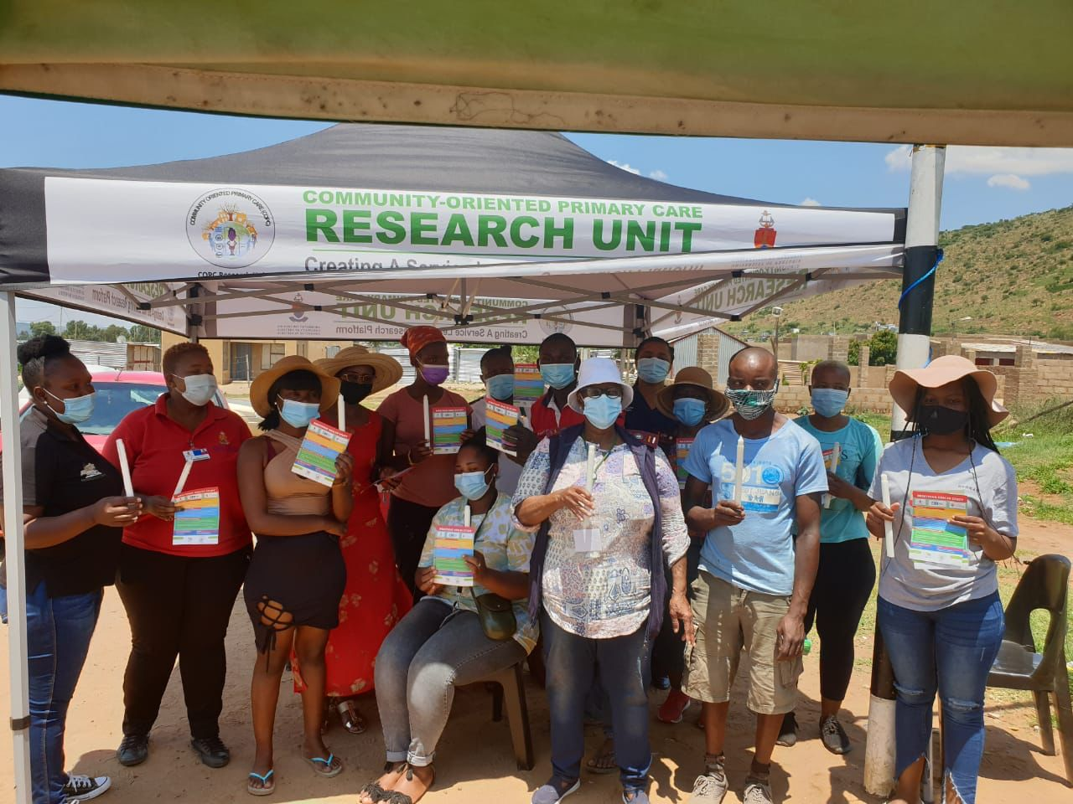
021-22 President: Shirley Downie | Vice President: Hans Mostert
President Elect: Charlotte Khoza | Treasurer: Carolyn Khoury | Secretary: Mbali Simelane

Rotary Club ID number 85613 | 165-703 Non-Profit Organisation
PO Box 709 | Fontainebleau, 2032
Web:www.rotaryeclubsa9400.org

Total Number of Direct Beneficiaries

Primary health care consultations and dispensing of medicine were offered at no cost to 93 patients on site in Melusi. 476 patients were screened within the community for Covid symptoms. The Melusi Clinic became a registered Covid-19 vaccination site in September and vaccinations continued during December. 7 patients were tested for Covid; 4 tested positive. For more details on the patients seen please view the attached COPC Gauteng Province summary statistical report for Dec 2021.

A total number of 35 health professionals representative of various organizations working in the community attended various health and nutritional educational sessions linked to community interventions, including the special health day on 1 Dec. During Nov a nutritional and oral health research and dietary intake assessment and support program that was approved by the University of Pretoria’s ethics committee commenced, this is focused on children and the assessment and support of children <5 continued in December.

Number of Maternal and Child Health Professional’s Trained

Patients were educated in groups as they were seen at the clinic (93). The educational sessions were facilitated by environmental health officer, Rebaone Molebatsi, for the community health workers and patients, and by Marion Beeforth for the nutritional interventions. Dr Edith Mntla took the lead on the inter-disciplinary health day for World Aids Day on 1 December. The CHWs were expected to visit high risk families or patients at home before the close of the program for the year end and Christmas.

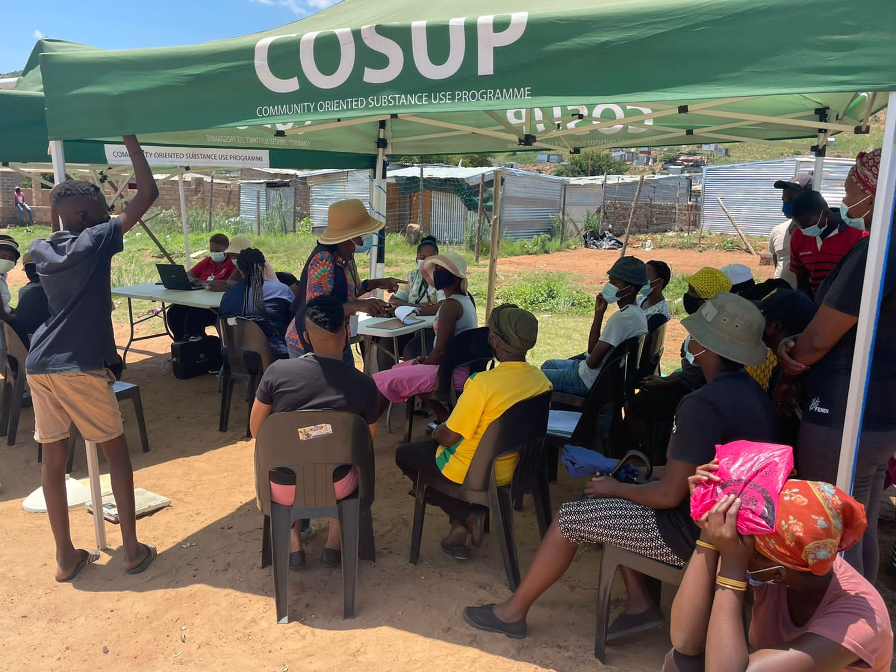

Image of patient education on HIV and preventative measures

Thirteen (13) community health workers and ten (10) fieldworkers were trained weekly within the community and as part of the weekly team meetings. The focus was on supporting the learning activities as part of the CHWs service-learning activities within the community. The theme for the month of Dec continued preventative care education with a focus on sexually transmitted diseases and more specifically, HIV.

16 Teachers from all 15 early learning centers in Melusi and MYDO NPO graduated as qualified ECD (early childhood development) teachers in December. A wonderful milestone for the Global Grant as this will empower thousands and thousands of children over time with quality early educational interventions. The excitement of the teachers to receive a validated qualification is immense. This ECD course is accredited through the University of Pretoria and a training program offered by Judea Harvest Non-Profit Organization. The course includes certification as an ECD teacher and a curriculum. In the local context most of the teachers have never been trained formally and this opportunity will have a major impact for the 240 children currently enrolled in their early learning centers.
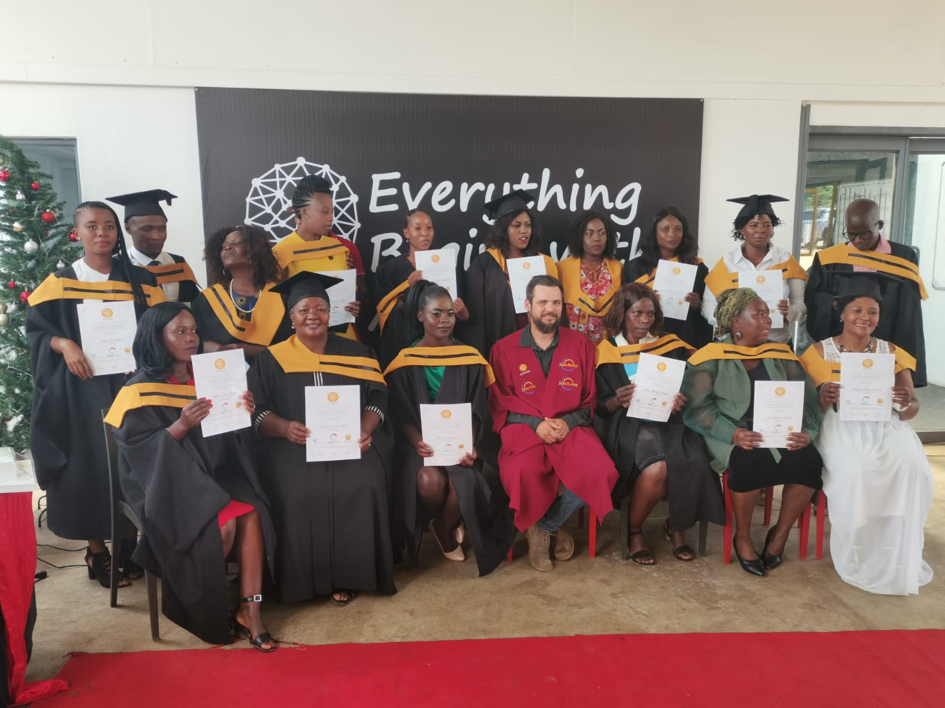
Graduation ceremony of the principals/teachers for the Melusi early learning centres

Number of mothers receiving ante-/post-natal care

44 (forty-four) patients received contraceptives within the Melusi community at the health hub. Pregnant mothers that are identified on site are referred for ANC (ante-natal care) to the nearby Daspoort clinic that has more services and resources.

Nutritional Status Assessment and Interventions

Fourteen (14) children consulted for a clinical condition and were assessed for their nutritional status at the health hub. Two hundred and forty (240) children <5 received micro-nutrient supplementation at early learning centers in Melusi for December before the schools closed. Daspoort Poli-clinic is the referral clinic for Melusi patients to receive childhood immunization. Nutritional assessments and interventions for children continued at the early learning centres.

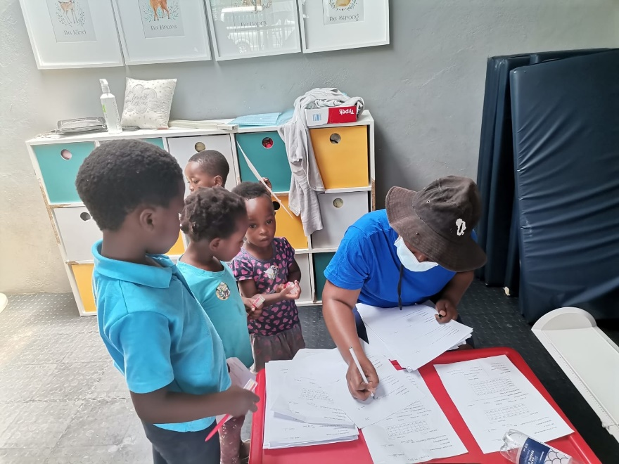

A community health worker records the anthropometry data, names and date of births from consent forms while children await their turn to be measured at Regae Day Care Centre

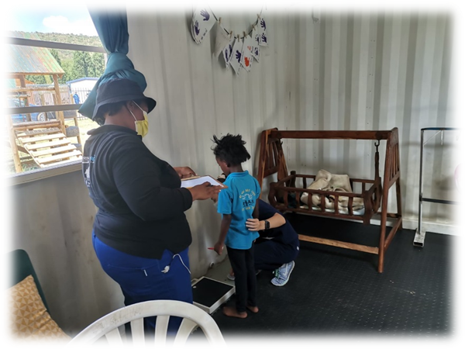
Anthropometric data collection recording by community health workers at the
pilot school Regae Day Care 29 November 2021

The nutritional interventions at the early learning centers are also used as a learning opportunity for students. Dietetic students had the opportunity to improve on their techniques as Covid_19 limited student practical exposure opportunities. Dentists and dietitians, students and community health workers collected dental and anthropometry data on the 29^{th of} Nov. Data collection continued 6-8 December 2021. 7 Community health workers and a dietitian student and a dietitian improved their anthropometric skills. Data analysis of the children under 5 years for the first round of data collection is summarized below.
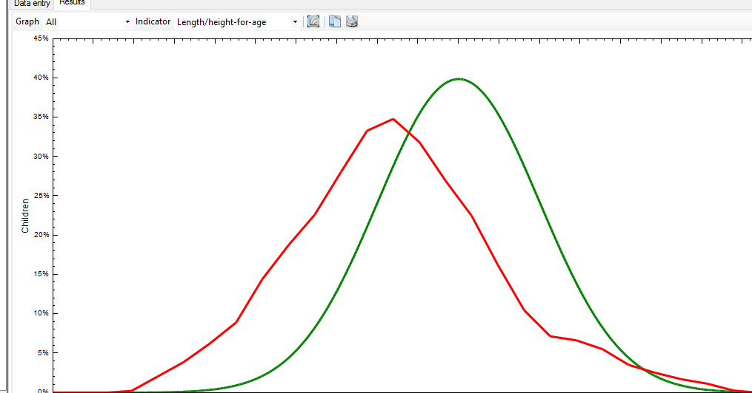

It is visible from the graphs that the weight for age, height for age and weight for heigh indicate that (n=31 children under 5 years) Ragae pre-school has a lower median than the normal distribution curve.

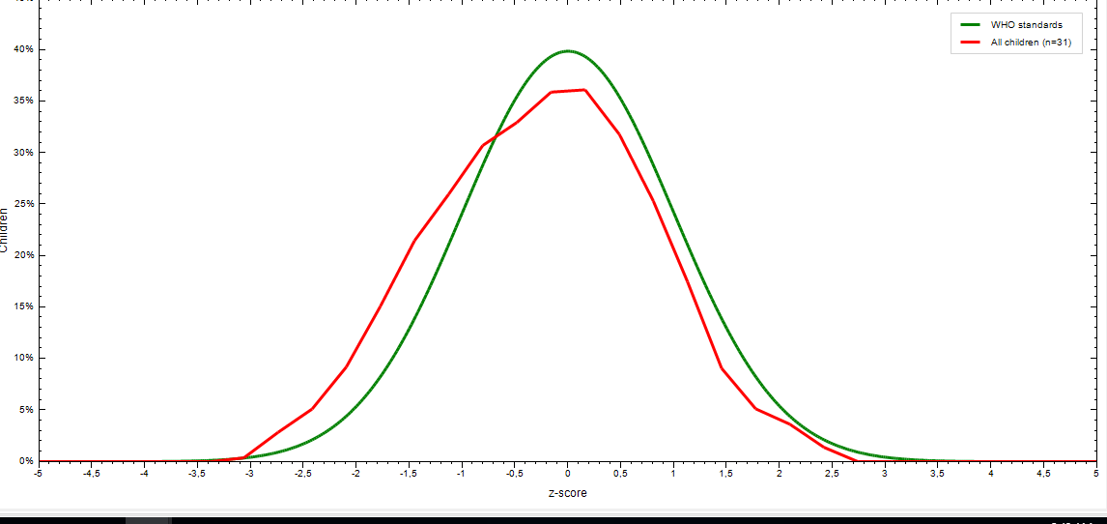
Weight-for-height (n=31 children under 5 years

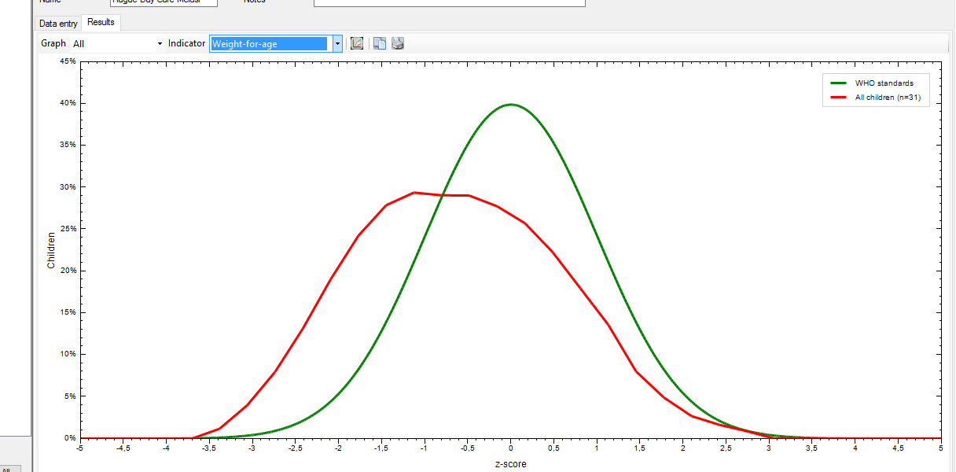
Weight for age (n=31 under 5 -year olds)

Anthropometric data is analysed at baseline and again at 6 months and 1 year to evaluate growth of children

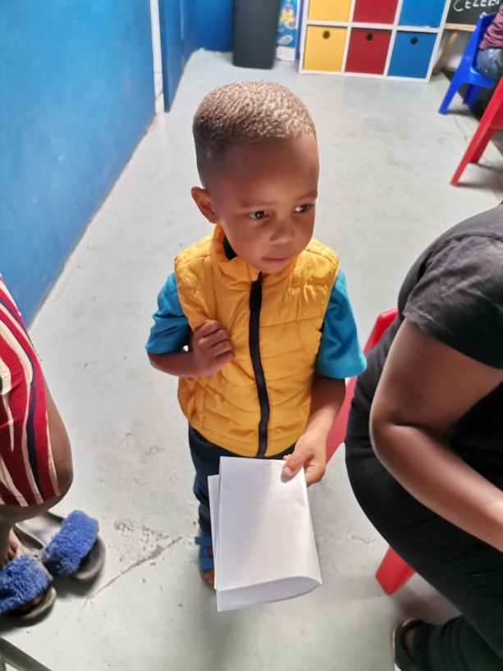

A child returns his dietary recall form with the parents being interviewed to ensure data was recorded complete

The first cooking demonstrations for the local residents to address food insecurity and malnutrition with on-site practical sessions commenced on 15 December. The Melusi Global Grant purchased a training centre and kitchen space that was placed the end of last year. The final component of the grant will also pay for the refurbishment of the kitchen to have quality on-site education continue after the grant has ended.
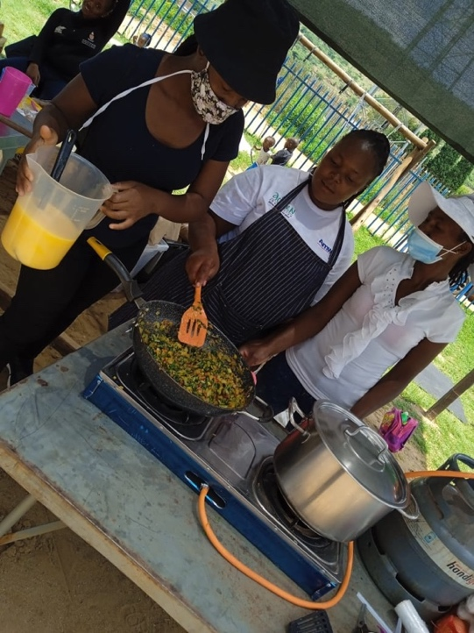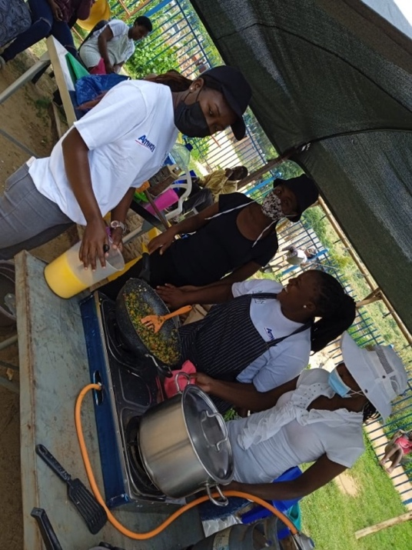
All parents whose children were still at school and who participated in the research were invited for a lunch preparation practical session
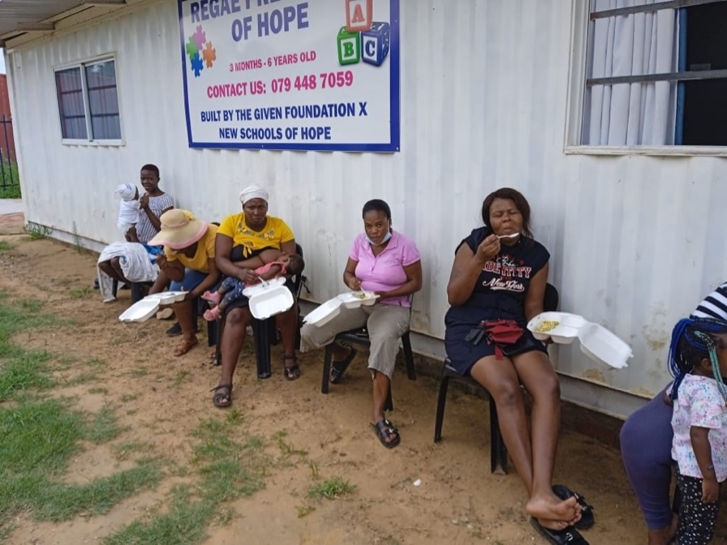

Parents, both mothers and fathers had positive feedback and discussions about the recipes
(15 mothers and 1 father attended together with 7 community health workers)

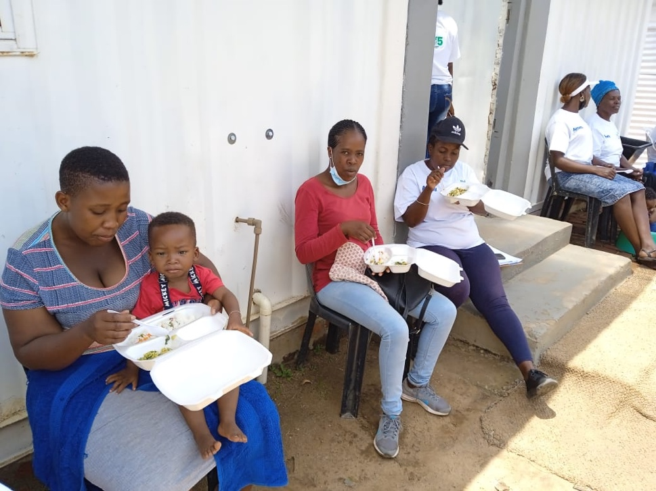
Egg fried rice was served with a pilchard potato dish.

Nutritional education on a diverse diet including daily vegetables daily and how to increase protein content of one’s diet.

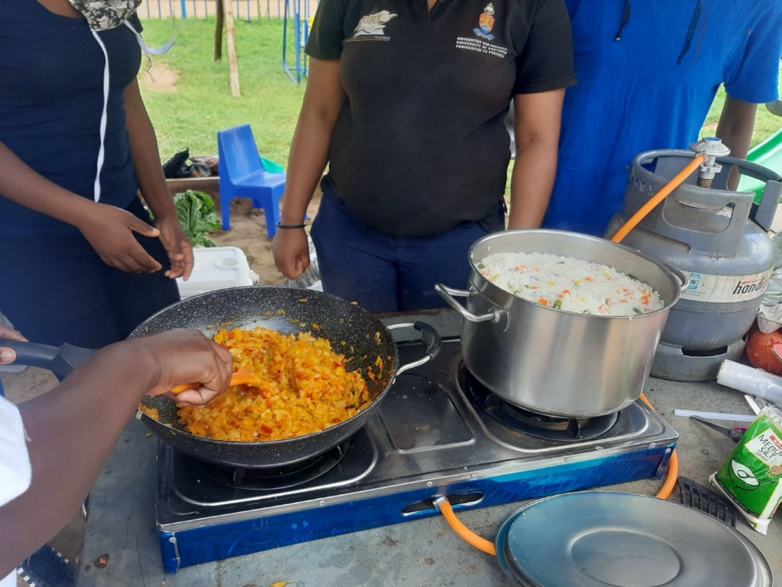

Mothers, community health workers and dietetic students and professionals actively engaged and discussed the different options of preparing this recipe

A step by step tutorial on how to prepare the meal

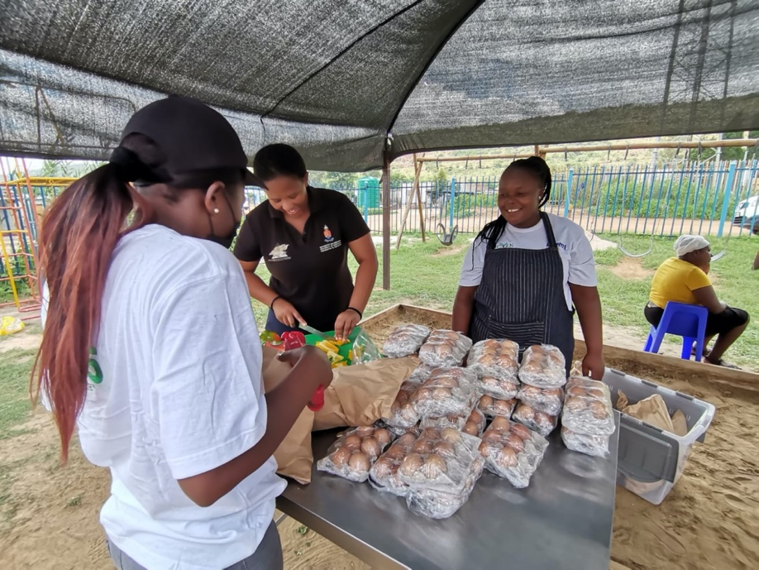

Community health workers prepared the vegetables and made the recipe in a bag hamper for the mothers to take home
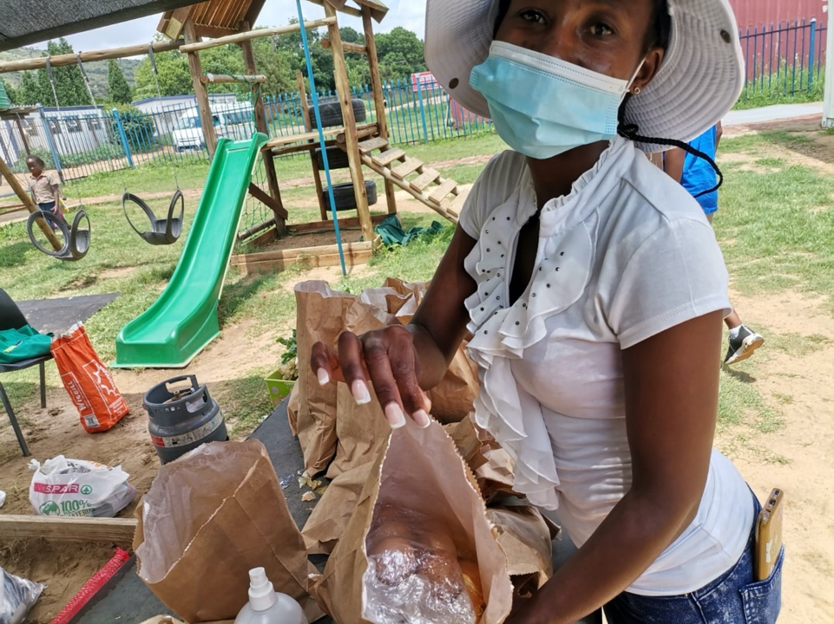
Each mother received 6 eggs, 2 mealies, green beans, tomato and onion as a recipe in a bag to reproduce at home

At the end of day children each received a toy from the LIONS INTERNATIONAL Toy drive. A second workshop was held just before Christmas on the 21st of December.

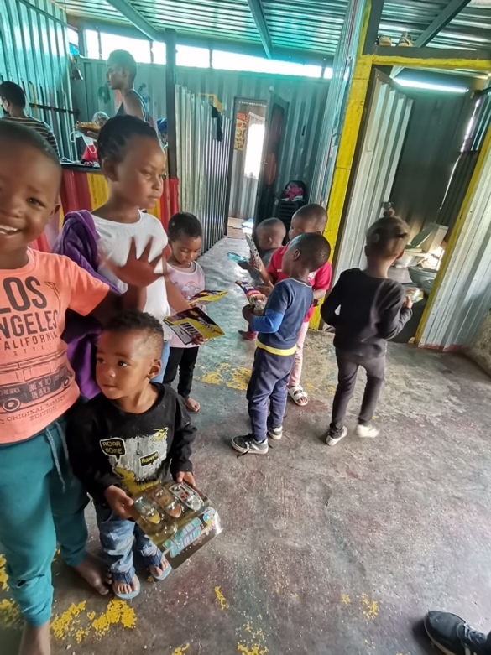
Each child received a gift sponsored by LIONS international

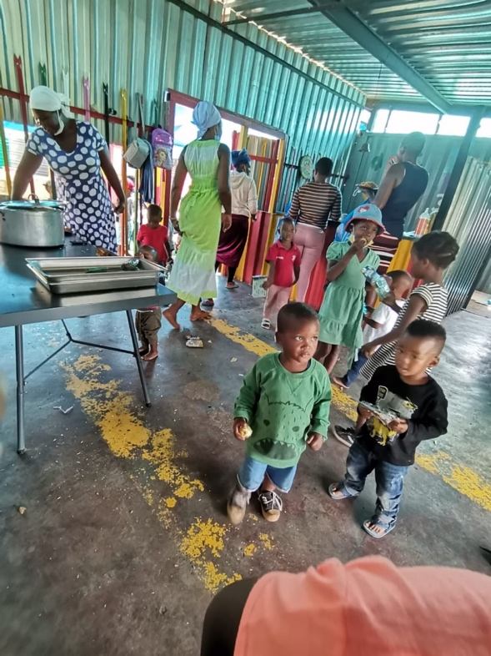
Three of the mothers helped cooking the recipe, while one mother put the recipe in bag hampers together and 3 mothers peeled the potatoes. Each child received a Lions International Toy drive toy. 40 children were present at the creche.

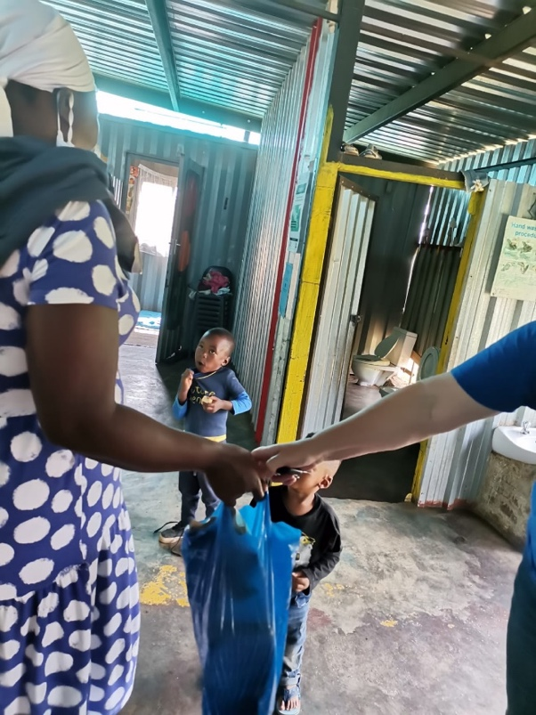

Each mother received a tin fish, three eggs, some tomatoes, potatoes and a brown bread onions, green beans and apple to make recipe at home.

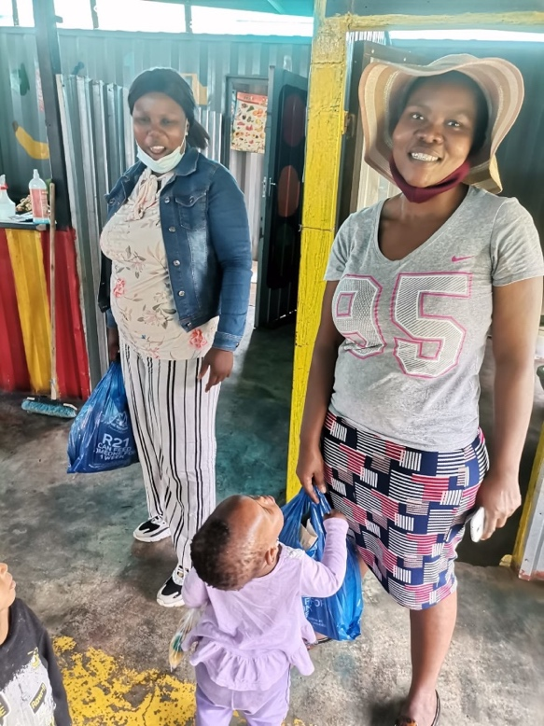

The mothers and children enjoyed the day and participated actively – Happi Sappi demonstration differed from Ragae as it was at the end of the year mothers were involved in the demonstration and the community health workers were already on leave.
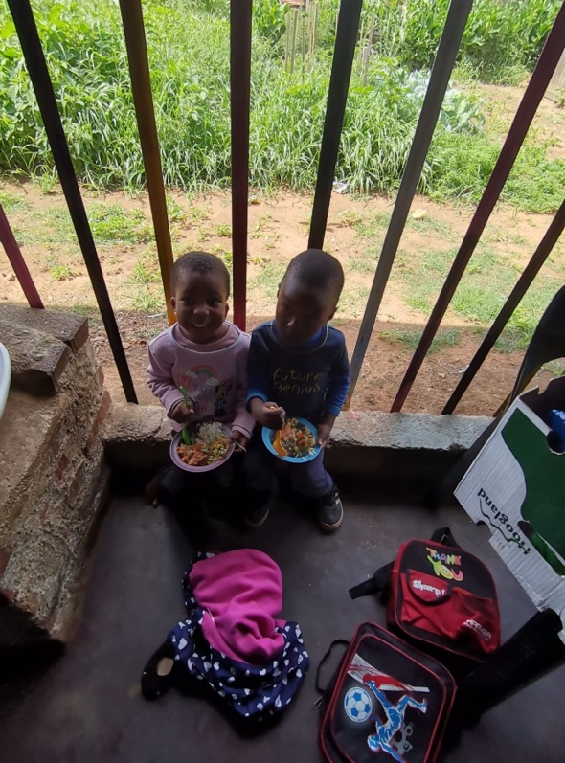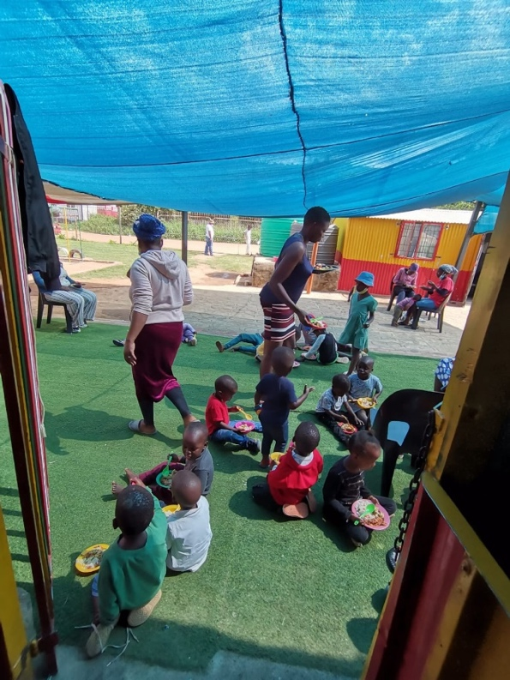

Children enjoyed the meal of pilchards and potato stew and also egg fried rice and vegetables.

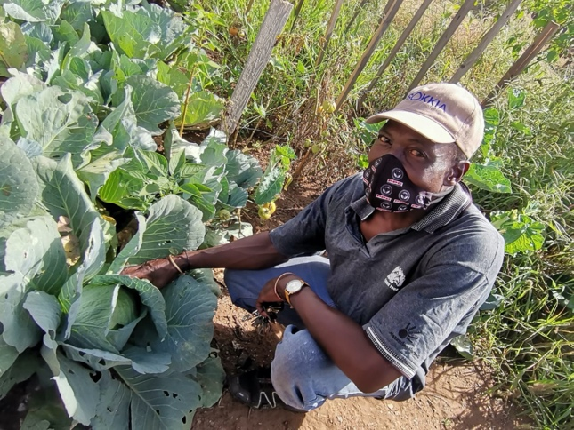
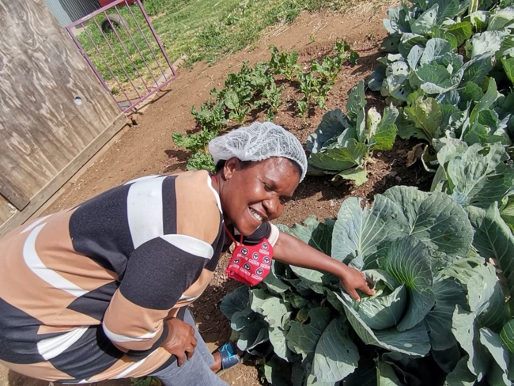

Mr and Mrs Skosana are very proud of their vegetable garden at the creche and Mrs Skosana says the teachers and children benefit as she cooks and also send home with teachers.

Two children were also assisted getting new road to health cards as theirs were water damaged. One child referred by community health workers to assist with food supplementation – foster care application in process, but women gets no support to care for child.

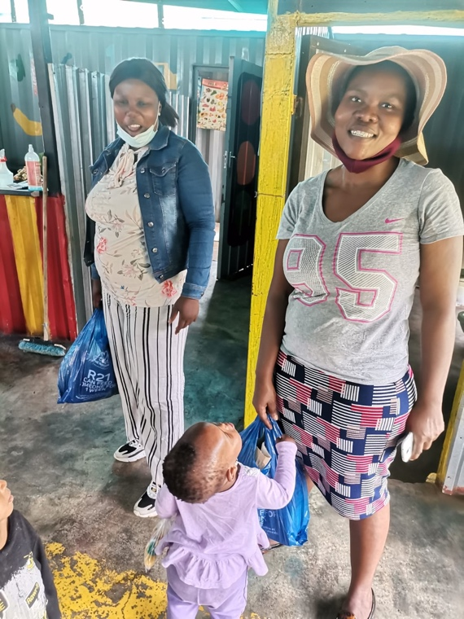
A wonderful end of year for the Rotary Grant, making a difference to those that need it most!
World Aids Day campaign in MELUSI – 1 December 2021
The UP SAPRIN Team held a World Aids Day event in Melusi on the 1st December. This was part of a World Aids week drive around informal settlements, in collaboration with Wits RHI. It included a pop-up vaccination station, HIV/Aids screening, counselling and testing, HIV/Aids and health education talks, as well as information and distribution of material on on-going research studies conducted by the COPC Research Unit. This report will however focus on the Melusi day only.
The station was popped up on the open sports field at Melusi 3, due to an unanticipated turn of events that had necessitated that the pop-up session be held at the Melusi clinic the Monday before, alongside the normally busy clinic service. 3 gazebos with COPC RU branding and a SAPRIN banner, provided the only shelter from the hot sun at the pop-up station. Various sub-stations were set up under the gazebos for clients to progress along the queue for Covid-19 vaccination. On the particular day, WHRI had another assignment and could not collaborate. However, the COPC team made up for it by doing an HIV/Aids health education and information session, as well as holding a small HIV/Aids candle lighting ceremony. The strong wind made it impossible for the candles to stay lit, but the event went ahead despite.
When the Head of CE visited the site, the team consisted of the COPC RU Registered Nurse, Sr Mulalo, with 2 sessional others, the Informal settlements coordinator, Ms R Madzivhandila and 4 CHWs, some of whom underwent HIV/Aids training in November 2021. Apart from health education on HIV/Aids, there were others on chronic diseases, the importance of visiting the clinic for both adults and children for various health reasons, the current Covid-19 positivity rates and importance of vaccination. They were also informed of the various current projects being undertaken by the Research Unit and its partners, and urged to open their doors to field teams when they visit. Pamphlets on the SAPRIN study and Respiratory Health study were handed out, content explained and community members addressed about the importance of participation. They were reminded of their leaders (with some saying they did not know them) and the role they played in linking up the Research Unit with the community for the latter’s benefit.
A total of 55 community members were vaccinated on the day, 11 of whom were foreign nationals. 7 of the 55 were minors under the age of 18. The Marketing and Communications Support Officer, Rochelle, was there to capture the event and communicate it on UP’s and the Research Unit’s websites.
The CAB meeting planned alongside ended up being held virtually with only the leaders of the 3 main community structures: Director of MYDO (local NGO), and the chairpersons of the Action Group and SANCO group respectively. Project posters and pamphlets were handed out and some left at the clinic to be picked up. These are tools requested by the leaders to assist them in addressing their constituencies about the Research Unit’s projects. These materials are expected to come in handy when leaders have to respond to community members’ queries about the Unit’s research projects.

In conclusion, the day went as expected, save for the venue change, which disrupted attendance of CAB members due to a breakdown in communication and/or transport inconveniences. A number of members live proximal to the Melusi clinic, and the sports ground is a driving distance away. The vaccination attendance was far more than any other pop-up session held before, due to the fact that this part of Melusi is generally far from most services and therefore took advantage of the opportunity presented by the occasion. From a community engagement perspective, this presented a sought-after opportunity to engage directly with community members apart from interacting through their leaders, a rare occasion in the context of the covid-19 lockdown.

Dr E Madela-Mntla (Senior Lecturer and Head of Community Engagement)
13 December 2021

