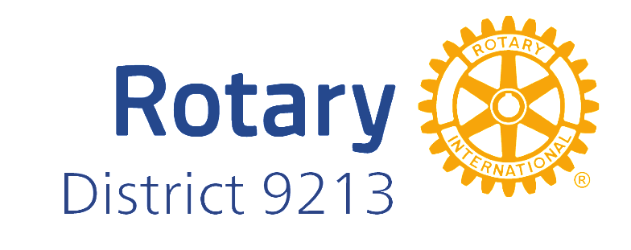

**PERCEPTIONS OF ROTARY IN UGANDA:**

**A PUBLIC IMAGE SURVEY REPORT**

**INSERT HATCHILE CONSULT LTD LOGO**

**INTRODUCTION**

This report presents the findings of a public image survey of Rotary in the Greater Kampala Metropolitan Area (GKMA), which includes Uganda’s capital and the neighbouring districts of Mukono and Wakiso. GMKA has the highest concentration of Rotary clubs in the country.

The survey was conducted by the polling firm Hatchile Consult between from 7th to 14th June 2024 in randomly selected urban, peri-urban and rural enumerator areas following a random selection of 2,000 adult residents from 200 enumeration areas, proportionally allocated across the study districts. The selection was based on the 2014 census household count as the measure of size. The survey was conducted through the SurveyToGo platform, enabling real-time data checks and quality control.

Respondents were asked, "What do you think of when you hear the term Rotary or Rotary Club?” The question was also translated into Luganda, the mostly widely spoken language in the region.

The question on perceptions of Rotary was embedded in a larger survey on democracy, gender and political participation.

**FINDINGS**

**Knowledge of Rotary**

Although a slight majority of the respondents had a perception or awareness about Rotary, nearly half of them (49%) expressed ignorance about the organisation.

**Knowledge of Rotary by Gender**

A higher percentage of men (58%) expressed awareness about Rotary compared to 45% of women. Conversely more women (55%) said they did not know about Rotary.

**Knowledge of Rotary by District**

Perhaps not surprisingly, Kampala returned a higher percentage of respondents (56%) with knowledge of Rotary while the more rural Mukono district retuned the smallest percentage (37%).

**Knowledge of Rotary by Education**

The findings show that the more educated the respondents, the higher the likelihood that they had some knowledge about Rotary. For example, 80% of respondents with a postgraduate degree and 79% with post-secondary or university education expressed an opinion about Rotary. On the other hand, only 35% of respondents who had not attended school and 34% who had only informal schooling or had completed primary school had some knowledge of or awareness about Rotary.

**Knowledge of Rotary by Age**

It appears that older Ugandans are more likely to know about Rotary than young people. More than half of the respondents aged 30 and above expressed an opinion or awareness about Rotary, with those above 50 returning the highest percentage (57%).

**Perceptions of Rotary**

A significant number of respondents (44.84%) associated Rotary with charity work and helping the less fortunate. “Rotary is an organisation that helps the needy,” said one respondent. “They support community projects and provide aid to the poor," said another. Others said:

* "An organisation that builds schools and provides clean water to communities."
* "They are heavily involved in charitable activities."
* "An organisation that donates blood."

However, an equally significant number of respondents had misconceptions about Rotary, with 6% associating it with “entertainment”, “enjoyment” or drinking. One respondent, echoing a few others, associated Rotary with "drinking alcohol and dancing overnight."

Another 5% associated Rotary with betting or gambling. It is possible that could have been a result of the wrong pronunciation of Rotary as “lottery”.

Four per cent of respondents associated Rotary with the rich or wealthy. A number of respondents said Rotary is “a club for rich people” while one said it’s “a place where rich people enjoy their money.”

Others associated Rotary with political influence (1.87%) and savings groups or cooperatives/Saccos (1.87%).

Some of the wilder misperceptions of Rotary, included the following:

* “To change power and governance.”
* “Kiboko/tear gas.”
* “A group of old, rich people.”
* “A group of people who are mistreated.”
* “A political organization.”
* “Illuminati.”

**CONCLUSION**

The perceptions of Rotary within the Greater Kampala Metropolitan Area are diverse, ranging from positive associations with charity and community service to more negative or misinformed views, such as associating Rotary with elitism or gambling.

It appears that a very big part of the population does not know about Rotary. Awareness levels vary significantly by demographic factors, with higher education and age groups showing greater awareness of Rotary.

Given that this survey was conducted in a mostly urban and peri-urban area, it is likely that there is even less awareness of Rotary in more rural parts of the country.

The findings highlight the need for Rotary to engage in targeted communication and outreach and efforts to correct misconceptions and broaden understanding of its impact within the community.