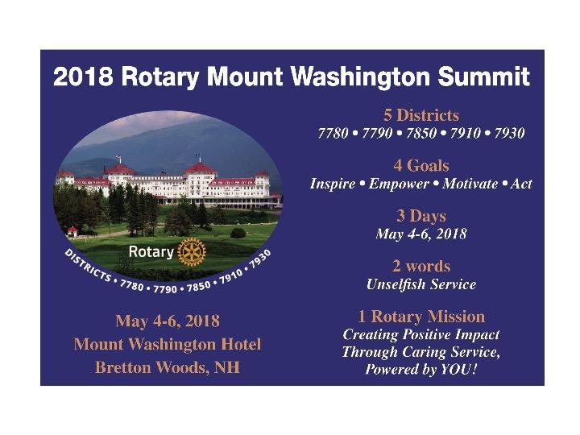
October 23, 2017
Registration is now open for the
2018 Rotary Mount Washington Summit!

Home page link: http://2018rotarysummit.org

Registration link: http://2018summit.org/sitepage/2018-summit-registration

Fellow Rotarians, we look forward to being with you at this exciting and historic event! Join over 500 Rotarians from Maine, Massachusetts, New Hampshire, Quebec and Vermont, at the beautiful Mount Washington Resort on May 4-6, 2018. Registration is now OPEN. Here’s what you need to know:

Three easy steps to register:

Step One: Summit conference events will take place in the Omni Mount Washington Resort, and you have several options to choose from for lodging that vary in price and amenities. The Omni Mount Washington Hotel is considered the “Main” hotel and there will be complimentary shuttle vans throughout the Summit connecting the main hotel to the Bretton Arms Inn and the Lodge. The Bretton Arms Inn and the Lodge both have lower pricing options available.

Step Two: Choose your Conference Package. This includes all meals from Friday evening through Sunday morning (for the full package) or shorter time frames at lower costs. The full adult package price of US $300 per person and does not include your hotel room. Children’s pricing is shown as well.

PAYMENT AND TERMS: The first $200 of every registration is considered a non-refundable deposit to secure your registration. Full payment, including hotel charges, must be made before March 1, 2018. In addition, if you are reserving a room, you will need to select the add-on hotel-lodging deposit of $200 to secure the room you will be choosing in step three. Be sure to write down your confirmation number; you will need it in step 3.

Step Three: Choose Your Hotel (Main hotel, Bretton Arms or Lodge) if you wish to book a hotel room. All rates are in $US, double occupancy per night and include taxes.

We greatly prefer credit cards. You may pay by check before December 31, 2017, if you prefer. All payments after January 1, 2018 must be made by credit card. Reservations not guaranteed by credit card (or by a check received within thirty days of the initial reservation) may be canceled. All bookings after March 1 must be paid in full immediately by credit card, and as of March 1, all bookings are not refundable.

Room blocks and waitlist:

Part of what makes this Summit unique and valuable is the opportunity to spend time with Rotarians from other Districts. To facilitate this, please be aware that during this EARLY registration period, a limit has been placed on how many rooms each district can reserve. We simply took the amount of rooms and divided them evenly. For this reason, you are likely to get a message that hotel rooms are not available to you and will ask if you would like to be on a waitlist.

Say YES to the list. We encourage you to say yes and to select your preferred hotel. As registration continues, some districts are likely to release excess rooms and we will fill waitlist requests in the order in which they were received, likely sometime in January and February. We will work to accommodate every request, and we reserve the right to reallocate rooms.

Act now!

This is going to be an historic event, and action packed (follow us on Facebook, Instagram and Twitter for up-to-the-minute announcements). We anticipate high demand for this event, and we hope you will join us. We believe the Summit will reach capacity, and we want to make every effort to accommodate the wishes and needs of Rotarians from across our five districts, so plan early and register today!

If you have questions, please contact:

District 7790 District Governor Lincoln Ehrlenbach, lehrlenbach@gmail.com

Summit registrar Louisa Tripp, 2018summitregistrar@gmail.com, 802-371-9819

