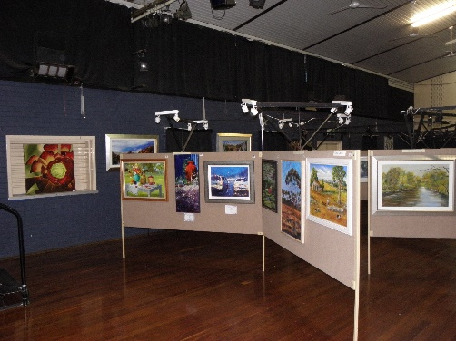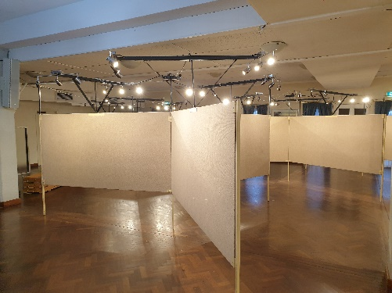
ART DISPLAY BOARDS FOR HIRE
The Pinjarra Rotary Club has a range of custom-made art display boards for hire – the funds raised are used on charitable causes in the Murray Shire and beyond. There are two types of boards – “star” boards and free-standing “flat” boards.
Each star consists of three 2.4 m wide x 1.2 m deep with 0.6 m floor clearance arranged in a star pattern (120 degrees to each other). There are 10 stars available – giving 30 boards – 60 sides – for display purposes. Additional free-standing flat boards are 1.8 m wide x 1.2 m deep, with 0.6 m floor clearance. There are 9 flat boards – 18 sides – for display purposes. The boards are lit by an overhead lighting system, and as the sides of each board are carpeted, art can be hung from self-tapping screws.
Hire costs depend on the number and type of boards, the length of the hire period, and the distance from Pinjarra to the display location. The Rotary Club will arrange delivery, set-up, dismantling and removal of the boards to suit the client. We are happy to supply these boards anywhere in the South West of WA, and further by individual negotiation. We regularly attend as far south as Busselton and Collie, to the Perth metropolitan area, and have been as far north as Morawa.
Each hiring is individually calculated, but as a rough guide, a star with lighting costs $180 per week. A free-standing board with lights costs $60 per week. There is a minimum delivery charge of $300 for the whole consignment – this charge varies with distance and the number of vehicles needed to transport the boards. There is an overall minimum hire cost of $500.
For more information, or to arrange the hire of art boards, please ring or e-mail
Don McClements – 08 9537 6568; 0448 882 730; mcclements@bigpond.com or
Geoff Hayward – 08 9582 2951; 0400 112 096;The Alcoa-Rotary Club of Pinjarra Annual Art Show and Sale is open to the public and is held on June long weekend each year from 10am-4pm at the Civic Hall, Pinjarra Road, Pinjarra. Entry is by donation, and subject to covid regulations. For further information go to https://pinjarraartshow.org/home

