Rotary Projects Timor-Leste East (RPTLE)
7th July 2021
20” Sea Container out fitted with SkyHydrant water filter and two internal rectangle water tanks
It has taken us awhile dealing with project management from afar, travel restrictions, Covid 19 lock downs both in Australia and Timor-leste and the devastating floods in Dili Timor-Leste but we are getting there.
Credit must go to Brother Adriano and the Students of The Don Bosco Technical Training Centre in Comoro, Dili, for completing our very first water container, now supplying approximately 10,000 litres of clean filtered potable water, daily to the students and the local community of the Don Bosco Comoro complex of approximately 1,000 people.
We at Rotary Projects Timor-Leste East (RPTLE) could not have completed this major worthwhile task without the support of all of you working together with Rotary clubs from NSW, Victoria, and Western Australia.
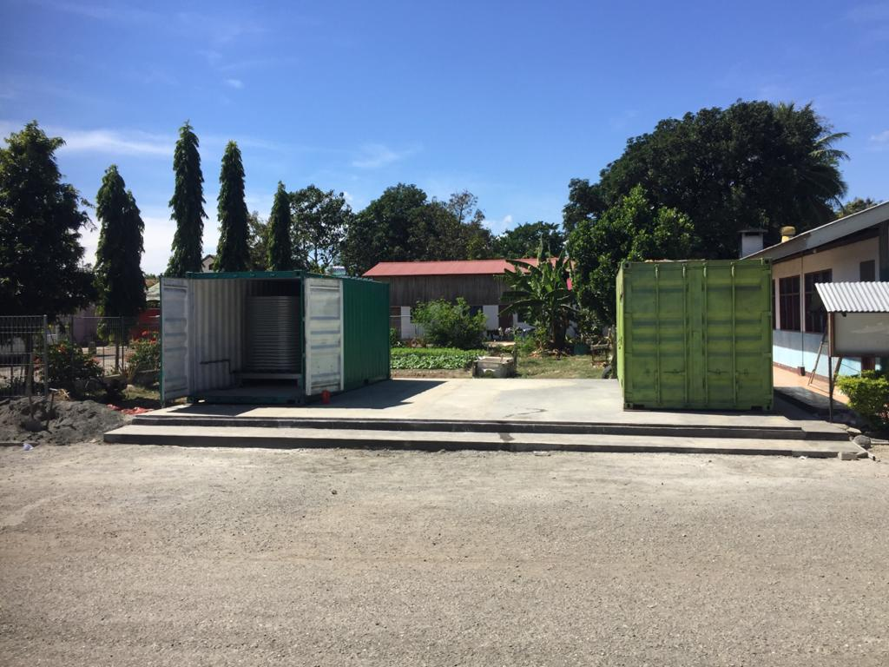
New Pad constructed for the container and work is under way again outfitting the unit

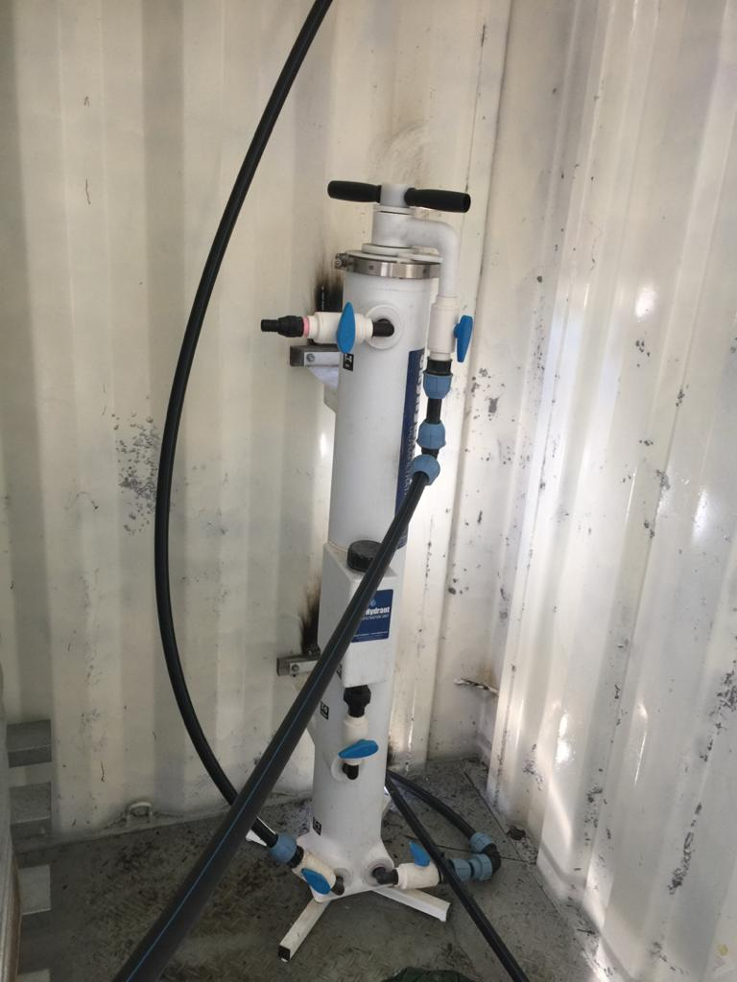
SkyHydrant Water Filter

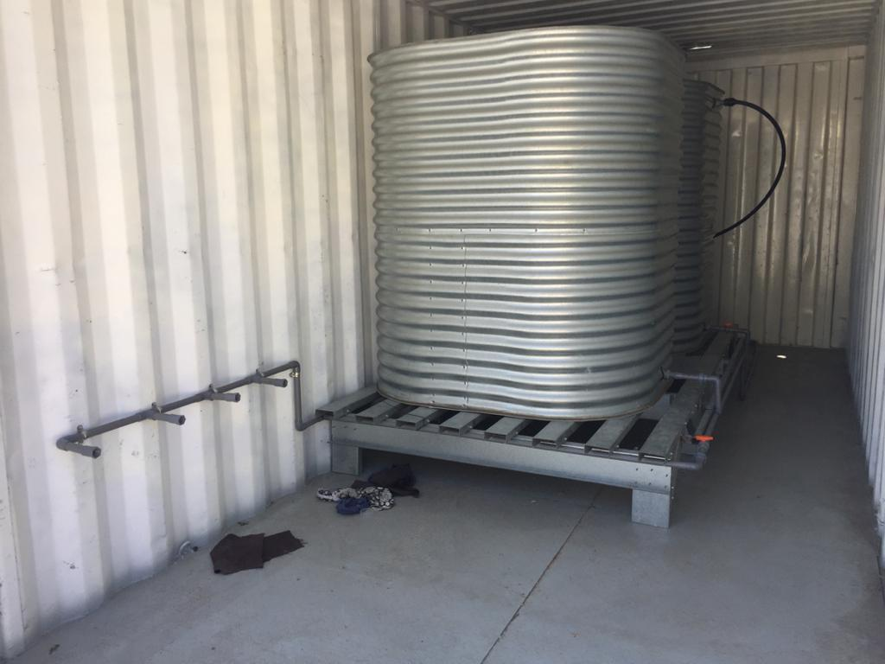
Two 3,000 retangle tanks inside the container

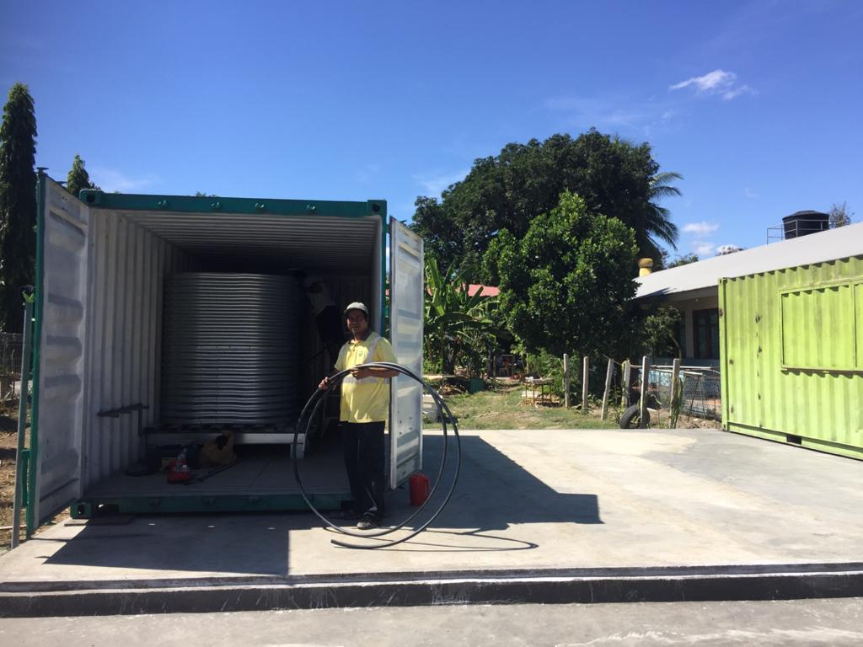

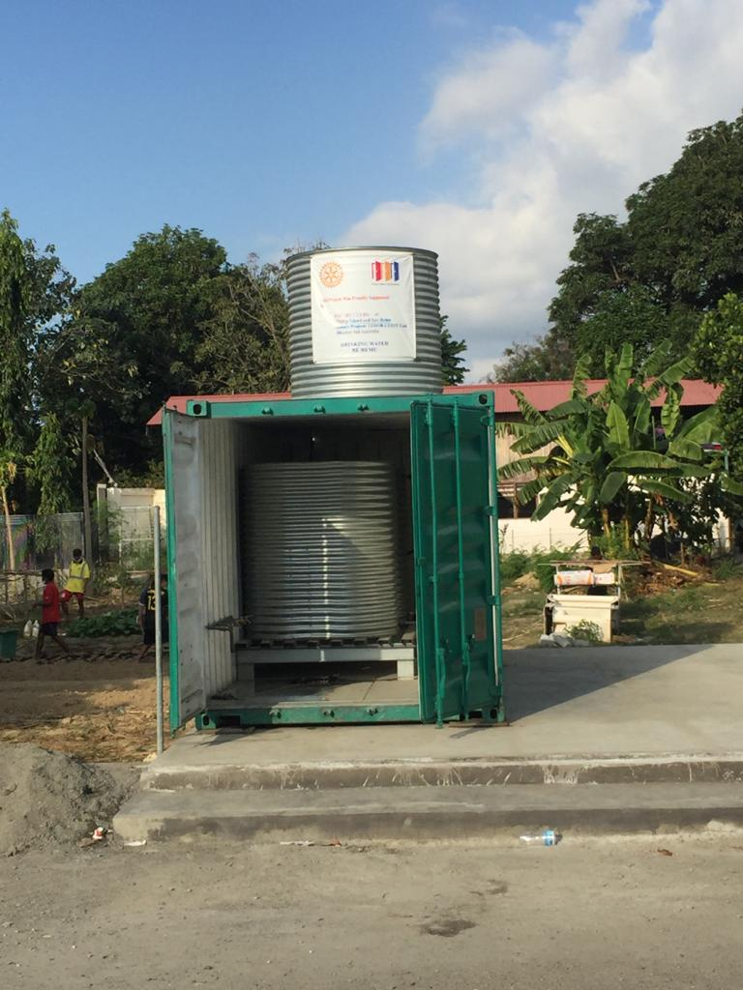
Outfitting the Container

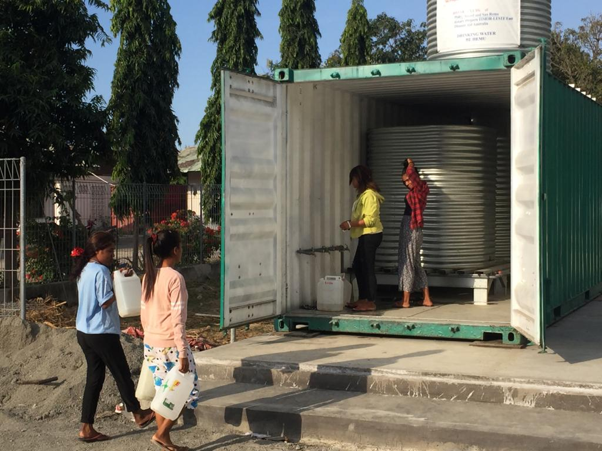
Hurry up we need our water too

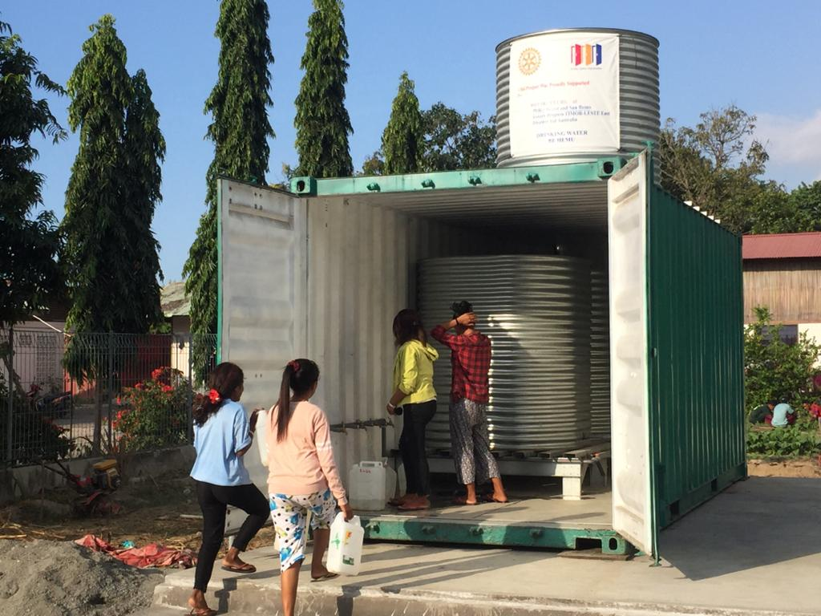
Okay our turn

Credit must also go to Duncan Hedditch from the Rotary Club of Phillip Island and San Remo in Victoria, who, not only designed the unit, but also had the construction drawings prepared. This allowed the Students of The Don Bosco Technical Training Centre in Comoro Dili Timor-Leste to follow the plans during the construction phase.
Thank you to both Duncan and Brother Adriano and his students, and just as importantly all the Rotary Clubs that have made this possible without any Foundation funding.

Again, I say, “Thank You All”, on behalf of the Timorese People

Now let’s start the next task.

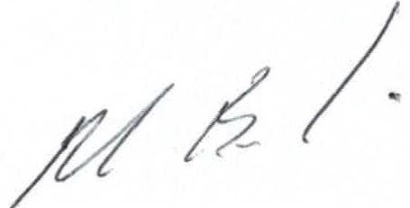
Max Bird
Project Manager for Rotary Projects Timor-Leste East
President Rotary Club of Kwinana Club 2015-17
Kwinana Rotary Club International Manager
Mobile +61 (0) 419045835
E-Mail maxbird@bigpond.com

