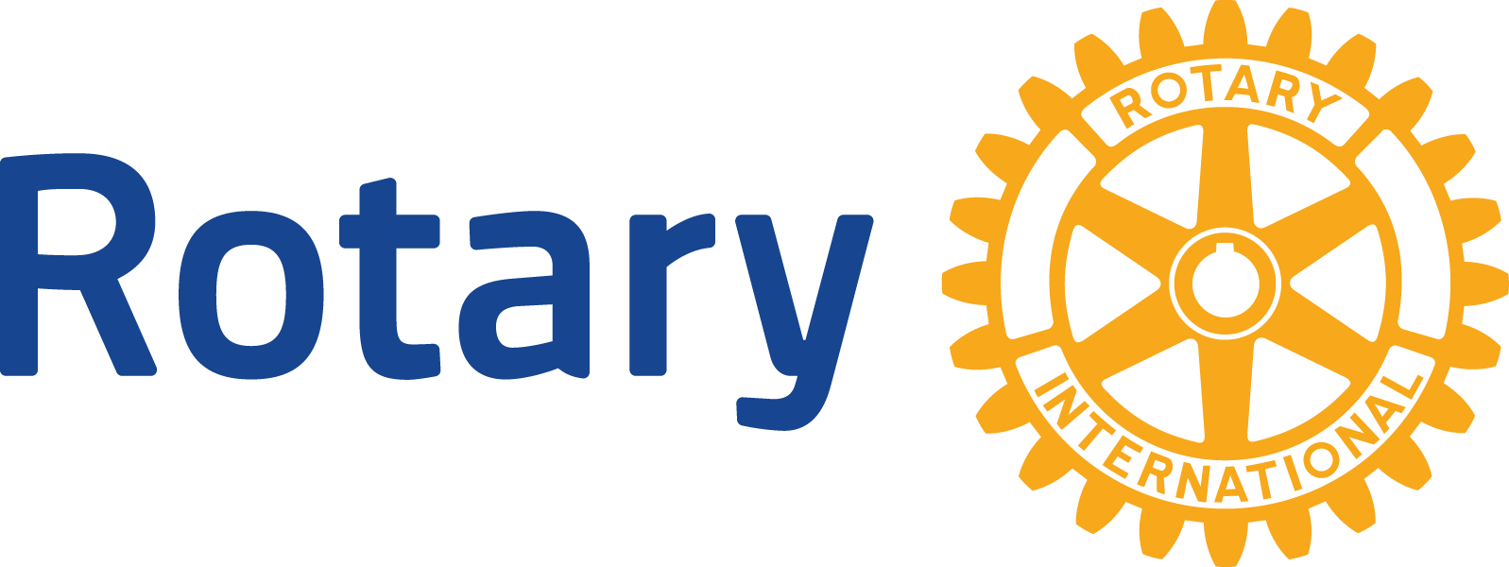

NEWS RELEASE
Headline
(optional subhead)

(City/Town) (Date) —

LEAD:
This is the first paragraph of your release and is as important (or more) than the headline. The news team will decide whether or not to cover your news or read further at this point.

Your lead should have the most newsworthy parts of your story. One helpful hint is to think about how you would tell a friend about this project/event/etc. Then work some details into the first paragraph.

Try to incorporate some (not all) of the 5 Ws 1H (who, what, why, when, where, how) into your lead.

Ideally, your lead will only be about 25 words. Keep it short and sweet.

Details can be weaved into the rest of the release. Try to move from the most important details to additional facts and then some background info.

BODY OF RELEASE:

This is where you’ll explain details for the event. You could even add quotes from your club’s president or the group you’re working to help.

BOILERPLATE INFO:
This is one more way to tell a reporter about your club. It’s a sentence about your club or Rotary International that could be used every time. The paragraph below is the one to be used to describe Rotary International.

About Rotary
Rotary brings together a global network of volunteer leaders dedicated to tackling the world’s most pressing humanitarian challenges. Rotary connects 1.2 million members of more than 34,000 Rotary clubs in over 200 countries and geographical areas. Their work impacts lives at both the local and international levels, from helping families in need in their own communities to working toward a polio-free world. For more information, visit Rotary.
###

Contacts: zxzxz zxzxzxzx (phone/email)

