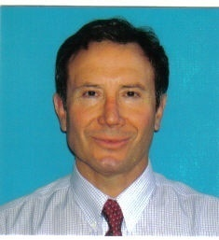

Team Leader
JORGE ANGEL SANTECCHIA
Civil Engineer – Master of Business Administration
Sponsored by Rotary Club Cordoba
ingjorgesantecchia@gmail.com

I am 51 years old. I was born in Cordoba and I still live here. My family consists of my father, my sister, my brother and my sister in law. I have one niece.
I studied at the National University of Cordoba and I got my degree in Civil Engineering in 1985. Then I studied at the Catholic University of Cordoba and I got my MBA degree in 1995.
I am part of a family-owned construction company and I am the general manager now. I am in charge of new projects and studying and planning works. Our main areas of work are road engineering, waterworks and infrastructure works for agricultural companies.
I joined Rotary eighteen years ago because thus I can contribute to Humanity by working with individuals from all over the world. Rotary is an amazing institution.
In my free time I enjoy outdoor activities like trekking and mountain-climbing. I took part in the Rotary’s Expedition to the Aconcagua, the highest mountain in the Americas. We climbed it in 2005 on the 23rd of February and from the summit (6.962 meters), we celebrated the first century of Rotary International. I do martial arts too.
I am proud of having been chosen as a team leader for our exchange and think it will be an unforgettable experience for me and the team. My topics of interest are Rotary topics, drinking water, Wisconsin's culture and traditions, construction equipment, alternative energies and engineering softwares.

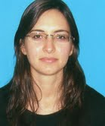

Team Member
MARIA EUGENIA VALDES
Bachelor’s Degree in Environmental Chemistry and Technology
Sponsored by Rotary Club General Bustos
mvaldes@fcq.unc.edu.ar

I am 28 years old and I grew up and currently live in Córdoba. I studied and got my Bachelor's Degree in Environmental Chemistry and Technology at the National University of La Plata (Buenos Aires). Then I started my PhD studies at the School of Chemical Sciences at the National University of Córdoba. I am in the third year of my thesis research which is focused on the main city river pollution caused by human pharmaceuticals and the effects to native fish. I also teach practical classes to first year students at the School of Chemical Sciences, one of the things I enjoy the most.
My family is from Cordoba. I have an elder brother who is currently working with my mother at her vegetarian restaurant “Sol y Luna”.
In my free time I practice English and take dancing and musical comedy lessons. I enjoy spending time outdoors in contact with nature and traveling to different places.
I believe this exchange would be a great opportunity to improve my professional and personal skills. I expect to meet professionals working in my field and also in other areas of my profession. Moreover, I hope to visit typical places of Wisconsin and share time with people from this district to understand American culture and share some Argentinean traditions.

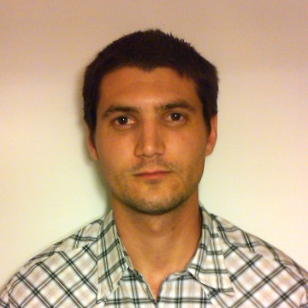

Team Member
PABLO BRESSANO
Civil Engineer
Sponsored by Rotary Club Las Varillas
chanobressano@gmail.com

I am 27 years old and I’m from Las Varillas, but I have lived in Córdoba since 2003 because I studied Civil Engineering there. I graduated in 2010 and after a few months I started to work for the government of Córdoba, at the Water Resources Secretary.
At the moment, I live with my younger brother Martín so we have to do everything at home; cooking, cleaning, keeping things in order, etc. My parents and my older brother live in Las Varillas, 160 kms away from Córdoba. I usually go there at the weekend. I enjoy spending my time with them and my new niece Paz. I really like doing sports. I play soccer, basketball and paddle regularly. I love music; I have a CD collection and I go to concerts whenever I can. I also like reading and writing.
I would really love to vist Wisconsin to learn about a foreign culture, make relationships with people from another country and show them Argentinian things. I would like to visit historical and famous places. I think this program could increase our knowledge and personal experience, and develop our sense of responsibility, education, friendship and make us better people.
I want to know different ways of working in my professional field. It interesting for me to visit a public office, to learn about rules of water protection, treatment of public lands and learn about hydrological and hydraulic softwares.

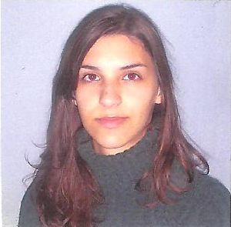

Team Member
MARIA LUCRECIA PAOLINI
Chemical Engineer
Sponsored by Rotary Club Ideas Unidas Bell Ville
lucreciapaolini@hotmail.com

I am 27 years old. I live in Cordoba city now but I was born in Bell Ville, a small city in the South East of the Cordoba Province. I have a very nice family: my parents, a brother and my boyfriend.
I love travelling and reading in my spare time.
I am a chemical engineer and I am currently working in a Thermoelectric Power Plant. I am the person in charge of the chemical area in the maintenance of the plant.
I love my work and every day I am more interested in learning new things.
One of the reasons why I chose to study Chemical Engineering is my great interest to know in detail how the products that surround us are created and managed.
I participated in a university work and travel program exchange in Seattle (USA) for four months in 2006 that confirmed my interests in working with people from different countries, practicing English and sharing experiences with a family who welcomed me so warmly.
I think that the GSE program is a great opportunity to open my mind not only in my professional training but also in my personality. I’m looking forward to travelling to the USA representing my country and exchanging my personal experience with people from other culture.
All the experiences I've added over the years and the ones that will come in the future are part of my vocational training and personality.

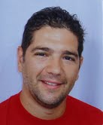

Team Member
DIEGO MAURICIO ALMADA BONFIGLI
Pediatrician
Sponsored by Rotary Club Jesús María Guanusacate
diegoalmadab@gmail.com

My name is Diego Almada and I´m 39 years old. I´m from Córdoba, a great city in Argentina. I studied medicine at the National University of Cordoba, the first founded in the country (1613). I’m a specialist in pediatrics and I work as a director in the area of Public Health in Jesus María, where I live. Jesus María is a town of 35,000 inhabitants located 50 km North of Cordoba.
I’m married to Eugenia; she is a pediatrician like me. We have a beautiful daughter, Paula; she is 2 years old. I like literature, sports and I love my job. In my free time I enjoy playing soccer, tennis and practicing outdoor activities. Life, knowledge, affections and dreams are very important to me.
The aim of this stay in the U.S.A. is to learn ways of technological development and health management, in order to apply them in my work and thus improve the quality of life of my fellow citizens. But above all I expect this time to be a real cultural exchange where I can share my experience and learn about the others’.
I am very happy and immensely grateful for this unique possibility. I hope to give back as much as Rotary gave me in this opportunity.

