On the morning of April 8, 2012 the Group Study Exchange team arrived from Rotary District 9820, Victoria Province, Australia. You can follow their blog at: rotarygse9820.wordpress.com
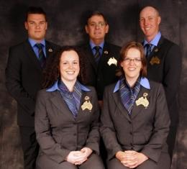
Identification left to right: back row-
Tim Bartle, Jeff Smallacomb, and Allen Van Kuyk;
front row- Lauren Caldwell and Mufanwy Kathleen Guay
Our team left on March 4 and returned back to Wisconsin on April 7.

Identification:
back row- Alexis Billings, Stacy Osten and Colleen Hahn;
front row-Jenny Knuth and Catherine Zimmerman
You can follow their adventures at: www.RotaryDownUnder2012.wordpress.com

