District 6270 Website – Contents Overview
What Information can you find on the District Website?
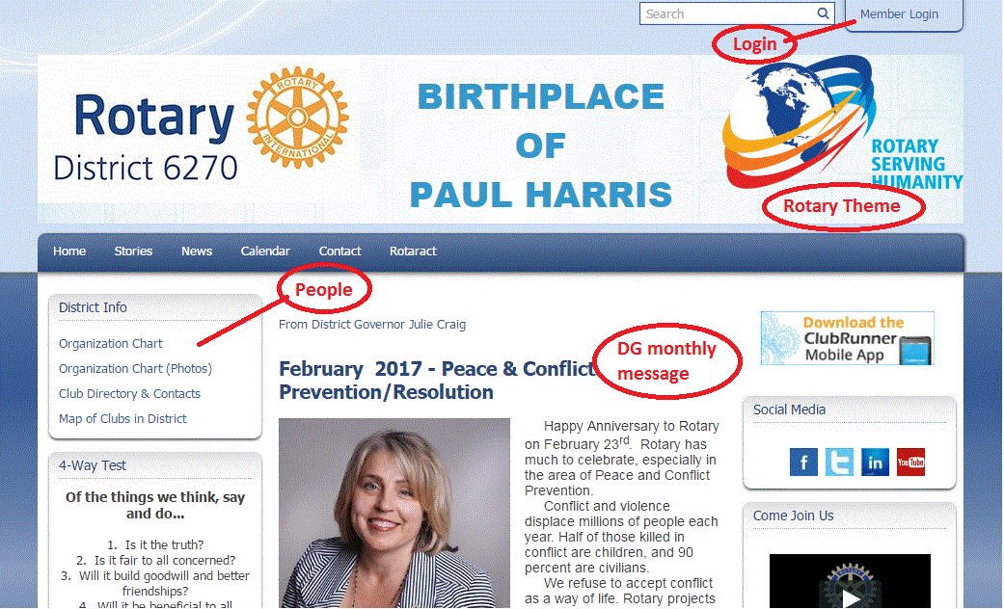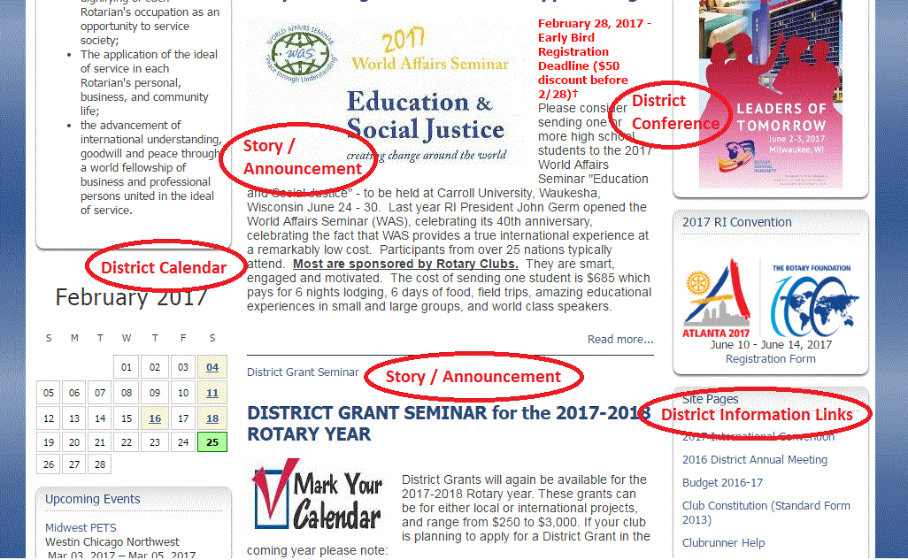
Header Menu: Links to portions of the site
People  - Org. Chart  - Directory  - Clubs/Map | - DG Monthly Message  - Announcements  - District Activities  - Stories  February 2017 – Peace & Conflict Prevention/Resolution Month  World Affairs Seminar Early Bird Registration Deadline – Feb. 28  Club Treasurer’s Webinar – March 7 @ 6:30 pm  District Grant Seminar – April 6  District Grant Applications Available | Links to: Vendors, Social Media
 |  | Video
 |  | District Conference
 |  | RI Convention
4-way test  Object of Rotary |  | Site Page Links:  - 2016 District Annual Meeting  - Budget 2016-17 D6270  - Club Constitution  - Clubrunner Help  - Council on Legislation 2016  - District Directory 2016-17  - DG 2019-20 Forms  - DG Club Visit schedule 16-17  - District Manual  - Fellowships  - Financial Reports  - Forms  - Foundation 101 (intro)  - Friendship Exchange 2017  - Grants – Rotary  - Group Study Exchange  - Insurance  - Interact/Rotaract  - International Serv. Comm.  - Membership Minute  - Minutes – District Meetings  - Newsletters  - Paul Harris  … etc …
District Event Calendar (including club events)
Upcoming Events
Link to: The Rotarian
Other Links:
- Club Locator
- CSRYE Youth Exchange
- District Support
- EClub One
- World Affairs Seminar
- Rotary Wisconsin
- Global Grant Scholar
Suggestions, Questions, Comments?

