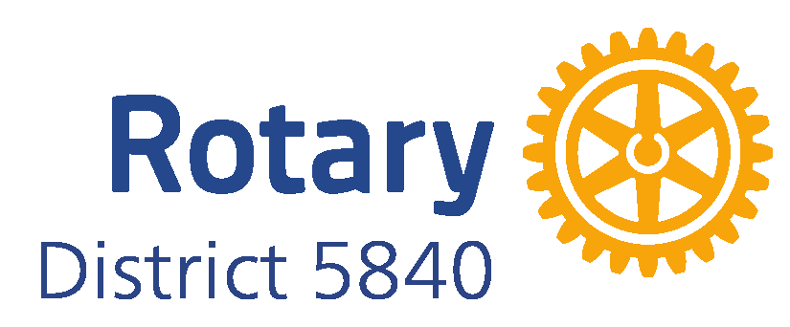

Qualification of Clubs
- Clubs must be qualified
- Ensure attendance at Grant Management Seminar by the Club President in the year grant awarded
- Sign Memorandum of Understanding (MOU)
- Sign the Addendum to the MOU
- Sign the Club Financial Management Plan
- Sign the Club Misuse and Mismanagement Plan

Attend: Grant Management Seminar
Download and Execute: Club Memorandum of Understanding (MOU) including the Addendum, Club Financial Management Plan, and Club Misuse and Mismanagement Plan

