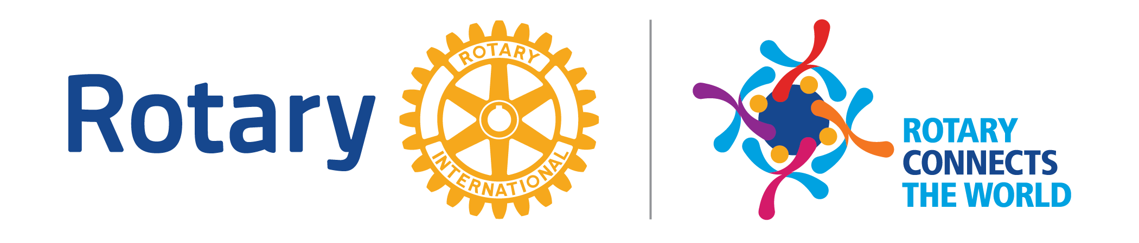
District 5930 Four-Way Test Speech Competition
Planning Guidelines for Schools

[Your Club Name] Rotary Club
1. Select one or more students to represent your high school for the [Your Club Name] 4-Way Test Speech Competition. [Clubs should decide how many students may compete from each school.] The student who wins the Club competition will be expected to represent the [Your Club Name] at the Area competition [on ____________ (Date)]. If the student wins the Area competition, he or she will be expected to represent the Area at the District Conference at Omni Hotel Corpus Christi on Saturday, May 2, 2020 starting at 9:00 am; students need to arrive by 8:15 am. To win the contest at the Club level, the student MUST agree to participate at the other (Area, District) levels should he or she be selected as the winner.
2. The winning student at the local Club level will receive a (amount) scholarship from the [Your Club Name]. The amount of the prize for the winner at the Area level is (amount); and the top three District contestants will receive scholarships of $750, $1000, and $1500. All other District participants will receive $250.
3. Students must prepare and present a speech on (date, time and location); this can be at a Club meeting (optional); you are more likely to have more students compete if you hold your contest on a Saturday or in the early evening. The speech must have as its basis the Rotary 4-Way Test.
Note cards are permitted but may result in point deductions for delivery at any level.
4. A teacher or counselor should accompany a student to the competition. Both should arrive on time. We would like for you to be there for (lunch, breakfast, or dinner) as our guests [optional].
5. The contest will begin at (time). At least three Rotarians will be judging the speeches. Enclosed is the scoring sheet so that you can see the judging criteria.
6. A successful speech will be at least five minutes and no longer than seven minutes. Speeches outside that time frame will be disqualified.
7. District scholarships will only be awarded to contestants who have competed at all three levels: Club, Area, and District.
8. A past District winner is not eligible to compete again.
9. If you have any questions, please contact (contact info here of Club or Area Four Way Test coordinator).
10. Visit the Rotary District 5930 website at www.rotary5930.org (Menu item > Youth Services > Student Four-way Test Speech Contest > view docs to the left side) to view the sample “FAQ” that should be helpful in enabling school personnel to recruit students. If you decide to use this FAQ, please revise it as you believe appropriate.
Speech Competition Information:
A five- to seven- minute speech will be presented to illustrate the Four Way Test of Rotary International and how it applies to you in your life, activities, interests, or goals, or any combination thereof.

FOUR WAY TEST OF ROTARY INTERNATIONAL
1. Is it the truth?
2. Is it fair to all concerned?
3. Will it build goodwill and better friendships?
4. Will it be beneficial to all concerned?

