|  |  |  |
| --- | --- | --- |
| ignite-logo | **South Texas Rotary District 5930**  **Andrew “Andy” Hagan  District Governor  2018-2019** | RI RY 2018-2019 Theme  Description: T1213EN-4pDescription: T1213EN-4p |

**To: 2018-2019 Club Presidents**

**From: Luis Cavazos, Lieutenant Governor – Membership**

**Subject: Re-IGNITE - District 5930 Best Practices Membership Attraction & Retention**

**OBJECTIVES**

* District 5930’s membership goal is to end the 2018-2019 Rotary year (RY) with a net increase of 5% membership growth – approximately 100 additional - interested, vibrant, dynamic, and determined Rotarians.

Working together D5930 Rotarians have “❤️ Heart ✋🤚 Hands ❤️ Hope.”   
We will Be The Inspiration.

**ORGANIZATION**

* The District has a Lieutenant Governor for Membership, who serves as the District Membership Chair, Membership Coordinators, and a committee of district supported leadership with the specific purpose of:
* Recruitment (Attraction)
* Development
* Retention (Engagement)
* Membership Awards
* Extension (New Clubs and Satellite)
* To better serve you and your Clubs there are Assistant Governors and where available, Area Membership Coordinators, who will be working closely with you and your club’s Membership Chair to provide support.

**PROCEDURES**

* 2013-2014: Ignite Pilot Club efforts yielded the first positive growth in the District in several years.
* 2014-2015: Year 1: Ignite is D5930’s recommended Membership Program.

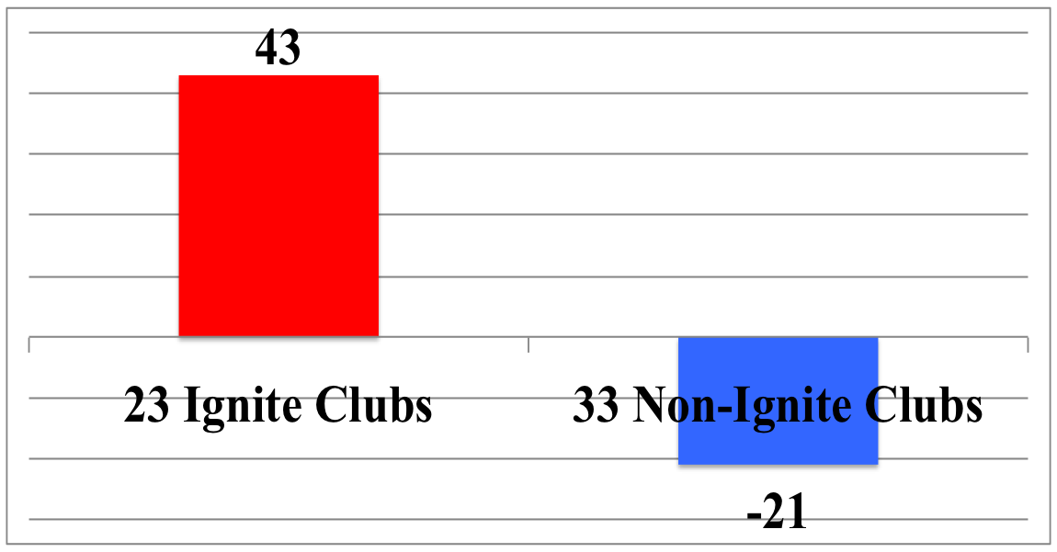

1 July 2014 - 1 July 2015

**WHY Ignite? Because it’s working!!!!**

In Rotary Year 2016-2017 District 5930 was **Number 1 in membership growth and retention in our Zone** (prior to Ignite we were “Dead” last for over 10 years).

**RETENTION**

* Your Club, nor any other Club, will grow if they lose more members than they attract (recruit). With your leadership and the Ignite “Toolkit,” your club will stop those losses through solid programs, great service projects, mentorship, engagement of new and current members, and interest in every member.

**EXTENSION**

* Greater than one new club will be developed. Opportunities for an “e” club and additional satellite clubs will also be explored. An active Extension Committee will be scouting the District for practical solid growth opportunities.

**SUMMARY**

* Clubs using the Ignite “Toolkit” and best practices have seen success with the Ignite membership initiatives in 2013-2014, 2014-2015, 2015-2016 and 2016-2017. **We don’t want to be guilty of doing nothing in the face of our membership needs**. With additional members and engaged members clubs are able to provide more opportunities for networking, fellowship, fun, and **expanded service opportunities**.

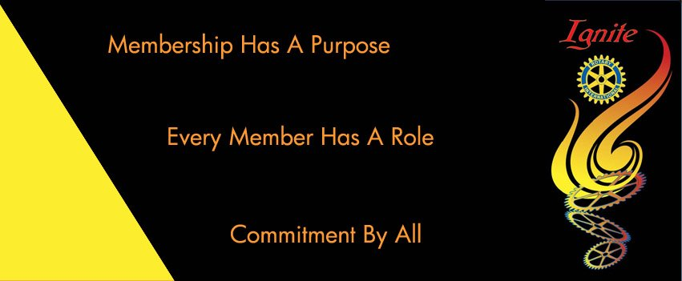

Thank you for your “Service Above Self.”

**History of IGNITE**

* IGNITE was developed by Ken Boyd, Past International Membership Chair for RIP Rick King.
* IGNITE was built on continuity.
* IGNITE is a focus on Membership program; every member has a role and commits to participate.
* IGNITE rationale - everyone has something to contribute to the success of their clubs; therefore every person has the power to make a difference.
* IGNITE has proven success in D5930.
* IGNITE handouts were developed as "best practices."  Clubs that have utilized the IGNITE focus on membership program have seen a dramatic improvement in membership attraction (recruitment) and retention, as well as extension.