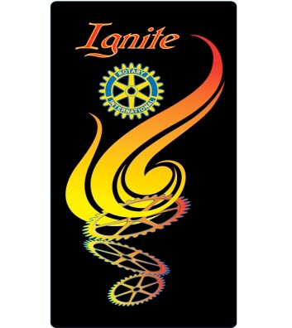
Premier Clubs
Governor’s Membership Citation

The Purpose:
To ignite every ROTARIAN by involving them in one or more of the following activities.

Rationale:
Everyone has something to contribute toward the success of their Club; therefore, every person has the power to make a difference.

How to Become a Premier Club and Receive the Governor’s Membership Citation:
Multiply the number of Club members by 10 (for example, 50 members x 10 = 500 points.) This will be the Club minimum number of points needed to become a Premier Club.
How to Obtain Points?
- Bring in a new member 25 pts.
- New member brings in a New Member (Bonus in addition to #1) 20 pts.
- Establish a Club Membership Goal 20 pts.
- Develop a Membership Committee of 4 or more 15 pts.
- Select and complete 4 or more of the
“15 + Tips for Successful Clubs” 10 pts.
- Assign a Mentor to each New Member 10 pts.
- Get New Member “engaged” (involved) within First Week 10 pts.
- Hold Firesides (Training) for New Members (orientation) 10 pts.
- New Member Participates in Service Project 10 pts.
- Potential Member gets Involved in Service Project 10 pts
- Invite District Membership Committee member to be speaker to 10 pts
your club.
12. Develop an Attractive Website. 10 pts
13. Hold a Club Assembly focused on Membership 5 pts.

- Bring a Visitor to a Club Meeting 5 pts.
- Propose a New Member 5 pts.
- Assign a Member to Keep Track of Points 5 pts.
- Attend the District Membership Seminar 5 pts. for each attendee
- If EVERY MEMBER of your Club Participates in 1 or more
of the above 50 pts.

Club Recognition:

Every Premier Club will receive the ignite emblem shown above for their banner.

