Sonny Brown Business of the Year Award
Established in 2005, Rotary’s Centennial Year, to honor

Past Rotary International Vice President
&
District 5520’s Past Governor Sonny Brown

for his many years of service, outstanding leadership skills
and on-going support!

Criteria
The Award recognizes businesses in District 5520 that exemplify the High Ethical Standards of Rotary.
The business must demonstrate excellence in the following areas:
- Employee Relations
- Quality of product and/or representation
- Community involvement of both management and employees
Categories
Non-Rotarian Owned Business
- Small Business Award from 1 to 10 employees
- Medium Business Award—from 11 to 50 employees
- Large Business Award—more than 50 employees
Rotarian Owned Business
- At-Large Business - Rotarian Owned Business of any size

Nominees businesses must be located within District 5520. The participating Rotary Clubs may submit one application in each category. Nominees must receive the Club’s endorsement before submission to the District 5520 Selection Committee.
Applications (download application - file to the left) must be submitted no later than March 22, 2022, to PDG Dick Jones at rjones9755@aol.com or mailed to:

Dick Jones
2527 Calle Delfino
Santa Fe, NM 87505

Selection Process
The District Selection Committee will review the nominations, choose the recipient for each of the categories and notify the sponsoring Club. The recipients of the District awards will be invited, as the District’s guest, to the District Conference on April 8th at the Isleta Resort. The sponsoring Rotary Club is responsible for making arrangements for its recipients’ attendance.

IRVING J. “SONNY” BROWN

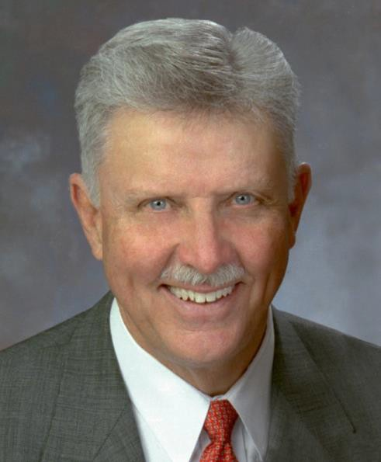
Sonny is Chairman and Founder of Sonny Brown Associates, an international commercial and industrial real estate consulting firm. He was born in Parral, Chihuahua, Mexico. Spanish is his first language. He is an active member of the Society of Industrial and Office Realtors and other regional and national real estate organizations.
He has served his community as director of the El Paso Industrial Development Corporation, as a commissioner on the Housing Authority of El Paso, and as vice president and director of the El Paso Chamber of Commerce. For his service to the El Paso Community, he was awarded the Distinguished Service Award, an award given annually by the Rotary Club of El Paso.
A Rotarian since 1960, Sonny has served RI as club president, district governor, RI director, and RI vice-president. In addition, he has served as an international Assembly training leader, vice-chairman of the World Community Service Resource Network, Chairman of the First International RYLA Committee, and chairman of the 2001 San Antonio Convention. A Trustee of the Rotary Foundation, 2000-04, he served as General Coordinator of The Family of Rotary Task Force in ’04-’05. He is currently the Moderator of the Regional Rotary Foundation Coordinators Institute and Advisor to the International RYLA Committee. Sonny also served as Chairman of the Rotary International Leadership Development and Training Committee in 2006-07: easily recognized when described as “RYLA for Rotarians”. Graduates from over 30 separate Institutes total more than 425 Rotarians, many of whom have become Rotary Club Presidents and District Governors.
Sonny has received the Rotary Foundation’s Citation for Meritorious Service and the Distinguished Service Award and his District named their new vocational service award “The Sonny Brown Business of the Year Award.”
Both he and his wife, Ann, are Major Donors of the Rotary Foundation and Members of the Bequest Society. They are proud parents of four children, all Paul Harris Fellows, along with most of their ten grandchildren.

