1915-16 W. H. Richardson, Jr. Austin, TX
J.J. Brunnier San Francisco, CA
1916-17 Lynn B. Milan Dallas, TX
H.W. Sumption San Diego, CA
1917-18 Elijah Coles Houston, TX
Dewy R. Powell Stockton, CA
1918-19 T.S. Reed, Jr. Beaumont, TX
Wm. R. McFarland Denver, CO
1919-20 Robert E. Vinson Cleveland, OH
Roger H. Motten New York, NY
1920-21 H.J. Lutcher Stark Orange, TX
B.F. Scribner Pueblo, CO
1921-22 George C. Holmgren San Antonio, TX
Harvey D. Parker Greeley, CO
1922-23 Charles B. Christy Phoenix, AZ
1923-24 G. A. Martin El Paso, TX
1924-25 Charles Barber Fairfield, IA
1925-26 Henry T. Fletcher Marfa, TX
1926-27 Clinton P. Anderson Albuquerque, NM
1927-28 Guy Harrington Santa Fe, NM
1928-29 Jeff D. Atwood Roswell, NM
1929-30 Hunter Metcalf Marfa, TX
1930-31 R. E. McBride Las Cruces, NM
1931-32 Charles J. Andrews El Paso, TX
1932-33 A. O. Bowden Silver City, NM
1933-34 William Kerr Midland, TX
1934-35 D.C. Peareson Roswell, NM
1935-36 Charles Graham El Paso, TX
1936-37 James F. Zimmerman Albuquerque, NM
1937-38 John W. Chapman Santa Fe, NM
1938-39 John P. Sheehan El Paso, TX

1939-40 Claude Simpson Roswell, NM
1940-41 Joel W. Wright Alpine, TX
1941-42 Oscar J. Allen El Paso, TX
1942-43 Morton M. Cheney Albuquerque, NM
1943-44 G.T. McWhirter Mountainair, NM
1944-45 Ray Stallings Moriarty, NM
1945-46 Oren W. Strong Albuquerque, NM
1946-47 R.W. Spence Carlsbad, NM
1947-48 H.C. Pannell Lovington, NM
1948-49 Floyd D. Golden Portales, NM
1949-50 Ray J. Lofton Melrose, NM
1950-51 Sloan Paxton Carlsbad, NM
1951-52 W. H. Duckworth Clovis, NM
1952-53 Ray Robbins Alamogordo, NM
1953-54 Harry P. Stagg Albuquerque, NM
1954-55 Byron D. Roberts Las Vegas, NM
1955-56 Warren Mithoff El Paso, TX
1956-57 George A. Dowdle Deming, NM
1957-58 Millard Murphey Tucumcari, NM
1958-59 L. A. Hendrix Alamogordo, NM
1959-60 Stuart Adler Albuquerque, NM
1960-61 Travis Stovall Clovis, NM
1961-62 Edwin Schmidt Pecos, TX
1962-63 W. A. Adams, Jr. El Paso, TX
1963-64 Dewey F. Langston Portales, NM
1964-65 Ted A. Bonnell Alamogordo, NM
1965-66 Melvin A. Hill Las Vegas, NM
1966-67 Zane E. Smith Carlsbad, NM
1967-68 Wilfred McCormick Albuquerque, NM
1968-69 Carl W. Connors El Paso, TX
1969-70 R. Ken Tucker Gallup, NM
1970-71 Walter Wade Alamogordo, NM
Born Died
1971-72 Martin W. Fleck Albuquerque, NM
1972-73 Robert Coltharp El Paso, TX
1973-74 Billie Holder Alamogordo, NM
1974-75 Ralph Stucky Las Cruces, NM
1975-76 Joe Henry Albuquerque, NM
1976-77 F.C. Williamson Carlsbad, NM
1977-78 Wayne F. Johnson Hobbs, NM
1978-79 Parker A. Woodul Portales, NM
1979-80 A. Vincent Ward El Paso, TX
1980-81 Marvin D. Rohovec Alamogordo, NM
1981-82 Henry Pick Santa Fe, NM July 25, 2020
1982-83 Marvin Trembly Belen, NM September 11, 1919 June 5, 2009
1983-84 Harold E. DeShurley Roswell, NM
1984-85 Robert “Si” Nanninga Albuquerque, NM
1985-86 Earl H. Hathorn Silver City, NM
1986-87 William L. Buhler T or C, NM
1987-88 C. Neal Johnson Newport Beach, CA
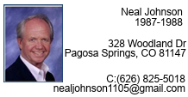

1988-89 Rex N. Brown Roswell, NM

1989-90 Irving J. “Sonny” Brown El Paso, TX
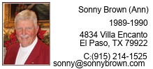

Born Died
1990-91 Paul Herring (Ann) Roswell, NM
200 Lasso, Horseshoe Bay, TX
W:(505) 622-6864
paulherring@cableone.net
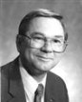

1991-92 Don C. Shuffstall (Lou) El Paso, TX
1480 Goldrush Ave
Melbourne, FL 32940
321-259-2358
shuffstall@efl.rr.com
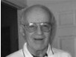

1992-93 Bill DeGroot Albuquerque, NM
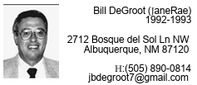
1992-93 Andy Anderson (Marleta) Placitas, NM Served in District 6600
310 Camino de las Huertas
Placitas, NM 87043
505-990-3546
ae5ea@arrl.net
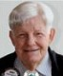

1993-94 Clark E. Lovrien, Jr. Albuquerque, NM November 1, 1937 May 3, 2015
1994-95 Richard Matthews Alamogordo, NM

1995-96 Reba Lovrien (Clark) Albuquerque, NM August 8, 1936 October 18, 2015
139 Buckboard Rd.
Tijeras, NM 87059
505-281-3269
rotaryreba@gmail.com
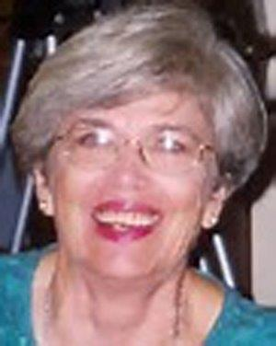

1996-97 John F. Lane Jr. El Paso, TX
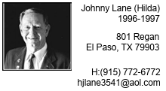
1997-98 Daniel J. Schulte El Paso, TX
3130 Mesa Verde Ln.
El Paso, TX 79904-3011
915-755-3387
schultedks@gmail.com
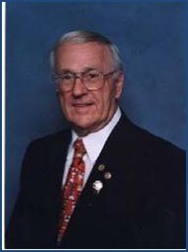
1998-1999 J. Robert Wootten El Paso, TX (Bob’s wife Gerri remains active)

1999-2000 Myrtle Fritschy Carlsbad, NM February 20, 2024
1702 Mountain Shadow Dr.
Carlsbad, NM
575-885-2542
mbfritschy@bajabb.com
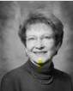

2000-2001 Randy Gleason Albuquerque, NM Served in another District


2001-2002 Bob DeLaHunt Chama, NM
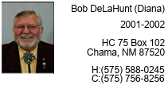
2002-2003 Daniel R. “Dan” Garrison Bosque Farms, NM
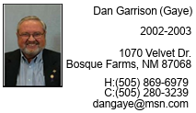

2003-2004 Bonnie Fairall (Jack) El Paso, TX
11204 Bill Hill
El Paso, TX 79936
915-592-4982
bfair91342@aol.com
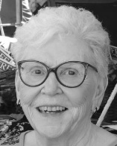
2004-2005 Rick Akins Rio Rancho, NM

Born Died
2005-2006 Mike Adkins El Paso, TX
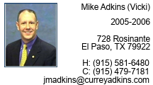
2006-2007 Dennis Edwards (Carolyn) Angel Fire, NM July 1, 1941 April 20, 2019
P.O. Box 2019
52 Valle Grande Trail North
Angel Fire, NM 87710
575-377-1078
jacquesdad@gmail.com
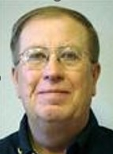
2007-2008 Jackie Morgan El Paso, TX
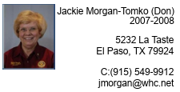

2008-2009 Tom Lindsay Deming, NM
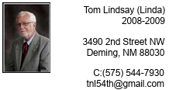

2009-2010 Dick Jones Santa Fe, NM
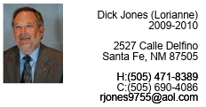
2010-2011 Tim Parker Roswell, NM
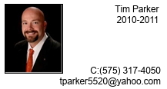

2011-2012 Bobby Wallace Albuquerque, NM
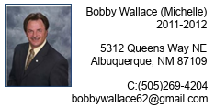

2012-2013 Mark Glenn Las Cruces, NM
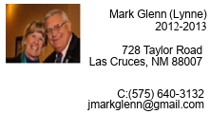

2013-2014 Kit Turpen Albuquerque, NM
3 El Nido Amado SW
Albuquerque, NM 87121
505-449-8565
kitturpen.5520@gmail.com
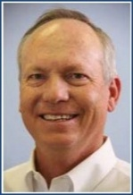

2014-2015 Lonnie Leslie Clovis, NM
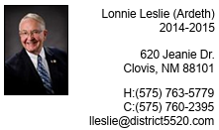

2015-2016 Tom Walker Albuquerque, NM
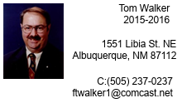

2016-2017 Dave Anderson Albuquerque, NM
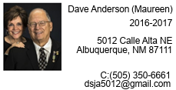

2017-2018 Doreen Kelsey Albuquerque, NM Served in another District


2018-2019 Linda Woodward Anthony, NM
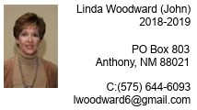

2019-2020 Gary King Moriarty, NM
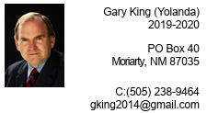

2020-2021 Sunny Kellerman Silver City, NM
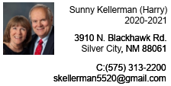

2021-2022 Bob Rausch Albuquerque, NM
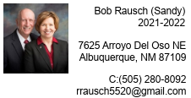

2022-2023 John Drusdrum Roswell, NM
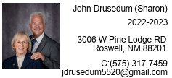

2023-2024 Richard Haas Las Cruces, NM
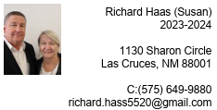

2024-2025 Yasser Murga El Paso, TX
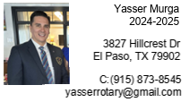

2025-2026 Tom Simon Santa Fe, NM
