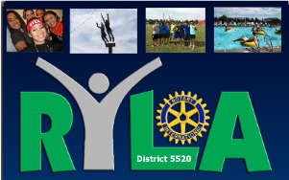

Dear

The Rotary Club of _________________ is interested in community leadership, not only for today, but for tomorrow as well. The students in your organization will, in a very few years, be assuming some of our community's leadership roles. We know you are working with them and training them for that task. Rotary would like to help also.

For this reason, the Rotary Clubs in District 5520 (New Mexico and West Texas) are holding their annual Rotary Youth Leadership Camp (RYLA) at Manzano Mountain Retreat near Mountainair, NM
July 16-22, 2017 (Boys Camp) and July 22-28, 2017 (Girls Camp). It will be staffed by carefully selected, experienced counselors. Our objective is to offer the challenge of accepting the responsibility of leadership. Much of each camper’s time will be structured with programs such as group discussions, guest speakers, career guidance, group sports and a newsletter. Perhaps the greatest benefit will come from sharing this experience with the 80-110 other outstanding young men and women from schools and similar organizations in our Rotary District.

Our Rotary Club is asking you to nominate young men and women, currently in their junior year of high school, who have already displayed leadership abilities and who will profit most from this experience. We suggest they be selected first for leadership potential, second for good citizenship, third for desire to attend RYLA, and fourth for scholarship. These characteristics are listed in that order so that latent leaders are not overlooked because of grades or other factors. The only requirement is that they must be students who will enter their senior class in September 2017.

Applications can be completed at our website: www.rotary5520.org under the New Generations (Youth Services) tab under RYLA (Forms tab). Our Rotary Committee will then conduct interviews and select the campers.

It is our hope that the selection for the RYLA Youth Leadership Camp might become a regular part of your award system, and an honor that students can work for and achieve. Thanks for your assistance in this project for the advancement of youth.

Sincerely,

RYLA Committee Chairperson (Rotary Club of ____________)

